- Composition
Sheikh Mohammad bin Ibrahim Al-Subaie is a great philanthropist and a prominent businessman.
Write an essay about him, using the table below:
Name | Sheikh Mohammad Bin Ibrahim Al-Subaie / renowned philanthropist
Wealth | $ 6.5 billion
Born | 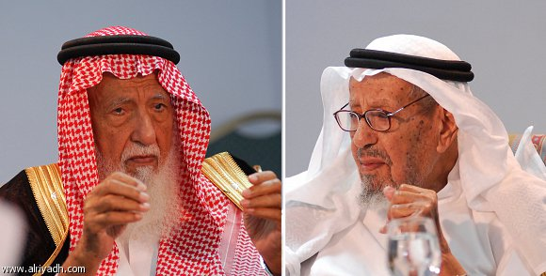1333 / Onaizah
Al-Subaie's early life | Jobs: porter / cook / security /trader
Al-Subaie's later life | Marriage : 1 time / 10 children
His achievements | Al- Belad Bank / Al-Malfa Hotel / shrimp farm
Award | King Faisal International Prize

A great philanthropist
Sheikh Mohammad Bin Ibrahim Al-Subaie is a renowned philanthropist. His wealth is about 6.5 billion dollars. In his early life Al-Subaie worked as a porter, a cook , a security and a trader. In his late life he married twice and he has 10 children. He founded Al-Belad Bank , Al-Subaie Charity Work ,
Al-Malfa Hotel and Shrimp farms in Thowal. He got King Faisal International Prize. In fact he is a good model for an independent person.

- Composition
Sheikh Mohammad bin Ibrahim Al-Subaie is a great philanthropist and a prominent businessman.
Write an essay about him, using the table below:
Name | Sheikh Mohammad Bin Ibrahim Al-Subaie / renowned philanthropist
Wealth | $ 6.5 billion
Born | 1333 / Onaizah
Al-Subaie's early life | Jobs: porter / cook / security /trader
Al-Subaie's later life | Marriage : 1 time / 10 children
His achievements | Al- Belad Bank / Al-Malfa Hotel / shrimp farm
Award | King Faisal International Prize

A great philanthropist
Sheikh Mohammad Bin Ibrahim Al-Subaie is a renowned philanthropist. His wealth is about 6.5 billion dollars. In his early life Al-Subaie worked as a porter, a cook , a security and a trader. In his late life he married twice and he has 10 children. He founded Al-Belad Bank , Al-Subaie Charity Work ,
Al-Malfa Hotel and Shrimp farms in Thowal. He got King Faisal International Prize. In fact he is a good model for an independent person.

