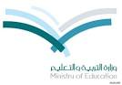Kingdome of Saudi Arabia 2nd Secondary English Exam (1)

The Ministry of Education Name:………………………….

Secondary school Class: 2\ S A

**I – Vocabulary:**

1. Write two sentences correctly about what is she wearing

………………………………………………………..

……………………………….……………………….

2. Write the correct word under each picture

Nervous - dizzy - skydiving – ice skating- printer – graduation – deodorantّ -

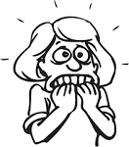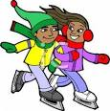

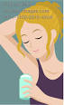

………………………….

…………………………….

…………………………….

……………………….

3. Give at least four related words to the given ceremony

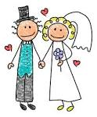

**II- Grammar**

**1. Tick ( ) correct sentence:**

a. Think carefully before you choosing your career.

b. Think carefully before choosing your career

a. She needn't to leave.

b. She doesn’t need to leave.

a. How much people are coming?

b. How many people are coming?

a. Ali is coming to visit us on October 13th.

b. Ali is coming to visit us in October 13th.

**2. Write the correct form of the verb**

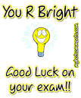If you had asked me , I ……………………………( give ) you the information.

**3. Use ( Should not )**

I left my umbrella at home . It's raining now. ……………………………………………………………..