English Exam First period (Third secondary grade )

10

Student`s name------------------------------------------------------------------------------------- Class-------------

Answer the following question:

1. Vocabulary

A- Write the following Words of subjects under their suitable pictures :

Engineering – chemistry- math-history

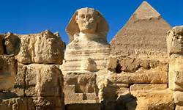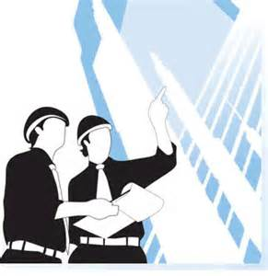

----------------------------- -------------------------------- ----------------------------------- --------------------------------------

B-complete the following gaps with a- suitable words cheat –pass- certificate B - suitable suffixes -or ,-ist-,-ee

1-usulay you need to get more than 50% in an exam to------------- 1- scient----------

2-when I finish my term , I will take ------------------ 2- employ---------

3- the teacher watch us during our exam so we can`t -------------------- 3- instruct--------

1. Grammar

A-Complete the second sentences using the correct forms of model verbs:

(must- mustn`t- can- can n`t- have to – don`t have to )

1- Making aloud voice is prohibited here, so you -------------------------------make a loud voice.

2- it`s obligatory to wear a seat belt, you -------------------------wear a seat belt.

3- It isn`t necessary for students to wear a uniform here, students -----------------------wear a uniform.

B- Complete the sentences with verbs in the correct tense:

1- If I were you, I ------------------ (tell) fawzi the truth.

2-My mum will be angry if she ------------------- (find) my dirty trainers.

3- If I-------------- (have) the time , I `d learn to speak another language .

Best wishes For you