**WORK SHEET**

**GROUP NAME :**

**arrange the correct letters to give a correct words :**

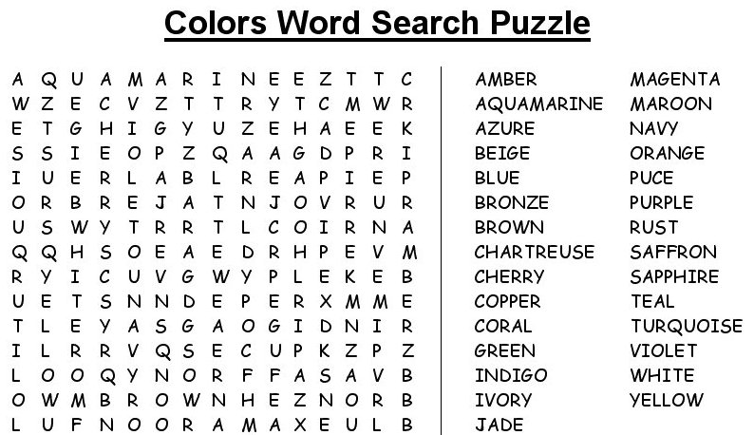

**First year .. first term ..**

**T , Muna**