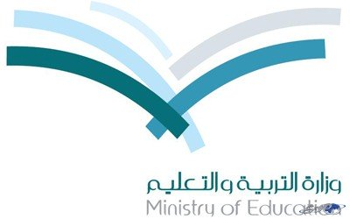
المملكة العربية السعودية
وزارة التربية والتعليم
الإدارة العامة للتربية والتعليم

Kingdom of Saudi Arabia
Ministry of Education
Administration of Education

Distribution of the syllabus for First grade Sec.
first term 1435- 1436
5th week |  | 4th week | 3rd week | 2nd week | 1st week
18 / 12 – 22/ 12 | 4 / 12 – 18 / 12 | 26/ 11 – 1 / 12 | 19 / 11 – 23 / 11 | 12 / 11 – 16 / 11 | 5/ 11 –9/ 11
U: 2 L :1-6 | hajj | Revision  Quiz | U : 1 L : 7-12 | U : 1 L : 1-6 | Registration
11th week | 10th week | 9th week | 8th week | 7th week | 6th week
1 /2 –5 / 2 | 23/ 1 –27 / 1 | 16 / 1 –20 / 1 | 9 / 1 – 13 / 1 | 2 / 1 – 6 / 1 | 25 / 12 – 29 / 12
U: 5 L: 1-6 | U: 4 L : 7-12 | U : 4 L : 1-6 | U : 3 L :7-12 | U : 3 L :1-6 | U: 2 L :7-12
17th+18th week | 16th week | 15th week | 14th week | 13th week | 12th week
13\3 - 24\3 | 6 \3 - 10\3 | 29\2 – 3\3 | 22 /2 – 26 / 2 | 15 / 2 – 19 / 2 | 8 / 2 – 12 / 2
Final Exams Revision |  | Revision | Lesson:7-12 | U : 6 L : 1-6 | U: 5 L : 7-12

Teacher : Principal :

