Kingdom of Saudi Arabia English Language
Question | الدرجـة رقما | الدرجـة كتابة | المصححة | المراجعة | المدققة
Composition | 5
Reading Comprehension | 5
Grammar | 6
Vocabulary | 5
Orthography (Spilling) | 3
Total | 24

Ministry of Education 1st Grade /Inter.
ministry for Girl's Education Second Term 1434/1435
Al-Barza School Final Exam-first round.

Name:…………………………………………. Time: 2 hours

Q1:

5
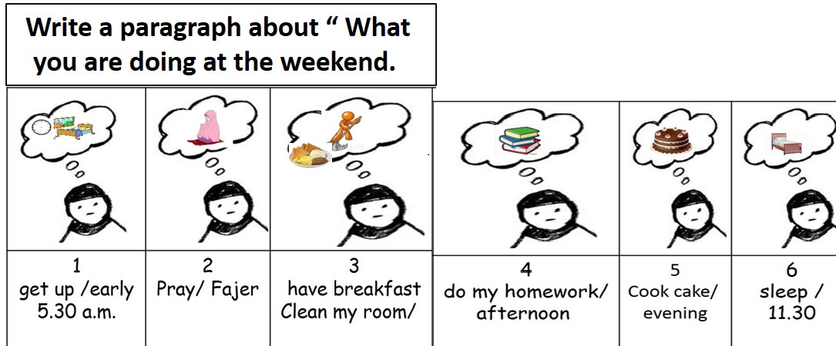
…………………………………………………………………………………………………………………………………………………………………………………………………………………………………………………………………………………………………………………………………………………………………………………………………………………………………………………………………………………………………………………………………………………………………………………………………………………………………………………………………………………………………………………………………………………………………………………………………………………………………………
( 1 )

Q2:Comprehension passage:

5
5
Read the passage then answer the questions ;
Wafa is a teacher at small school . She teaches children . She has 21 children in her class ,12 boys and 11 girls .She likes them too much and they like her too . She is very patient and helps them a lot . She is a very good teacher .
- Questions :
- Where does Wafa teach ?
……………………………………………………
- How many girls are there in Wafa 's class ?
……………………………………………..

- Choose :
1- She is very [ bad - good - big ]
2- Wafa works at small [ house – mosque – school ] .
C) Put (✓) or (✗) and correct:
3- She has 100 children in her class .( )
4- She is very patient.( )

6
Q3:Grammar: 5
A-Choose the right word :
1-He is ( play – playing –played –plays ) basketball .
2- we must ( clean – cleaning – cleaned – cleans ) the house .
3- I ( eat – eating – ate – eats ) cake yesterday ,
4- Cheetah is ( fast –faster than –fasting – fasted ) Camel.
5- The Elephant is ( big – bigger – the biggest – bigs ) animal,
6- they will ( travel – travelled –travelling – travels ) next week .

( 2 )
B -Do as shown between brackets :
- He is sleeping now .
……………………………………………..…. ( Change into Negative using not )
2 - are - stories - They - reading - .
…………………………………………………………………. ( Re-arrange the sentence )

3- Will she study English ? ( Write short answer with Yes )
………………………………………………………………..

Vocabulary

A) - Circle the odd word :

5
1- Pilot – Dentist – Barber –
3- Flat –House – Castle – 5
4- Eagle – swan – Cats –
B) - Match [ A] with [ B ] : :-
A | B
- Plane | [ ] station .
- Ship | [ ] stop .
- bus | [ ] port .
- train | [ ] airport .

C) : Match words with photos : ( igloo – camel –space ship –tower )




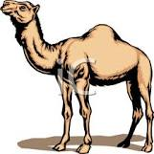

1 | 2- | 3- | 4-

( 3 )

Q5:Orthography (Spilling)

A-Choose the correct spelling:

3

 |  |  |  | 
1-nayri | 1-ylocud | 1-cold | 1-bike | 1-football | 1-wnosy
2-rainy | 2-cloudy | 2-dolc | 2-keib | 2-fotoblal | 2-snowy

My best wishes
Mrs.Rania

( 4 )

