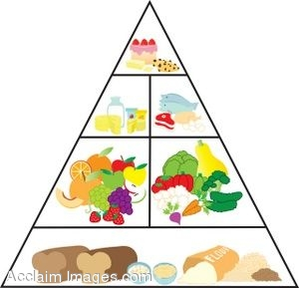



### Kingdom of Saudi Arabia Month Exam

***Ministry of Education Time: 45 minutes***

***21st Intermediate school First Grade***

**Read the following passage then, answer the questions**

There are four main food groups . Bread , cereals , rice and macaroni are in the first group . They give us B vitamins and starch . Fruit and vegetables are in the second group . They give us vitamins A and C. Milk , butter , cream , cheese , and yoghurt are in the third group . They give us vitamins and calcium . Meat , fish , eggs , beans , and nuts are also in this group.

|  |
| --- |
|  |
| ***10*** |

**Name:……………………………………..Class:……………Date:…………**

1

A)\_ How many food group are there?....................................................................

B)\_ PUT {T} OR { F}:

1- Milk and Cheese give us calcium { }

2- Fruit and vegetables are in the third group { }

2

Number the balloons togive the correct order :





TT





***Choose*** *:*

3

*1)*  *Is there ( any – some ) coffee ? .*

*2) There is (an – a – any) banana on the table*

*3)* I reach school ( in – on – at ) 6 : 30 a.m.

*4)* Huda ( wake up – wakes up ) early every morning .

*.*

Do as shown between brackets :

I go to school on Friday . { Add **never** and re-write the sentence}

……………………………………………………………………………………………………

4

Match :

1- a cup of ( ) coffee

2- a bottle of ( ) bread

3- a piece of ( ) clock

**circle the odd word**

1- beef- lemon – fish – chicken

2- flour – bread – rice – eggs

5

**Copy the following sentence once :**

**You must keep your classroom tidy**

………………………………………………………………………………………………………………………………………………………………………………………………..…………………………………………………………………..…..………………………..………………..……………………

6

Write the word :

 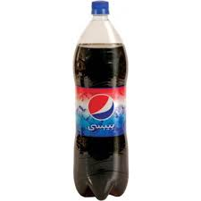

GOOD LUCK

T.AFAF

………………….

………………….

C:\Documents and Settings\acer\My Documents\Pictures\c_food\أطعمة\COLABTL2.WMFC:\Documents and Settings\acer\My Documents\Pictures\c_food\أطعمة\COLABTL2.WMFC:\Documents and Settings\acer\My Documents\Pictures\c_food\أطعمة\COLABTL2.WMF

C:\Documents and Settings\acer\My Documents\Pictures\c_food\أطعمة\COLABTL2.WMF