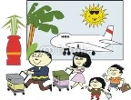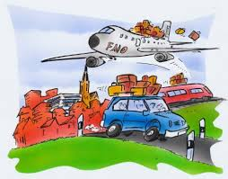 Review Unit ( 3 )

My Name ……………………………………………………………………………………………class…………………………..

***Q 1: Write the correct number under each picture :***

( 1.smoke – 2. ship – 3.short– 4. Passport– 5. bus – 6. passenger –7.Seat– 8. Suitcase - 9.humid - 10. plain - 11. tent – 12. build - 13.sun cream - 14. rucksack - 15.train)

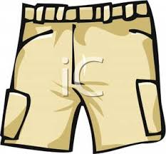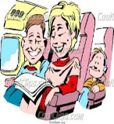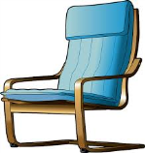

……… …....… …..…. …..… …..…. ….….. ……. ……

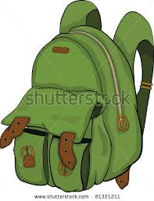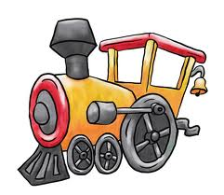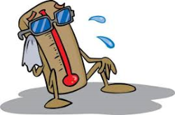

……… …....… …..…. …..… …..…. ….….. ……. ……

***Q2: Choose :***

1-My father ( was – is - were ) angry last night .

2- She ( cook – cooked – cooking ) the dinner yesterday .

3- They ( was - were - are ) absent yesterday .

4- Ali ( wear - wears - wore ) his new shirt an hour ago .

***Q3: Change the verbs to the past simple :***

1- live ………………….. 2- cry ………………………. 3- go ……………….

4- need ……………………. 5- stop ……………………... 6- buy………………



Mrs: Lamia

( 12 )