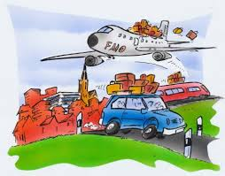 Unit ( 3 ) Lesson ( 2 )

My Name ……………………………………………………………………………………………class…………………………..

***Q 1: Write the correct word under each picture :***

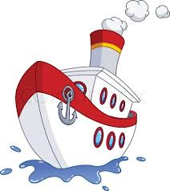 ( passenger – smoke - humid - build – bus - train – plain - ship )

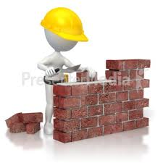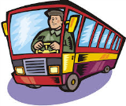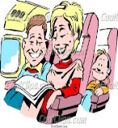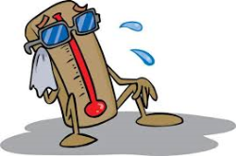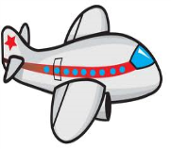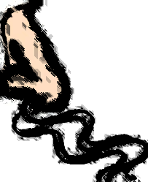

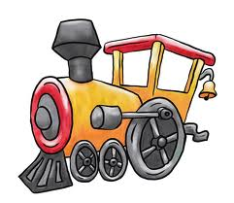

……… …....… …..…. …..… …..…. ….….. ……. ……

***Q2: Choose :***

1- Jeddah is a famous ( port – airport) .

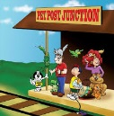2- The train is at the ( stop – station ) .

3- We are waiting on the ( port – platform ) for the next train .

4- The plane stopped at the ( station – airport ) .

5- He is waiting at a bus ( stop – port ) .

***Q3: Choose :***

1- My sister ( cook – cooked – cooking ) the dinner yesterday .

2- She ( walk - walked - walking ) down the street last hour .

3- They ( visit - visited - visiting ) Jeddah a week ago .

***Q4: Change the verbs to the past simple :***

1- like ………………….. 2- try ……………………….

3- stop……………………. 4- look ……………………...



Mrs: Lamia

( 10 )