**Revision Unit ( 3 ) Space and time**  3rd grade secondary

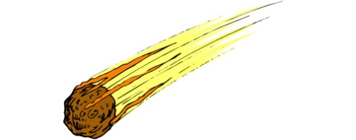**1]: Write the correct word under the picture:**

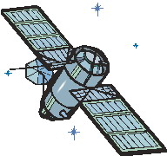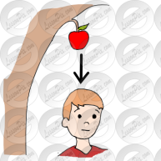

a- (astronaut- gravity) b- (spacecraft- satellite) c-(telescope- orbit) d-(meteorite – asteroid )

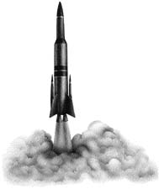

e-( launch- landing )

**2]: Dialogue:** **Complete the following dialogue between Talal and Sameer about space explorations :**

**Talal** : What was the name of the 1st space shuttle ?

**Sameer** : -----------------------------------

**Talal** :Do you know who is the youngest and first Arabic astronaut ?

**Sameer** : ---------------------------------------------------------------------------

**Talal** : What is his nationality ?

**Sameer** : ------------------------------------------

**Talal** : I read a n article about the space junk , do you think it will be serious problem ?

**Sameer** :--------------------------------------

**3]: Fill in the spaces with the correct words , use the given words in the box :**

**travel - trip - journey - voyage**

a- My students went on a school ------------------------- to the university.

b- I read a book about the long ----------------------- of Ibn Battuta .

c- Nawal and her family ----------------------- to Makkah to perform Omrah every year .

d- It was a long ---------------------- to space , it took two years .

**4]: Match the words with their meanings :**

**( A ) ( B )**

1- trivial ( ) – rubbish or junk

2- debris ( ) – operated or controlled by people

3- manned ( ) – causing someone to die

4- in no hurry ( ) – not wanting to do something very quickly

5- fatal ( ) – not very important .

5:

**Future Forms :**

**1: Will** a- for predictions based on thoughts ,opinion and expectation

b- for decisions made at the moment of speaking

c- for future facts

**2: be going to** a- for prediction based on evidence

b- for plans and intensions

**3: Present continues**  for confirmed plans and arrangements

**4: Present simple** a- for events that are part of timetable or routine

b- after expressions of time such as ( when , before , after , by the time

, until , as soon as )

**Correct the verb between brackets :**

a- As soon as , the class **(will start )**------------------------, I will take my books out

b- Don’t worry , I **( am going to)**------------------------ help you in your homework

c- I think humans **( are going to land )**-------------------------- on the moon again in the future .

d- Look at the clouds , It **( will rain )** ----------------------------- .

e- I **( will see )**--------------------------- the doctor tomorrow , the appointment is for 10:30 .

f- Do you think it **( is going to snow )** ----------------------------- next week ?

6:

**Future activities in the past:**

Was - was going to – would – (was + (v+ing )

**Complete the following sentences with these words in the box:**

**going – to - was - would**

a: He thought the sun ------------------- shine the next day , but it was really cloudy .

b: They ran to catch the train because it was ------------------- to leave at that moment.

C: The interview was --------------- start at 10 am but she was late .

D: They thought the conference ------------- starting at 9 pm , but they were wrong .

7:

**Prefixes :** the adding to the beginning of the word which give different meaning

**Mis** = wrong or incorrect **pre**= before **post**= after

**Under**= not enough **inter**= between **un + dis** = the opposite or not

**Re**= again **co**= with or together **ex**= position or situation that excited before but not now

**Add the correct prefix to the followings** :

a- please don’t --------understand me , it was just a joke.

b- There is no space in this flight . It is already -------booked

c- Bill Clinton is an ------- president of the USA.

d- This essay has got lots of mistakes . I’d like you to -------- write it .

e- This is ------possible, I can’t believe it happened .

8:

**Future continuous , future perfect simple and future perfect continuous:**

**Future continuous** :activities in progress at a particular moment in the future

**will/ won’t + be + (v+ (ing ))**

By the end of the year , I will be living in Makkah

**Future perfect simple** : activities that will be finished before a particular time in the future

**Will/won’t + have + 3rd (v)**

By the end of the year , she will have been in Hajj

**Future perfect continuous :( we specified the time)**

**Will/won’t + have + been + (v+(ing ))**

Next month , I will have been living here for ten years .

**Correct the verb between brackets** :

a- I will have **( go )** ----------------- to bed by midnight.

b- By 8 pm , I ‘ll have **( revise )**------------------------- for five hours

c- This time tomorrow , he will be **( fly )** --------------------- to Riyadh .

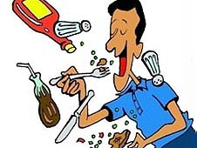**9: Express and justify your opinion about the following phrase :**

One day , when we go to live on other planets, we are going to

do the same as we have done to the earth , Ruin it

---------------------------------------------------------------------------------------------------------------------------------------------------------------------------------------------------------------------------------------------------------------------------------------------------------------------------------------------------------------------

**10 : Comprehension :Read the following imaginary story and answer the questions below :**

One day, Little Alien decided he was going to really explore the blue planet, so he jumped in his spaceship and off he went. First, he came to the **little** ball orbiting the blue planet. It was a nice shiny ball and he noticed it had been hit by a lot of rocks from space over time. Interesting to Little Alien was that it made the ball look like it had a face on it. Next, he hovered over the ice at the north pole of the planet. It was very white here and there didn't seem to be anything of interest, so he started to fly over the different land masses. There were several large continents on this planet and several big oceans as well. The land was green and brown and the water was blue. This must be how the planet gets the blue color, Little Alien thought to himself. Well, he had to have a closer look, so he put his spaceship closer to the planet and noticed the mountains and the trees and all the little creatures running around everywhere. There seemed to be tall creatures and small creatures and metallic creatures and wooden creatures. Little Alien saw this planet was teaming with life and it was very exciting. He got so excited that he just had to tell his family and he pulled up from the planet and returned to his ship where he told his family all about what he'd seen on the blue planet and they were very **happy** for him.

a- What was the blue planet ?

--------------------------------------------------------------------------------------------------

b- Who is the hero of this imaginary story ?

---------------------------------------------------------------------------------------------------

**c- Give the opposite of the underlined words :**

little # ---------------------- happy #-------------------------

**d- Complete:**

1-The alien was travelling by using his ---------------------------

2-The nice and shiny ball planet is the -------------------------

**11:Composition : Write short story by using different past tenses and start with this sentence :**



When Nura woke up that morning , he had no idea that the events of

The day would change her life forever .

--------------------------------------------------------------------------------------------------------------------------------------------------------------------------------------------------------------------------------------------------------------------------------------------------------------------------------------------------------------------------------------------------------------------------------------------------------------------------------------------------------------------------------------------------------------------------------------------------------------------------------------------------------------------------------------------------------------------------------------------------------------------------------------------------------------------------------------------------------------------------------------------------------------------------------------------------------------------------------------------------------------------------------------------------------------------------------------------------------------------------------------------------------------------------------------------------------------------------------------------------------------------------------------------------------------------------------------------------------------------------------------------------------------------------------------------------------------------------------------------------------------------------------------------------------------------------------------

Teacher .. Bushra Assiri