**\*Put ( √ ) or ( ×) in front of each sentence:**

**1- fire is a discovery ( )**

**2- paper isn`t invention ( )**

**3- al-Kindi invented perfume ( )**

**4- Hajj is one of Islam's third essential pillars ( ).**

**2* GRAMMAR / 1. Choose :**

**1- they have ( be –been – being ) collecting stamps for 3 years .**

**2-the company was ( named – name – naming ) in Goodyear's honour .**

**3- my uncle has 2 cars , a red ( one – this – ones ) & a blue one .**

**4- She was ( go – going- gone ) to study Art .**

**\*Do between brackets:**

**been/feeling/ they /well/ have / . { put in order } / recently**

**…………………………………………………………………………………………**

**\*3-Word builder**

**Write noun for the person :**

**1- write //…………. 2- produce //……………**

**Write the opposite meaning:**

**1-successful ×………………. 2- moral × ………………**

**Choose:**

**1- my brother is a good student and …. Likes reading . ( he / it )**

**2- the café….that their coffee is the best in town . ( claim / tell )**

**Match the words with their meanings :**

**1-obliged ( ) eating a lot of food**

**2- feasting ( ) must**

**Write the correct words under each pictures :**

**{ compass – soap – gum –rubber tyre }**

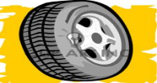 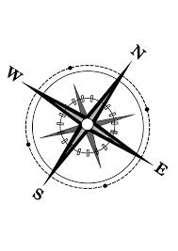

**Choose the abbreviation for following words :**

**1-one night { B&B - 1Nt } 2- room only { S/C – R/O }**