**Worksheet – Unit (1)- *flying high -2-\***

**General Questions:**

1-Where would you go if you could go on a virtual trip ? ……………………………………………………………………………………

2- What are the most common forms of transports in your country?.......................................................................................................................

3- How do you prefer to travel?......................................................................................

4-What reasons are there for people to travel?.............................................................................................................................

**\*Put ( √ ) or ( × ):**

1-Madame Tussauds is a mall ( ).

2- Heathrow airport isn`t the busiest international airport ( )

3- Everybody says that Dubai is the wonderful city ( )

4- Hajj is one of Islam`s five essential pillars ( )

**GRAMMAR :**

A)Do as shown between brackets :

1- Experts ( believes ) tourism will continue to grow …………………………………………………………………………… ***( correct)***

2- Do you know if can I park here ?.................................................... **( correct )**

3- is \ can \ tell \ me \ you\ where \ market \ the \? **( rearrange)**

……………………………………………………………………………..

4- a) Do he can swim ? b) Can he swim? ***( choose the correct question)***

------------------------------------------------------

**B) Choose :**

1- They ( **say- says – tell** ) that travel broadens the mind

2- The café (***claim*- *claims – tells*** ) that their coffee is the best in the town.

3- Do you know if ( **there is – is there** ) a café on the second floor ?

Vocabulary :

1-Put appropriate word under each picture :

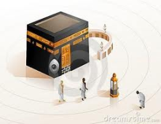 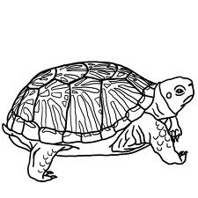

**Match :**

|  |  |  |
| --- | --- | --- |
| Single ( ticket) |  | Rtn |
| One night |  | S\C |
| Self-catering |  | Sgl |
| Join togather |  | 1 Nt |
| Eating a lot of food |  | Gather |
| Return ( ticket) |  | Feasting |
| Want very much. |  | Yearn |

GOOD LUCK

***Your teacher :***

**Nahla K. Al-Qublan**