 Unit ( 1 ) Lesson ( 2 )

My Name ……………………………………………………………………………………………class…………………………..

***Q 1: Write the correct word under each picture :***

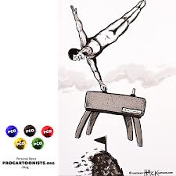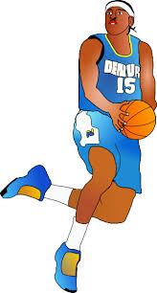 ( cyclist – basketball player - tennis player – gymnast - swimmer - footballer )

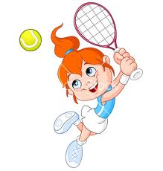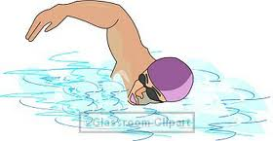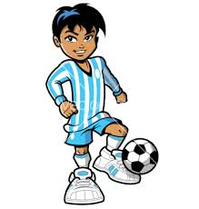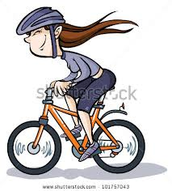

………... …....… …..….. …..…… …..….. ….…..

***Q 2: Complete :***

1- Is she playing basketball ?

Yes, ………………………………………………

2- Are they working hard ?

No , ……………………………………………..

***Q3: Change to Negative :***

1. We are playing football .

………………………………………………………………….

1. He is ( clean ) the room .

…………………………………………………………………….



Mrs: Lamia

2 ) )