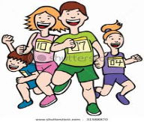 Unit ( 1 ) Lesson ( 1 )

My Name ……………………………………………………………………………………………class…………………………..

***Q 1: Write the correct word under each picture :***

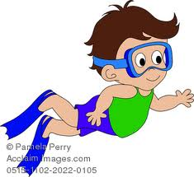 ( cycling – runing - sailing – diving - climbing - riding )

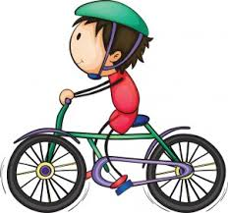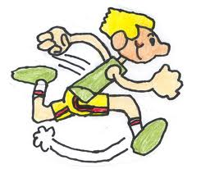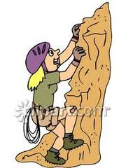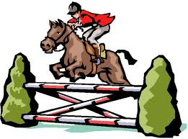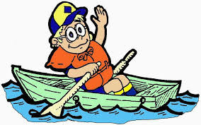

………... …....… …..….. …..…… …..….. ….…..

***Q 2: Complete the sentences with these words :***

( enter – race – push – cross – leave )



1- Please don't ……..………….. me .

2- You can …………………… the race this year .

3- I ………………………. the finishing line first .

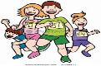4- …….………………… me alone .

5- Congratulation you win the ………………………..

***Q3: Choose :***

1- He ( am – is - are ) reading a book .

2- They are ( work - works - working ) hard .

3- My friends ( am – is - are ) sleeping .

***Q4 : Correct :***

1. We ( Be ) watching T.V .

………………………………………………………………….

1. I am ( clean ) my room .

…………………………………………………………………….

***Q4 : Correct :***

* What is the name of a group of horses ?

……………………………………………………………………………………

Mrs: Lamia