Teacher's

Profile

Personal Information

Name: ……………………

Nationality :……………….

Date of Birth :………………

City :……………………….

Telephone Number :…………..

Home Address:……………….

Subject: English.

School Name : ………………

Academic Year: ……………..AH.

Term: …………………………

Stages of Teaching: …………………..

Class: …………………………….

My

Vision

in

education

Contents

Index

|  |  |
| --- | --- |
|  | 1 |
|  | 2 |
|  | 3 |
|  | 4 |
|  | 5 |
|  | 6 |
|  | 7 |
|  | 8 |
|  | 9 |
|  | 10 |
|  | 11 |
|  | 12 |
|  | 13 |
|  | 14 |
|  | 15 |
|  | 16 |
|  | 17 |
|  | 18 |
|  | 19 |
|  | 20 |
|  | 21 |
|  | 22 |
|  | 23 |

Timetable

***Teacher's Timetable***

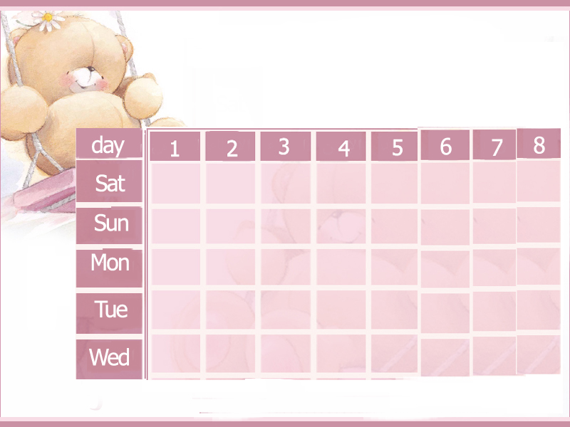

Teacher's

Absence

And

Holidays

|  |  |  |  |
| --- | --- | --- | --- |
| *Reason* | *Day* | *Date* | *No.* |
|  |  |  | *1* |
|  |  |  | *2* |
|  |  |  | *3* |
|  |  |  | *4* |
|  |  |  | *5* |
|  |  |  | *6* |

Circulars

**أهم التعاميم**

|  |  |  |
| --- | --- | --- |
| الموضوع | الرقم | التاريخ |
|  |  |  |
|  |  |  |
|  |  |  |
|  |  |  |
|  |  |  |
|  |  |  |
|  |  |  |
|  |  |  |
|  |  |  |
|  |  |  |
|  |  |  |
|  |  |  |
|  |  |  |
|  |  |  |
|  |  |  |
|  |  |  |
|  |  |  |
|  |  |  |
|  |  |  |

Instructional Materials

References

Some References

1-Teacher's Manual

2-Oxford Dictionary

3-Basic Grammar

4-Englishtown website

5-Student's book

6-English for Arabs website

The distribution

Of

Marks

General

And

Specific

Objectives

General Aims

1- To afford the secondary school pupil a window on the world.

2- To give the secondary school pupil an experience of delight through reading samples of English that have a universal appeal both in arts and sciences.

3- To cultivate the pupil's critical thinking as a useful adjunct to intelligent reading of English texts.

4-To give play to the pupil's imagination by means of imagery in poetry and visualization of character .

5-To provide the pupil who intends to join the university or other higher institutes with an adequate knowledge of English to help her in her future studies .

6- To give the pupil who finishes her formal education in the third year secondary sufficient knowledge of the language .

7- To help the pupil gain a reasonable command of English in order to be in a better position

to defend Islam against advice criticism and to participate in the dissemination of Islamic

Specific Aims

1- To help the pupil gain in three years a reasonable mastery of the four language skills which are :

a- Listening with understanding to spoken English .

b- Speaking current English correctly .

c- Reading with understanding English texts that very in difficulty from adapted and simplified material .

d- Writing a connected passage of up to a full page on a subject of descriptive or a discursive native.

2- To stress the utilitarian point of view of learning a foreign language as a useful tool for cultural as well as social and economic communication.

3- To foster in the pupil an interest in reading so that later on she may be prepared to read reference books, periodicals and pamphlets bearing on her future field of specialization.

Track

Syllabus

Model [A] for intermediate schools

Teacher's name\----------------------------------- School\------------------------------------------

|  |  |  |  |  |  |  |  |  |  |
| --- | --- | --- | --- | --- | --- | --- | --- | --- | --- |
|  | Written Work | | | | | | Unit | Class | Month |
| Composition | Handwriting | Dictation | Vocabulary | Structure | Comprehension | Dialogue |
|  |  |  |  |  |  |  |  |  |  |
|  |  |  |  |  |  |  |  |  |  |
|  |  |  |  |  |  |  |  |  |  |
|  |  |  |  |  |  |  |  |  |  |
|  |  |  |  |  |  |  |  |  |  |
|  |  |  |  |  |  |  |  |  |  |

Model [B] for secondary schools

Teacher's name\----------------------------------- School\------------------------------------------

|  |  |  |  |  |  |  |  |  |  |
| --- | --- | --- | --- | --- | --- | --- | --- | --- | --- |
|  | Written Work | | | | | | Unit | Class | Month |
| Composition | Writing | Orthography | Vocabulary | Structure | Comprehension | Dialogue |
|  |  |  |  |  |  |  |  |  |  |
|  |  |  |  |  |  |  |  |  |  |
|  |  |  |  |  |  |  |  |  |  |
|  |  |  |  |  |  |  |  |  |  |
|  |  |  |  |  |  |  |  |  |  |
|  |  |  |  |  |  |  |  |  |  |

Worksheets

**Module 1**

# *VOCABULARY­­*

***A. Complete the sentences with the words in the box.***

communicate cool talented expedition interview bossy promise truth interested

**1.** I really like your new computer game. It’s very .

**2.** To tell you the I didn’t like the food that much.

**3.** Barry is really in photography. He took some great pictures and I think he’s very .

**4.** Jake went on a(n) in the Sahara desert.

***B. Choose a, b or c.***

1.Paul can be so sometimes. I can’t stand him.  
**a.** well-known **b.** helpful **c.** rude

**2.** Many famous people try to be good for teenagers.

**a.** qualities **b.** role models **c.** competitions

**3.** I was never of football. It’s boring.  
**a.** aware **b.** fan **c.** fond

**4.** We were having a meeting when Jake suddenly .  
**a.** displayed **b.** trained **c.** appeared

***COMMUNICATION***

***Choose a, b or c.***

**1. A:** What does Ben look like?

**B:** __________________________ .

**a.** He’s quite tall, with short, dark hair.  
**b.** He’s shy.

**c.** He likes reading.

**2. A:** Hi, Faisal. What are you up to?  
**B:** .

**a.** Nice one!

**b.** Nothing much.

**c.** I suppose so.

**3. A:** Fancy going to a restaurant tonight?  
**B:** .

**a.** You can’t be serious. I can’t stand him.

b.Got to go. See you tomorrow **.**

c.I’m afraid I can’t make it. I have other plans.

***grammar***

***A. Complete with the Present Simple or the Present Progressive of the verbs in brackets.***

**1.** **A:** Hi, Nasir. What (you / do)?

**B:** I (talk) with a friend on the phone.

**2. A:** What’s the problem, Kevin?

**B:** I (not / understand) this exercise. Can you help me?

**A:** Sure.

**3. A:** Neil (keep) in touch with his   
 friends?

**B:** Yes, he (often / drop) them a line.   
 He (send) an e-mail to Ken at the moment.

***B. Complete with the correct form of used to and the verbs in the box.***

have not play be walk live not study

**1.** When she was a teenager, Pauline very shy.

**2.** Henry when he was at school, but now, as a university student, he studies hard.

**3.** My dad to work but now he takes the bus.

***C. Complete with the Past Simple of the verbs in brackets.***

**1.** How people (communicate) in the past when

they (not / have) phones?

**2.** Peter (leave) because he (have) other plans for tonight.

**3.** I (promise) to give Tom a call but   
I (forget) to and now he doesn’t want to talk to me.

***READ***

***Read the texts and the statements. Write R for RIck, A for Ann or B for both.***

**Rick Smith**

I've always loved hats and I've had several collections over the years. I sold my first collection when I was in college. Then, I started collecting hats again in 1975, when I was studying at the university. However, in 1976, I decided to move to London and had to sell my second hat collection because I needed the money. The first time I showed my current collection was when I put a few hats on the wall of my office. My friends and colleagues loved the idea and gave me a few hats of their own. I've collected 362 hats so far and I'm still collecting. I have also made a website where people can admire my hat collection and also sell me their hats, if they like!

**Read about two people with strange collections**

**What do you collect?**

**Ann Mitchell**

I love bananas! When I was a kid, my parents called me ‘Anna Banana’. But it wasn't until I went to Hawaii in 1980 that I really got stuck on bananas and started collecting banana items. Over the years, I've found other items to add to my collection. My friends have also helped me out and today my collection is quite big. I've collected nearly 4,000 banana items!

1.I have more than a thousand items in my collection.

2.My friends have helped me with my collection.

**3.** People can see my collection on the Internet.

**4.** I sold my first two collections.

***Choose a, b or c.***

**1.** There are very tomatoes left. Let’s go to the supermarket.  
**a.** a little **b.** few **c.** a lot

**2.**Is there orange juice in the fridge?  
**a.** any **b.** some **c.** little

**3.**Jason can’t come with us. He doesn’t have money.  
**a.** no **b.** many **c.** much

**4.**Alice is very kind, that’s why she has friends.  
**a.** few **b.** lots **c.** a lot of

**5.** I’m sorry but there’s milk left in the fridge. Have some juice.  
**a.** any **b.** no **c.** a few

2,5

score

***Choose a, b or c.***

**1.** There are very tomatoes left. Let’s go to the supermarket.  
**a.** a little **b.** few **c.** a lot

**2.**Is there orange juice in the fridge?  
**a.** any **b.** some **c.** little

**3.**Jason can’t come with us. He doesn’t have money.  
**a.** no **b.** many **c.** much

**4.**Alice is very kind, that’s why she has friends.  
**a.** few **b.** lots **c.** a lot of

**5.** I’m sorry but there’s milk left in the fridge. Have some juice.  
**a.** any **b.** no **c.** a few

2,5

score

***Choose a, b or c.***

**1.** There are very tomatoes left. Let’s go to the supermarket.  
**a.** a little **b.** few **c.** a lot

**2.**Is there orange juice in the fridge?  
**a.** any **b.** some **c.** little

**3.**Jason can’t come with us. He doesn’t have money.  
**a.** no **b.** many **c.** much

**4.**Alice is very kind, that’s why she has friends.  
**a.** few **b.** lots **c.** a lot of

**5.** I’m sorry but there’s milk left in the fridge. Have some juice.  
**a.** any **b.** no **c.** a few

2,5

score

**Module 2**

# *VOCABULARY*

***A. Complete the sentences with the words in the box****.*

course hand burglar experience   
hurt dizzy abroad explore

**1.** I felt and sick all day yesterday.

**2.** A broke into Tom’s house yesterday.

**3.** When you go to the desert, just be prepared for extreme heat.

**4.** We want to go this summer.

***B. Choose a, b or c.***

**1.** It was early in the morning and I could hear a dog in the distance.

**a.** pushing **b.** barking **c.** reaching

**2.**  This journey was really . I need two more days to relax.

**a.** bored **b.** tired **c.** tiring

**3.** Paul the chocolate cake but he didn’t like it.

**a.** tasted **b.** offered **c.** cut

**4.** When a swarm of bees stung him, the boy .

**a.** followed **b.** fainted **c.** wondered

***COMMUNICATION***

***Complete the dialogues with the phrases in the box.***

**a.** I’m afraid not. **b.** Believe it or not he went hiking **c.** What have you been up to? **d.** How are things?

**1. A:** Where is Ray?

**B:** (**1**) .

**A:** No way. He never walks anywhere, not even to the shop on the corner!

**B:** I know.

**2. A:** Hey, Julie. (**2**) .

**B:** Nothing much. What about you?   
 (**3**) .

**A:** OK. I am taking a cookery course but I think it’s boring.

**B:** Oh, no. You don’t like it, eh?

**A:** (**4**) **.**

***grammar***

***A. Complete with the Present Perfect Simple or the Past Simple of the verbs in brackets.***

**1. A:** I (already/see) this football match.

**B:** Really? When (you/see) it?

**A:** Yesterday with Charles.

**2. A:** Is Khalid at home?

**B:** No, he (go) to school.

**A:** What time __________________ (he/leave)?

**B:** About half an hour ago.

***B. Circle the correct words.***

**1. As / As soon** as I was getting ready, the phone rang.

**2.**  Colin has **just / lately** returned from his trip to Asia.

**3.** Fortunately, my cousin hasn’t had any accidents **since / for** he bought his car.

**4.**  Majed was cooking dinner **when / while** the lights went out.

***READ***

***Read the text and answer the questions.***

**The lost city of the INCAS**

High in the Peruvian Andes, on a mountain called Machu Picchu, lies the Lost City of the Incas, which at one time was the centre of the greatest empire in South America.

The journey to Machu Picchu begins at Cuzco, one of the oldest cities in South America and once the capital city of the Inca Empire. Today you can get to Machu Picchu by train from Cuzco and then continue by bus. For the more adventurous, there's the Inca trail, of course! This three to five-day trek is one of the most popular in South America.

Thick jungle and some of the world's highest mountains surround the mysterious city of Machu Picchu. What makes it so mysterious is that, to this very day, nobody really knows what happened to the people who lived there. Archaeologists have found the skeletons of 173 people and 150 of them were women. However, that discovery didn't help solve the mystery. What's even more amazing is that the Incas managed to build this stone city high up on a mountain top and that the stones fit perfectly together. One thing is certain however. It will be a long time before archaeologists manage to put all the pieces of the puzzle together and solve the mystery of Machu Picchu

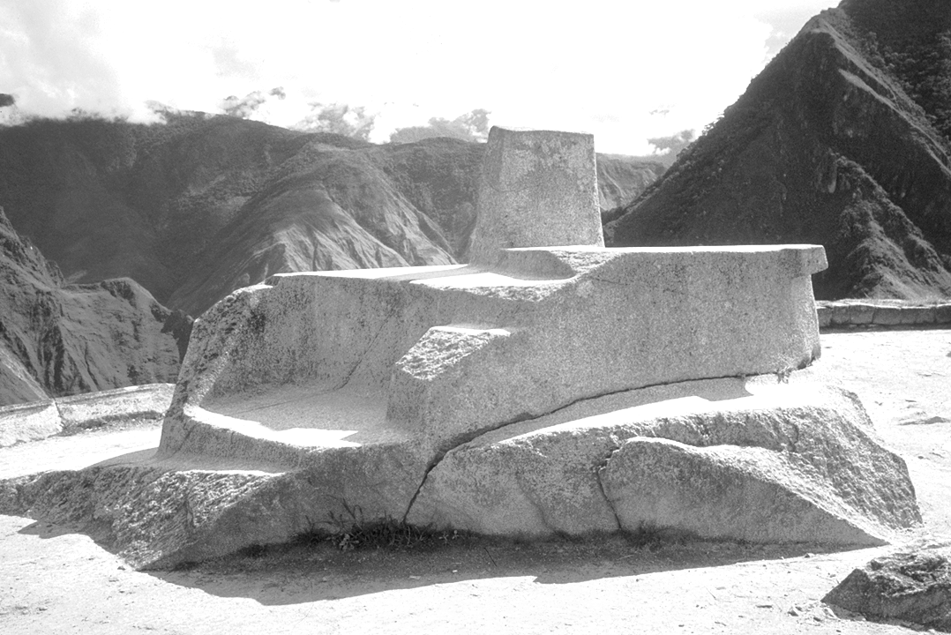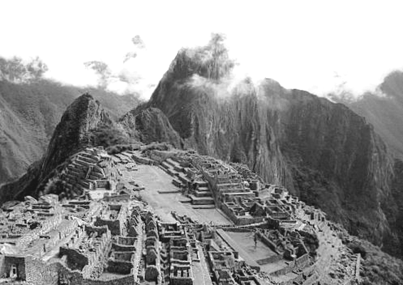

**1.** Where is the Lost City of the Incas?

**2.** How can you get to Machu Picchu? .

**3.** Why is it considered a mysterious city?

**4.** How many male skeletons did archaeologists find at Machu Picchu?

.

**Module 3**

# VOCABULARY

***A. Complete the sentences with the words in the box.***

receptionist exploration delay crowded ladder minimum colourful range

**1.** Ali is very experienced in cave .

**2.** Jake bought a(n) T-shirt last week but nobody liked it.

**3.** The restaurant was really so they had to leave.

**4.** There was a lot of snow on the mountain .

***B. Choose a, b or c.***

**1.** May I see your please?

**a.** boarding card **b.** destination **c.** conveyor belt

**2.** We were amazed by the scenery.

**a.** comfortable **b.** special **c.** spectacular

**3.** I always ask for a(n) when I travel by plane.

**a.** formation **b.** equipment **c.** aisle seat

***C. Circle the correct words.***

**1.** What a **cosy / fascinating** story! I liked it a lot.

**2.** Does the hotel room have **parking / air conditioning**?

**3.** The museum attracts lots of **tourists / flight attendants** every year.

**4.** The park is important for the **communication / protection** of pandas in the area.

***Communication***

***Match.***

**a.** Sorry, I can’t. They’re too heavy.

**b.** I could understand it but I wasn’t able to communicate very well.

**c.** Sure. Do you also need some bread?

**d.** Yes, I know. But we needn’t spend all our money on gifts.

**e.** I’m afraid so. I have to give it to my teacher tomorrow morning.

**f.** OK. Thanks for letting me borrow it.

**1.** Can you get me some milk when you go to the supermarket?

**2.** Do you need to finish this project today?

**3.** Excuse me, could you help me with these bags?

**4.** We need to buy some souvenirs for our friends.

**5.** Remember to bring me the car before 5pm.

**6.** Could you speak Italian before you went to Rome?

***GRAMMAR***

***A. Circle the correct words.***

**1. A:** **Can / Must** I go out on Saturday night?

**B:** Of course. But don’t be late.

**2. A:** Is your brother feeling better?

**B:** Yes, but the doctor said he **needs to / mustn’t** go to work till he is completely well.

**3. A:** Did you finish your project last night?

**B:** I’m afraid not. I **need to / couldn’t** work on it again today.

***B. Complete the dialogues with the modal verbs in the boxes.***

**do I have to can need to mustn’t**

**1.**

**A:** Excuse me, I use my mobile in here?

**B:** No, I’m afraid not. You make phone calls here.

**A:** So, go out?

**B:** Yes, you go outside. Sorry!

***C. Complete with the correct form of the adjectives in brackets.***

**1.** Our old sofa wasn’t as (comfortable) as our new one.

**2.** Diana is (interested) in going shopping than in going to school.

**3.** Climbing that mountain was (tiring) than I thought.

**4.** Mark is as (careful) as his brother when he drives.

***D. Rewrite the questions in Indirect Speech.***

**1.** Where is your passport?   
Can you tell me

**2.** Who is Jack’s mother?   
Do you know

***READ***

***Read the text below and write T for True or F for False.***

Havasu Falls are in the Havasu Canyon next to the Grand Canyon in the southwestern USA. There are actually three waterfalls in the area: Havasu, Mooney and Navajo. The waterfalls are in the Havasupai Indian Reservation, the home of the Havasupai people. ‘Havasupai’ means ‘people of the blue-green waters.’

The best time to visit the falls is in spring, in the months of April and May because the weather is cool, but it is warm enough to swim. Later, in summer, it gets hot and rainy and there can be floods, too. Visitors can camp in a campsite or stay at the Havasu Lodge. But you have to book a room at the Lodge three or four months before you plan to go.

To reach the falls you start at the parking area at Hualapai Hilltop. From there you can walk, ride a horse or fly in a helicopter to Supai village, 13 km away. From Supai village it is about 4 km to Mooney Falls.

You don’t have to be an experienced hiker to walk to the falls because the walk is safe, even for beginners. However, you must be very careful because there are many dangerous cliffs. There are also caves to explore on the way. It is a good idea to take water with you and to watch out for rattlesnakes, too.

Whether you walk, ride a horse or take the helicopter, the impressive waterfalls and the peaceful surroundings make this one of the most fascinating places you can visit. It is an unforgettable experience.

**1.** *Havasu* is one of the three waterfalls in the Grand Canyon.

**2.** The months of July and August are not a good time to visit the falls.

**3.** The *Mooney Falls* are about 17km from the parking area.

**4.** The walk to the falls is dangerous for walkers without experience.

**Module 4**

# VOCABULARY

***A. Complete the sentences with the words in the box.***

antivirus expert careless cancel sure afford handy failed socialise addicted range

**1.** I’m sorry Abdulaziz, but we’ll have to today’s meeting.

**2.** You need to install a(n) program in your computer.

**3.** Mark was disappointed when he his driving test.

**4.** He couldn’t to buy the painting, so I lent him some  
 money.

**5.** Young children can easily become to computer games.

***B. Choose a, b or c.***

**1.** Ian was of money and had to borrow some from Matt.

**a.** broke **b.** short **c.** saved

**2.**  How do they tomorrow’s weather?

**a.** predict **b.** exist **c.** destroy

**3.** this button to turn on the machine.

**a.** Create **b.** Enter **c.** Press

**4.** Alan has my files by mistake!

**a.** deleted **b.** caused **c.** delivered

***Communication***

***Choose a or b.***

**1. A:** By the way, when are you going to pay me back?

**B:** .

**a.**  Trust me. I won’t forget about it.

**b.** Go on then.

**2. A:** I bought this computer game for 200 euros.  
**B:** .

**a.**  I’m getting to that.

**b.** What a waste of money!

***GRAMMAR***

***A. Complete the sentences with the Present Simple or the Future will of the verbs in brackets.***

**1.** As soon as I (know) the results, I .   
 (call) you.

**2.** He (not be able to) help us until he  
 (finish) his homework.

**3.** When we (visit) China, we (see)  
 the Great Wall.

**4.** Richard (wash) his car before he  
 (go) to the gym.

***B. Complete with too or enough and the words in brackets.***

**1.** Stan is (tired) to meet his friends tonight.

**2.** Jason isn’t running (fast). He won’t win the race.

**3.** I won’t be able to walk through the park at 10 o’ clock in the evening. It will be  
 (dark).

**4.**  Hugh isn’t (tall). He can’t become a basketball player.

***C. Complete the sentences with who, which, that or where. If they can be omitted, put them in brackets.***

**1.** That’s the artist you met at my house last week.

**2.** Stratford-upon-Avon is the place my cousin lives.

**3.** That’s the house Paul will buy.

**4.** Ron is the student won the short story competition.

***READ***

***Read the text and write T for True or F for False.***

**and much more…**

**E-clothes**

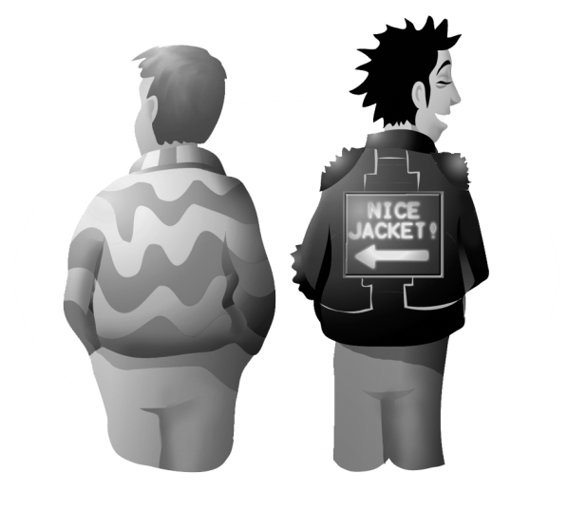

**1**

It's called ICD+ and it's a denim

jacket. It's got a hands-free mobile   
phone with an Internet connection,

a radio, a remote control and

a microphone. The ICD+ jacket is,

unfortunately, a bit expensive. It’s

between six and nine hundred dollars!

Before you say ‘no’, just think of all the

things it has to offer!

**2**

Here's another great invention you can wear. Stephan Fitch of   
the MIT Media Lab has managed to fit a computer into a leather jacket. But where is the screen? It's on the back of the jacket, which means everyone can see it, except you! So, what possible purpose could this jacket serve? Advertising, of course. Anybody out there interested in becoming a ‘walking’ advertisement? First it was cars, now it's jackets, what's next?

**3**

Intelligent wool! An Australian company sees a new future for wool.. Imagine that you're wearing a ‘smart’ woollen jumper. It looks and feels just like an ordinary jumper only it can do all sorts of things. For example, you're sitting on the sofa and you want to turn the lights on, but you're too lazy to get up. No problem! Just touch your elbow and the lights will come on!

**1.** When you’re wearing an ICD+ jacket, you don’t need a mobile phone.

**2.** Not everybody can afford an ICD+ jacket.

**3.** Fitch made an advertisement for his leather jacket.

**4.** An Australian company created intelligent wool to make clothes.

Module 1

***Write a description of a person you have recently met .***

***Your description should be between 100-120 words.***

***_________________________________________________________________________________________________________________________________________________________________________________________________________________________________________________________________________________________________________________________________________________________________________________________________________________________________________________________________________________________________________________________________________________________________________________________________________________________________________________________________________________________________________________________________________________________________________________________________________________________________________________________________________________________________________________________________________________________________________________________________________________________________________________________________________________________________________________________________________________________________________________________________________________________________________________________________________________________________________________________________________________________________________________________________________________________________________________________________________________***

Module 2

***Imagine a friend has send you an e-mail .Write an e-mail to reply to her . Say how happy you are that she is coming to your city to study and give her your news . Your e-mail should be between 80- 100 words.***

***_________________________________________________________________________________________________________________________________________________________________________________________________________________________________________________________________________________________________________________________________________________________________________________________________________________________________________________________________________________________________________________________________________________________________________________________________________________________________________________________________________________________________________________________________________________________________________________________________________________________________________________________________________________________________________________________________________________________________________________________________________________________________________________________________________________________________________________________________________________________________________________________________________________________________________________________________________________________________________________________________________________________________________________________________________________________________________________________________________________***

Model 3

***You are planning a trip to Paris . Your friend recently stayed at a hotel there and was very pleased with it . Write an e- mail to your friend asking for more information about the hotel. Your e-mail should be between 80-100 words.***

***_________________________________________________________________________________________________________________________________________________________________________________________________________________________________________________________________________________________________________________________________________________________________________________________________________________________________________________________________________________________________________________________________________________________________________________________________________________________________________________________________________________________________________________________________________________________________________________________________________________________________________________________________________________________________________________________________________________________________________________________________________________________________________________________________________________________________________________________________________________________________________________________________________________________________________________________________________________________________________________________________________________________________________________________________________________________________________________________________________________***

Model 4

***Imagine that your school magazine has asked you to write your opinion about mobile phones . Write a paragraph .Your paragraph should be between 80- 100 words.***

***_________________________________________________________________________________________________________________________________________________________________________________________________________________________________________________________________________________________________________________________________________________________________________________________________________________________________________________________________________________________________________________________________________________________________________________________________________________________________________________________________________________________________________________________________________________________________________________________________________________________________________________________________________________________________________________________________________________________________________________________________________________________________________________________________________________________________________________________________________________________________________________________________________________________________________________________________________________________________________________________________________________________________________________________________________________________________________________________________________________***

Module 3

***Complete the sentences with the correct words :***

**[ been- gone- for- since- yet ]**

1-I haven't play tennis ------------------------six years .

2-Andrew hasn't returned from work ----------------

3-She's ----------------- to work .

4-I haven't seen Mike -------------------- we finished school.

5-Fahad has never ----------------- to an English –speaking country .

***Complete the sentences with the correct words :***

**[ been- gone- for- since- yet ]**

1-I haven't play tennis ------------------------six years .

2-Andrew hasn't returned from work ----------------

3-She's ----------------- to work .

4-I haven't seen Mike -------------------- we finished school.

5-Fahad has never ----------------- to an English –speaking country .

***Complete the sentences with the correct words :***

**[ been- gone- for- since- yet ]**

1-I haven't play tennis ------------------------six years .

2-Andrew hasn't returned from work ----------------

3-She's ----------------- to work .

4-I haven't seen Mike -------------------- we finished school.

5-Fahad has never ----------------- to an English –speaking country .

***Complete the sentences with the correct words :***

**[ been- gone- for- since- already ]**

1-I haven't checked my e-mails ---------a month .

2-I have-----------called him three times.

3-Ray and Mark haven't been scuba-diving ----------their trip to the Caribbean.

4-Where's Dan ? He has-----------to the library.

5-Fahad has never ----------------- to an English –speaking country .

***Complete the sentences with the correct words :***

**[ been- gone- for- since- already ]**

1-I haven't checked my e-mails ---------a month .

2-I have-----------called him three times.

3-Ray and Mark haven't been scuba-diving ----------their trip to the Caribbean.

4-Where's Dan ? He has-----------to the library.

5-Fahad has never ----------------- to an English –speaking country .

***Complete the sentences with the correct words :***

**[ been- gone- for- since- already ]**

1-I haven't checked my e-mails ---------a month .

2-I have-----------called him three times.

3-Ray and Mark haven't been scuba-diving ----------their trip to the Caribbean.

4-Where's Dan ? He has-----------to the library.

5-Fahad has never ----------------- to an English –speaking country .

Model 1

**Fill in the missing letter:**

**1-My role mo___el is King Abdul Aziz .**

**2-I try to kee___ in touch with people .**

**3-Jake is so la__y .He just sits there all day doing nothing .**

**4-I'm so quick –te__pered .**

Model 2

**Fill in the missing letter:**

**1-What happene____ ?**

**2-Belie__e it or not .**

**3-B___oaden your mind .**

**4-Antaractic is a cold deser___ .**

Model 3

**Fill in the missing letter:**

**1- The Himalayas are ____ountain ranges**

**2-Scientists explored ___aves for study .**

**3- I sta___ in a hotel.**

**4- I'm afraid of volcan__ .**

Model 4

**Fill in the missing letter:**

**1-This car is wort__ buying.**

**2-The Wright brothers i__vented the first plane .**

**3-I write a no__e to my friends .**

**4-It's great to use USB hoove___ in your office.**

Model 5

**Fill in the missing letter:**

**1-**

**2-**

**3-**

**4-**

Model 6

**Fill in the missing letter:**

**1-**

**2-**

**3-**

**4-**

Tests

First Year Secondary The First Exam Name/------------------------------------------

***Grammar:***

***A-Choose the correct answer:***

1-He isn't [ work – works- working ] in the office this week .

2-Susan's graduation is [ on – in – at] June .

3-I [ watch – watching – was watching ] TV when my sister walked into the house with a paper bag.

***Do as shown in the brackets :***

1- We------------------(talk) about this yesterday. [ Correct ]

2-Did you --------------------------(live) in London ? [Use used to ]

3------------------ you ------------------( visit ) the Colosseum yet ? [ Complete with the present perfect simple ]

***Vocabulary:***

***A-Circle the correct word:***

1-Ted is ----- in modern art. a-interested b- fond c- a fan

2-When I saw the-----, I knew a storm was on its way . a- thunder a- lightning c- ice

***B ) Match the words in ( A ) with the suitable completion in ( B ) :-***

|  |  |  |
| --- | --- | --- |
| *Very great* |  | *1 .Hold on* |
| *Wait* |  | *2 .Survive* |
| Stay alive |  |  |

***Spelling :***

***Fill in the missing letters :***

1- What an expe____ience ! 2-Keep in ____ouch .

3-**_______**elieve it or not . 4-Broaden your min______ .

***Communication :***

***_Complete with the phrases a-c .There 's one extra phrase .***

***[ a-He's good fun to be with . b-I have other plans . c- What does he look like ?]***

Sam\ Do you remember Pete from the computer course?

Len\ I'm not sure. -----.

Sam\ He has dark hair and brown eyes.

Len\ Oh ! I remember him .What 's he like ?

Sam\ ------- We 're even going bungee jumping together next week .

***Reading: Read this paragraph then answer the questions:***

A farmer was working in his field when he noticed a number of birds busy eating his corn . He decided to try to put an end to this . Above all, he wanted to preserve his corn . He got a long stick and stuck it in the ground in the middle of the field . On the stick he hung some old pieces of clothes and he placed a hat on the top so that the whole thing looked like a man . On seeing this strange object , the birds flew away . Finally , the farmer was happy because his crop was saved .

***A-Answer the following questions:***

1-What did the farmer notice in his field ?

…………………………………………………………………………………………………………

2-What did he hang on the stick?

…………………………………………………………………………………………………………

***B- Choose the right answer :***

1- The farmer was…………………….to save his crop.

a- sad. b- happy. c-angry.

***C- Put [ T] for the true sentence and [ F] for the false one:***

1- He put something in his field that looked like an animal . ( )

***Writing :***

***Imagine a friend has sent you an e- mail .Write an e-mail to reply to her . Say how happy you are that she is coming to your city to study and give her your news .***

----------------------------------------------------------------------------------------------------------------------------------------------------------------------------------------------------------------------------------------------------------------------------------------------------------------------------------------------------------------------------------------------------------------------------------------------------------------------------------------------------------------------------------------------------------------------------------------------------------------------------------------------------------------------------------------------------------------------------------------------------------------------------------------------------------------------------------------------------------------------------------------------------------------------------------------------------------------------------------------------------------------------------------------------------------------------------------------------------------------------------------------------------------------------------------------------------------------------------------------------------------------------------------------------------------------------------------------------------

--------------------------

--------------------------

Table

of

Excellent

And

Weak

Students

**بـــــــــــســـــــــم الــــــــــلـــــــــه الــــــرحــــــمـــــــن الـــــــرحــــــيـــــــــم**



**بيان متابعة الطالبات المتفوقات مادة اللغة الانجليزية**

**مدرسة \ ----------------- العام الدراسي \ 1433-1434 هـ**

|  |  |  |  |  |  |  |  |  |  |  |  |  |
| --- | --- | --- | --- | --- | --- | --- | --- | --- | --- | --- | --- | --- |
| **اسم الطالبة** | **الدرجة** | **نواحي التميز** | | | | | **الجهود المبذولة** | | | **النتائج** | | **ملاحظات** |
| **الدقة و النظام** | **المشاركة**  **الفعالة** | **سرعة**  **البديهة** | **مشاركة متميزه** | **متفوقة**  **بشكل**  **عام** | **تشجيع**  **مستمر** | **بطاقة**  **شكر** | **لوحة**  **تفوق** | **سلبي** | **ايجابي** |
|  |  |  |  |  |  |  |  |  |  |  |  |  |
|  |  |  |  |  |  |  |  |  |  |  |  |  |
|  |  |  |  |  |  |  |  |  |  |  |  |  |
|  |  |  |  |  |  |  |  |  |  |  |  |  |
|  |  |  |  |  |  |  |  |  |  |  |  |  |
|  |  |  |  |  |  |  |  |  |  |  |  |  |
|  |  |  |  |  |  |  |  |  |  |  |  |  |
|  |  |  |  |  |  |  |  |  |  |  |  |  |
|  |  |  |  |  |  |  |  |  |  |  |  |  |
|  |  |  |  |  |  |  |  |  |  |  |  |  |
|  |  |  |  |  |  |  |  |  |  |  |  |  |
|  |  |  |  |  |  |  |  |  |  |  |  |  |
|  |  |  |  |  |  |  |  |  |  |  |  |  |

معلمة المادة \--------------------------------- مديرة المدرسة \----------------------------

**بـــــــــــســـــــــم الــــــــــلـــــــــه الــــــرحــــــمـــــــن الـــــــرحــــــيـــــــــم**



**بيان متابعة الطالبات ذوات المستوى المتدني مادة اللغة الانجليزية**

**مدرسة \ ----------------- العام الدراسي \ 1433-1434 هـ**

|  |  |  |  |  |  |  |  |
| --- | --- | --- | --- | --- | --- | --- | --- |
| **اسم الطالبة** | **الدرجة** | **أسباب التدني** | **الجهود المبذولة** | | | | **ملاحظات** |
| **التشجيع**  **مستمر** | **التعاون مع**  **المشرفة** | **أوراق**  **عمل** | **أشعار**  **ولي**  **ألأمر**  **ايجابي** |
|  |  |  |  |  |  |  |  |
|  |  |  |  |  |  |  |  |
|  |  |  |  |  |  |  |  |
|  |  |  |  |  |  |  |  |
|  |  |  |  |  |  |  |  |
|  |  |  |  |  |  |  |  |
|  |  |  |  |  |  |  |  |
|  |  |  |  |  |  |  |  |
|  |  |  |  |  |  |  |  |
|  |  |  |  |  |  |  |  |
|  |  |  |  |  |  |  |  |
|  |  |  |  |  |  |  |  |

معلمة المادة \--------------------------------- مديرة المدرسة \----------------------------

Notification

**بـــــــــــســـــــــم الــــــــــلـــــــــه الــــــرحــــــمـــــــن الـــــــرحــــــيـــــــــم**



**إلى ولى أمر الطالبة \_______________________**

**انطلاقا من حرصنا على ابنتكم نود إفادتكم بان مستواها الدراسي متدني في**

**ماده اللغة الانجليزية ودرجاتها في الاختبار الدوري ----- ضعيفة . ونعوز هذا المستوى للاتي :**

**1-الإهمال العام**

**2- عدم المذاكرة**

**3- عدم المشاركة أثناء الحصص**

**متمنين منكم مزيدا من الحرص والاهتمام بالطالبة لترتقي بمستواها الدراسي وتعود إلى صفوف المتفوقات بإذن الله تعالى .**

**شاكرين تعاونكم معنا مقدما لكل ما فيه خير ومصلحه الطالبة.**

**معلمه المادة \ مديره المدرسة \**

**______________ _________________**

**بـــــــــــســـــــــم الــــــــــلـــــــــه الــــــرحــــــمـــــــن الـــــــرحــــــيـــــــــم**



**شهادة تفوق**

**يسر إدارة مدرسة --------------- للمرحلة المتوسطة والثانوية أن تهنئ الطالبة ---------------**

**من الصف ------------- لتفوقها في مادة اللغة الإنجليزية**

**للفترة الأولى ونتمنى لها دوام التقدم والنجاح .**

**معلمة المادة \ مديرة المدرسة \**

**______________ _________________**

Projects

And

Extra

Works

Project 1

Youth culture

**My role models**

Choose a few of your role models and do some research about them .Make a poster giving information about the people and say why they are your role models . Stick pictures for decoration .

**--------------------------was born in ----------------------------------------She/ He is my role model because ------------------------------------------------------------------------------------------------------------------------------------------------------------------------------------------------------------------------------------------------------------------------------------------------------------------------------------------------------------------------------------------------------------------------------------------------------------------------------------------------------------------------------------------------------------------------------------------------------------------------------------------------------------------------------------------------------------------------------------------------------------------------------------------------------------------------------------------------------------------------------------------------------------------------------------------------------------------------------------------------------------------------------------------------------------------------------------------------------------------------------------------------------------------------------------------------------------------------------------------------------------------------------------------------------------------------------------------------------------------------------------------------------------------------------------------------------------------------------------------------------------------------------------------------------------------------------------------------------------------------------------**

**Module 2**

**What an experience !**

Have you ever thought of exploring the Antarctic ?

Do research about the Antarctic and make a guide for someone who wants to travel there . Orgnise your ideas under headings . Use ideas page 26 of the Student's book and draw or stick pictures for decoration.

--------------------------------------------------------------------------------------------------------------------------------------------------------------------------------------------------------------------------------------------------------------------------------------------------------------------------------------------------------------------------------------------------------------------------------------------------------------------------------------------------------------------------------------------------------------------------------------------------------------------------------------------------------------------------------------------------------------------------------------------------------------------------------------------------------------------------------------------------------------------------------------------------------------------------------------------------------------------------------------------------------------------------------------------------------------------------------------------------------------------------------------------------------------------------------------------------------------------------------------------------------------------------------------------------------------------------------------------------------------------------------------------------------------------------------------------------------------------------------------------------------------------------------------------------------------------------------------------------------------------------------------------------------------------------------------------------------------------------------------------------------------------------------------------------------------------------------------------------------------------------------------------------------------------

**Module 3**

**Going places**

**My favourite holiday destinations**

**Choose three or four of your favourite holiday destinations and make a poster .Say where they are, why you like them ,what you can do there , describe the facilities ,etc. Add pictures and maps for decoration.**

------------------------------ is one of the most beautiful and most popular --------------------------------------.

It 's--------------------------------------------------------------------------------------------------------------------------------------------------------------------------------------------------------------------------------------------------------------------------------------------------------------------------------------------------------------------------------------------------There are lots of impressive -------------------------------------------------------------------------------------------------------------------------------------------------------------------------------------------------------------------------------

I love this ------------------------because -------------------------------------------------------------------------------------------------------------------------------------------------------------------------------------------------------------------

**Model 4**

**Nowadays**

**Crazy Gadgets**

Make adverts for interesting gadgets. Do some research about real gadgets or make up your own . Write a small description of the gadget , draw or stick pictures of it , and add any other important information .e.g. price . Use ideas from p. 54 of the student's Book .

________________

__________________________________

---------------------------------------------------------------------

-------------------------------------------------------------------

-------------------------------------------------------------------

---------------------------------------------------------------------

-------------------------------------------------------------------

-------------------------------------------------------------------

---------------------------------------------------------------------

--------------------------------------------------------------------

---------------------------------------------------------------------

---------------------------------------------------------------------

---------------------------------------------------------------------

----------------------------------------------------------------------

-----------------------------------------

Exchange

Visiting

Refresher

Meeting

Certification