***My name: ……………………..………..  
My age: ………………………….………...***

***My place of Birth: …………………………***

***My school:…………….……………….  
My class :……………………………….***

***My role models of life: ………………..  
My best friend: …………………………  
My Hobby: .............................................***

***I would like to be .................................in the future .***

Module 1

**Vocabulary**

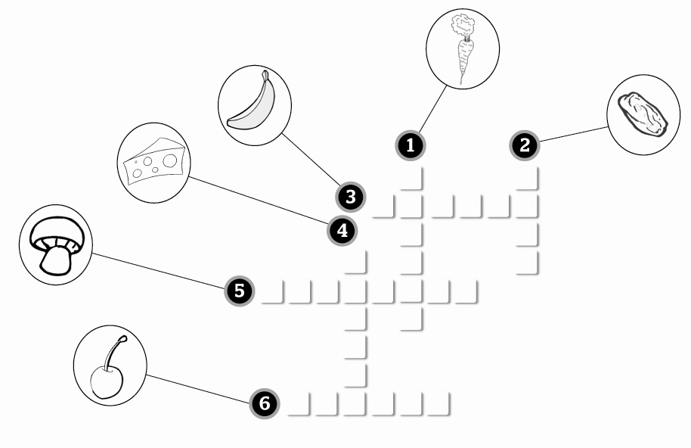**A. Look at the pictures and complete the crossword.**

**B. Complete the sentences with the words in the box.**

dangerous dessert horrible change delicious junk juice

**1.** My dad never eats food. He hates pizza.

**2.** Yuck! This yoghurt is !

**3.** Would you like some orange ?

**4.** This is a great meal. What’s for ?

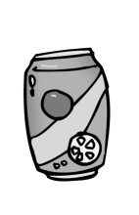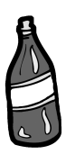**C. Complete the phrases.**



1-a of biscuits 2- a of lemonade 3- a of ketchup

**Communication**

**Choose the correct answer.**

**Waiter** Good afternoon. (**1**) **Can I take your order? / What do you usually have for lunch?**

**Man** Yes, I’d like some pasta, please.

**Waiter** Would you like the pasta with meatballs? It’s very nice.

**Man** (**2**) **Have some. / Yes, please.**

**Waiter** OK then. (**3**) **Are you thirsty? / Would you like something to drink?**

**Man** Just some water, thank you.

**Waiter** (**4**) **Is that all? / What else would you like?**

**Man** Yes. But can I have the water now?

**Waiter** (**5**) **No problem. / No thanks.**

**Man** Thank you.

**Grammar**

**A. Write the words under the correct heading.**

|  |  |
| --- | --- |
| **COUNTABLE NOUNS** | **UNCOUNTABLE NOUNS** |
|  |  |
|  |  |
|  |  |
|  |  |

soup

milk

cheese

doughnut

sandwich

pancake

tomato

meat

**B. Complete the sentences with *some, any* or *a(n).***

**1.** Would you like sauce on your rice?

**2.** There’s slice of cheese in the fridge.

**3.** My grandfather always has eggs for breakfast.

**4.** I need butter for the cake.

**C. Complete the sentences with *How much* or *How many.***

**1.** chocolate bars do you eat a week?

**2.** ketchup do you want on your chips?

**3.** players are there in a basketball team?

**4.** lemonade is there in the bottle?

**Reading**

**Read the text and write T for True or F for False.**

**ICE CREAM FUN!**

*By Andy Jones*

I just love ice cream. Sometimes my mum makes spaghetti ice cream. It tastes delicious and my friends and family love it. But there isn’t any spaghetti in the dessert. She uses ice cream for the spaghetti, cherries for the ketchup and a white chocolate bar for the cheese. I have ice cream nights and all my friends have fun. We also eat banana cake and try fruit pizzas. We always play games, too. We close our eyes and taste different flavours of ice cream. I’m good at this, so I’m usually the winner!

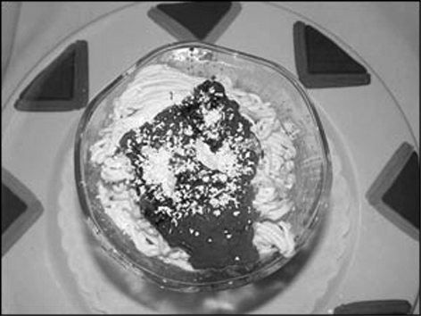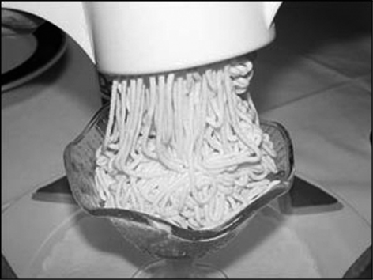

**1.** Andy’s friends make spaghetti ice cream.

**2.** Spaghetti ice cream hasn’t got ketchup on it.

**3.** There’s only spaghetti ice cream at Andy’s ice cream nights.

**4.** Andy usually plays games at his ice cream nights.

**Module 2**

***Vocabulary***

***A. Write the words in the box under the correct heading.***

windy monkey autumn cloudy lion spring bear summer hot

|  |  |  |
| --- | --- | --- |
| **SEASONS** | **ANIMALS** | **WEATHER** |
|  |  |  |
|  |  |  |
|  |  |  |

***B. Circle the correct words.***

**1.** Look! They’re **bringing / building** a castle.

**2.** Here’s a(n) **invitation / celebration** to the school fête.

**3.** We can’t go swimming **because / why** it’s cold outside.

**4.** My mum is **preparing / inviting** some sandwiches for us.

***Communication***

***Choose a or b.***

**1.** How’s life?

**a.** I hope you’re fine. **b.** Great.

**2.** What’s the weather like?

**a.** It’s snowing. **b.** It’s winter.

**3.** Are you ready to leave?

**a.** No, I’m looking for my jacket. **b.** No, nothing much.

**4.** What’s the date?

**a.** It’s Eid ul-Fitr. **b.** It’s 20 April.

***Grammar***

***A. Complete the sentences with on or in.***

1. The race is July.

2. The weather is always nice spring.

3. The competition is 9th May this year.

***B. Look at the pictures. Complete the sentences using the Present Progressive of the verbs in the box.***

plant have snow not cook

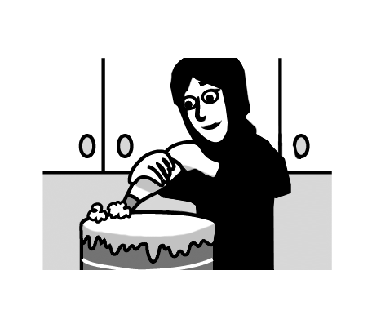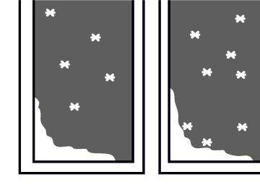

3. Sarah .  
 pasta at the moment.

4. The boys .  
 a barbecue in the garden  
 now.

**1.** It at  
 the moment.

**2.** Bob and Tom  
 a  
 tree in the park now.

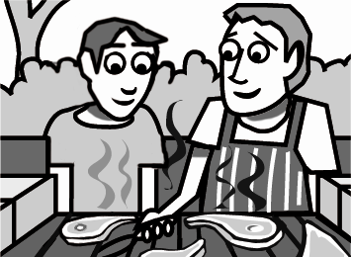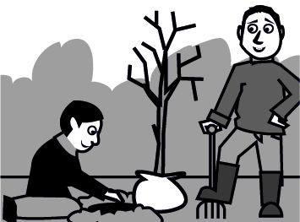

***C. Complete with the Present Simple or the Present Progressive of the verbs in brackets.***

**1.** Patrick (watch) the dolphins at the aquarium now.

**2.** My brother (buy) new trainers every winter.

**3.** David (not wear) jeans. He hates them.

***D. Look at the prompts and make sentences.***

**1.** Ted / love / go / to school fêtes

.

**2.** Hasan / hate / play / baseball

.

***Reading***

***Read the e-mail and complete the sentences.****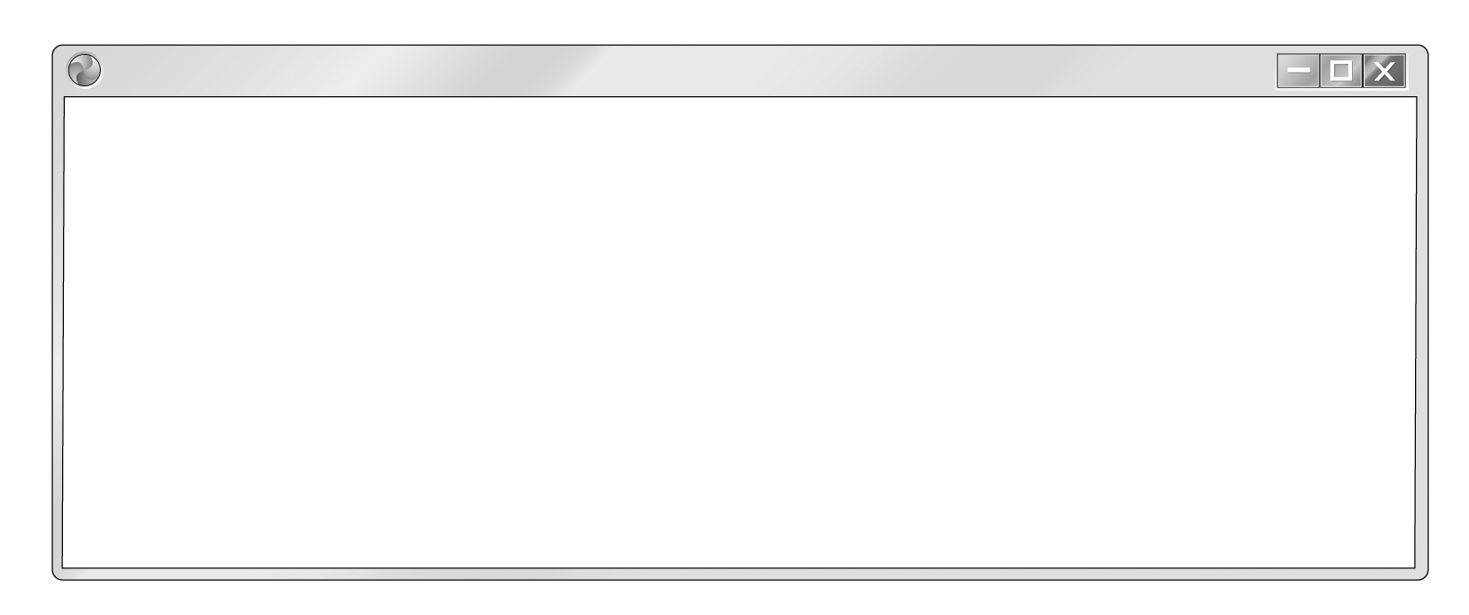*

Hi Fahad,

How are you? I hope you’re fine. I’m writing this from the bus station in Milan. It’s 5th  
November today and I know it’s Eid al-Adha tomorrow, so Happy Eid! I know you usually   
have a get-together at your house and I’m very sorry I can’t be there. It’s very cold here and   
I’m wearing two jumpers. I’m sitting in a café and I’m drinking some very nice hot chocolate.   
Milan is beautiful. Anyway, bye for now! See you in two days.

Yours,

Tony

**1.** Tony is sitting in a at the bus station in Milan.

**2.** Tomorrow is November.

**3.** Tony can’t go to tomorrow.

**4.** Tony is wearing because it’s cold.

**5.** He is writing the e-mail and drinking .

**Module 3**

***Vocabulary***

***A. Circle the correct words.***

**1.** My friends and I are basketball **mates / fans**. Our favourite team plays on Fridays and  
 we never miss a game.

**2.** I fell because the floor was **wet / dark**.

**3.** What time did your parents **return / spend** home yesterday?

**4.** I don’t like sharks. They’re **interesting / scary**.

***B. Complete the sentences with the prepositions in the box.***

up of for in of

**1.** I met Sally 2005.

**2.** Last night I had a salad instead a meal. I wasn’t hungry.

**3.** It’s 11am. Wake , children!

**4.** Yesterday my brother and I played computer games a while and then  
 we did our homework.

**5.** Our fridge is full fruit and vegetables. My mum loves them!

***Communication***

***Complete the dialogue with the sentences a-d.***

**a.** Did you call him today?

**b.** He called me in the middle of the night last night.

**c.** Maybe there’s something wrong with it.

**d.** I’m worried about Lee.

**A:** John!

**B:** Hi, Brian. What’s wrong?

**A:** (**1**) .

**B:** Not again! You two always argue. Try to be nice to each other.

**A:** It’s not that. (**2**) But he didn’t speak.

**B:** That’s strange. (**3**) .

**A:** Yes, I tried but I think he turned his phone off.

**B:** (**4**) .

**A:** Let’s go to his house and find out.

**B:** OK. Come on then.

***Grammar***

***A. Complete the sentences with was, wasn’t, were or weren’t.***

**1. A:** Tom and Jake in Italy last year?

**B:** No, they , but Jake’s father there for a month.

**2. A:** John, I found your diary.

**B:** Where it?

**A:** Under your bed. It in the wardrobe.

***B. Complete with the Past Simple of the verbs in brackets.***

**1.A:** you (buy) a new car?

**B:** Yes, I (buy) it last month.

**2. A:** We (go) to the swimming pool last Friday.

**B:** Really? you (have) a good time?

**A:** Yes, we (have) a fantastic time. We (swim) for hours.

**3.** Yesterday, my aunt and uncle (visit) us, but my cousins  
 (not come).

***C. Circle the correct words.***

**1.** Debbie **sleeps / slept** for 10 hours last night.

**2. A:** **Do / Did** you eat mushrooms?

**B:** Yes! I **love / loved** them. I **make / made** a delicious mushroom soup two days ago.

**3.** My friends and I **go / went** to the skating rink every week.

**Reading**

Read the text and tick (4) or cross (8) the pictures.

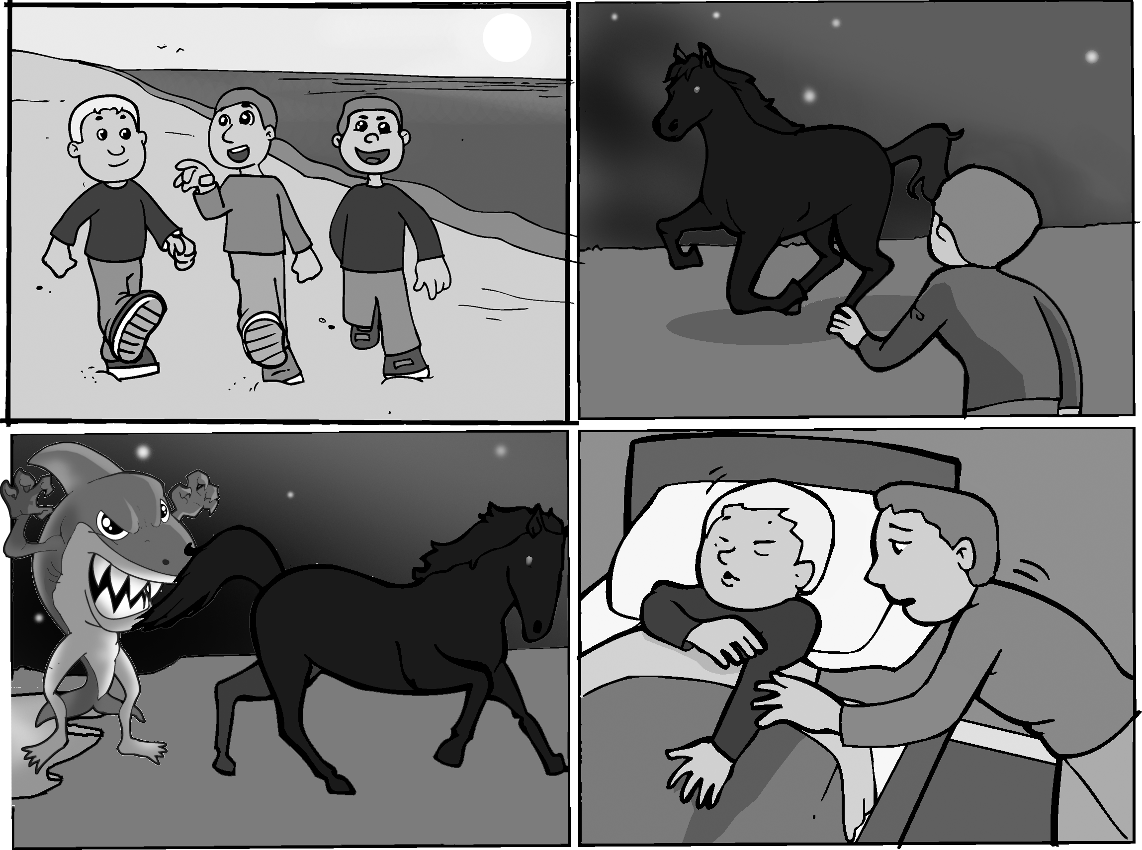

**1**

**2**

**3**

**4**

I had a very strange dream last night. I was by the sea with my friends and it was night time. Suddenly, we saw a beautiful black horse. Then there were lots of black horses but they were scared and they started running. My friends and I tried to understand why. And then we saw a really big shark. It was a strange shark because it had arms and legs. It came out of the sea and tried to eat one of the horses. Then the shark saw us! We started running and screaming! Luckily, that’s when my mum came into my room and woke me up. I was very scared, but it was just a dream.

**Module 4**

***Vocabulary***

***A. Match.***

**a.** souvenirs

**b.** by train

**c.** money

**d.** a fire

**e.** a trip

**1.** spend

**2.** put out

**3.** go on

**4.** travel

**5.** buy

***B. Complete the phrases with one word.***

**1.**  water sports

**2.**  hiking

**3.** -aid kit

***C. Complete with the words in the box.***

warm equipment tiring population village sailing capital sightseeing

**1.** We’re going this summer. I can’t wait. I just love the sea!

**2.** I don’t like . I just want to sit on the beach all day.

**3. A:** What’s the of your town?

**B:** One million.

**4.** Our instructor gave us the scuba-diving .

***Communication***

***Complete the dialogue with the phrases a-d.***

**a.** But it’s worth it!

**b.** I can’t wait!

**c.** How long are you staying?

**d.** When are you getting back?

**A:** OK. See you next Tuesday.

**B:** Actually, I’m going to Fiji!

**A:** Wow! (**1**) .

**B:** For about three weeks. But it’s a long trip. I must go to Australia first.

**A:** (**2**) .

**B:** Definitely. Fiji is a beautiful place.

**A:** (**3**) .

**B:** On the fourteenth of August.

**A:** OK, don’t forget to get me a souvenir.

**B:** OK.

**A:** Have a nice trip, then.

**B:** Thanks. (**4**) **________**

***Grammar***

***A. Complete the sentences with the Future going to of the verbs in the box.***

explore make organise put up drive arrive buy

**1.** We our tent near the river and then Greg  
 a fire.

**2.** Your torch isn’t working. you a new   
 one from the shop?

**3.** There aren’t any buses tomorrow so Lee to work.

**4.** The schools in my area a fundraiser.

**5.** Bye, now. I the area. I’ll be back in half an hour.

**6.** What time your dad home tonight?

***B. Write sentences using must/mustn’t and the prompts given.***

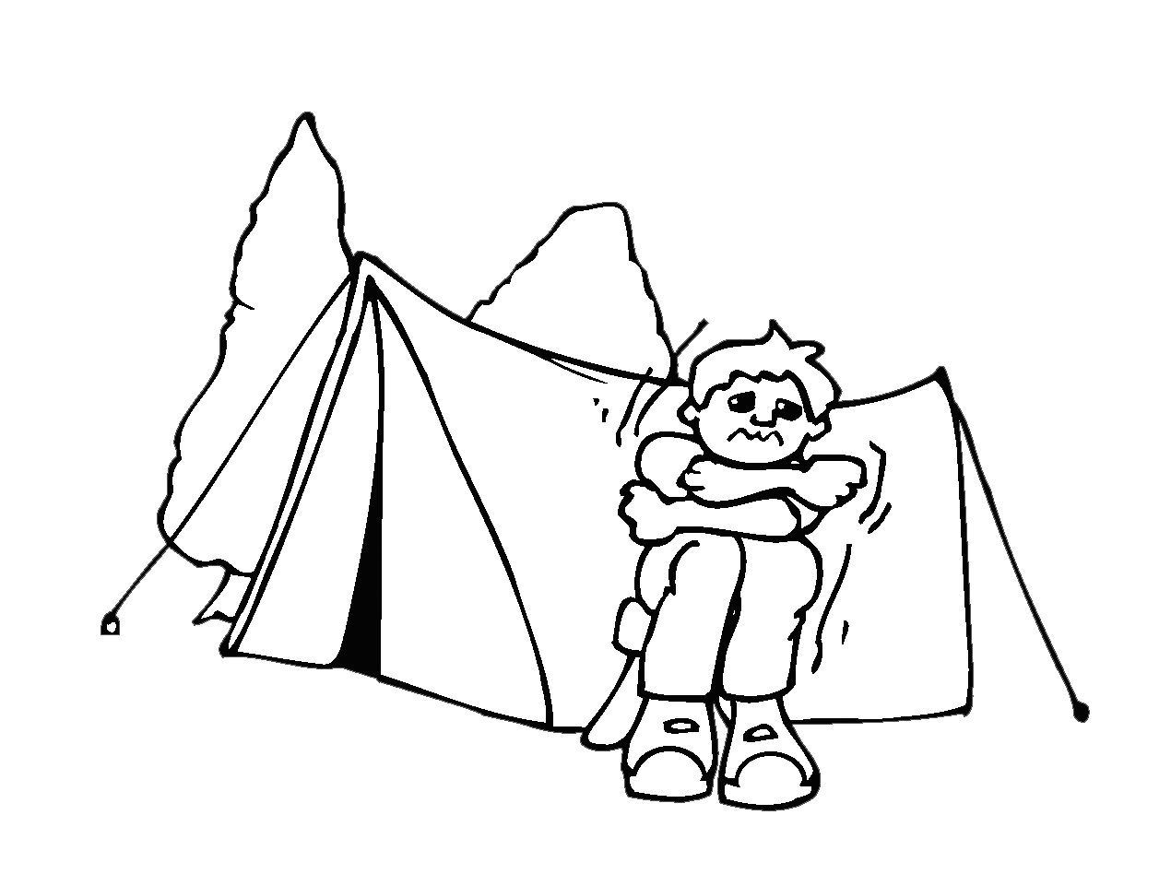

**2.** It’s almost nine.

(walk / fast)

(not be / late)

.

.

**1.** I’m cold.

(make / fire)

**. _________________**

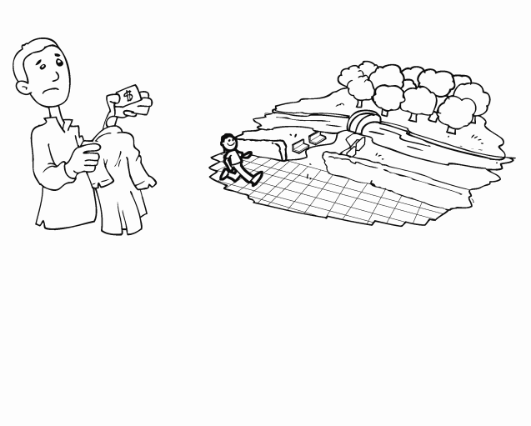

***C. Complete with the comparative or the superlative form of the adjectives in brackets.***

**1.** My brother is (tall) than my father.

**2.** Basketball is the (popular) sport at my school.

**3.** We visited the (beautiful) village on the mountain.

**4.** Your cake is (delicious) than my mum’s, but don’t tell her.

***Reading***

***Read the text and write T for True or F for False.***



**Craig’s trip**

Craig found a good website on the Internet with different trips to Central America. He wanted to go to Honduras but the trip to Costa Rica was cheaper so he’s going to go there. He’s leaving in two weeks and he’s very excited. It’s a one-month trip and he’s going to go on a tour of the rainforest. He’s also going to travel up the Rio Grande de Tárcoles. It’s Costa Rica’s longest river and he’s going to see beautiful birds and maybe monkeys. Of course, he’s also going to climb Cerro Chirripó, Costa Rica’s highest mountain. Unfortunately, it rains a lot there in June, so he’s going shopping tomorrow to buy an umbrella!

**1.** The trip to Honduras is more expensive than the trip to Costa Rica.

**2.** Craig’s going to stay in Costa Rica for two weeks.

**3.** The Rio Grande de Tárcoles is Costa Rica’s highest mountain.

**4.** Craig is going to buy an umbrella for his trip.

Dictation

|  |  |  |  |
| --- | --- | --- | --- |
|  |  |  | 1. |
|  |  |  | 2. |
|  |  |  | 3. |
|  |  |  | 4. |
|  |  |  | 5. |
|  |  |  | 6. |
|  |  |  | 7. |
|  |  |  | 8. |
|  |  |  | 9. |
|  |  |  | 10. |
|  |  |  | 11. |
|  |  |  | 12. |
|  |  |  | 13. |
|  |  |  | 14. |
|  |  |  | 15. |
|  |  |  | 16. |
|  |  |  | 17. |
|  |  |  | 18. |
|  |  |  | 19. |
|  |  |  | 20. |
|  |  |  | 21. |
|  |  |  | 22. |
|  |  |  | 23. |
|  |  |  | 24. |
|  |  |  | 25. |
|  |  |  | 26. |

Module 1

|  |  |  |  |
| --- | --- | --- | --- |
| Lesson b |  | Lesson a |  |
|  |  |  |  |
|  |  |  |  |
|  |  |  |  |
|  |  |  |  |
|  |  |  |  |
|  |  |  |  |
|  |  |  |  |
|  |  |  |  |
|  |  |  |  |
|  |  |  |  |
|  |  |  |  |
|  |  |  |  |
| Lesson d |  | Lesson c |  |
|  |  |  |  |
|  |  |  |  |
|  |  |  |  |
|  |  |  |  |
|  |  |  |  |
|  |  |  |  |
|  |  |  |  |
|  |  |  |  |
|  |  |  |  |
|  |  |  |  |
|  |  |  |  |
|  |  |  |  |

|  |  |
| --- | --- |
| Lesson e |  |
|  |  |
|  |  |
|  |  |
|  |  |
|  |  |
|  |  |
|  |  |
|  |  |
|  |  |
|  |  |
|  |  |
|  |  |

Module 2

|  |  |  |  |
| --- | --- | --- | --- |
| Lesson b |  | Lesson a |  |
|  |  |  |  |
|  |  |  |  |
|  |  |  |  |
|  |  |  |  |
|  |  |  |  |
|  |  |  |  |
|  |  |  |  |
|  |  |  |  |
|  |  |  |  |
|  |  |  |  |
|  |  |  |  |
|  |  |  |  |
| Lesson d |  | Lesson c |  |
|  |  |  |  |
|  |  |  |  |
|  |  |  |  |
|  |  |  |  |
|  |  |  |  |
|  |  |  |  |
|  |  |  |  |
|  |  |  |  |
|  |  |  |  |
|  |  |  |  |
|  |  |  |  |
|  |  |  |  |

|  |  |
| --- | --- |
| Lesson e |  |
|  |  |
|  |  |
|  |  |
|  |  |
|  |  |
|  |  |
|  |  |
|  |  |
|  |  |
|  |  |
|  |  |
|  |  |

Module 3

|  |  |  |  |
| --- | --- | --- | --- |
| Lesson b |  | Lesson a |  |
|  |  |  |  |
|  |  |  |  |
|  |  |  |  |
|  |  |  |  |
|  |  |  |  |
|  |  |  |  |
|  |  |  |  |
|  |  |  |  |
|  |  |  |  |
|  |  |  |  |
|  |  |  |  |
|  |  |  |  |
| Lesson d |  | Lesson c |  |
|  |  |  |  |
|  |  |  |  |
|  |  |  |  |
|  |  |  |  |
|  |  |  |  |
|  |  |  |  |
|  |  |  |  |
|  |  |  |  |
|  |  |  |  |
|  |  |  |  |
|  |  |  |  |
|  |  |  |  |

|  |  |
| --- | --- |
| Lesson e |  |
|  |  |
|  |  |
|  |  |
|  |  |
|  |  |
|  |  |
|  |  |
|  |  |
|  |  |
|  |  |
|  |  |
|  |  |

Module 4

|  |  |  |  |
| --- | --- | --- | --- |
| Lesson b |  | Lesson a |  |
|  |  |  |  |
|  |  |  |  |
|  |  |  |  |
|  |  |  |  |
|  |  |  |  |
|  |  |  |  |
|  |  |  |  |
|  |  |  |  |
|  |  |  |  |
|  |  |  |  |
|  |  |  |  |
|  |  |  |  |
| Lesson d |  | Lesson c |  |
|  |  |  |  |
|  |  |  |  |
|  |  |  |  |
|  |  |  |  |
|  |  |  |  |
|  |  |  |  |
|  |  |  |  |
|  |  |  |  |
|  |  |  |  |
|  |  |  |  |
|  |  |  |  |
|  |  |  |  |

|  |  |
| --- | --- |
| Lesson e |  |
|  |  |
|  |  |
|  |  |
|  |  |
|  |  |
|  |  |
|  |  |
|  |  |
|  |  |
|  |  |
|  |  |
|  |  |

Handwriting

Write the sentences in cursive :

-You can find dragon fruit in South America.

_______________________________________________________________________________________________---------------------------------------------------------------------------------------------------------------------------------------------------------------------------------------------------------------------------------------------------------------------------------------------------------------------- _______________________________________________________________________________________________

-Can I have some peace and quiet, please?

_______________________________________________________________________________________________---------------------------------------------------------------------------------------------------------------------------------------------------------------------------------------------------------------------------------------------------------------------------------------------------------------------- _______________________________________________________________________________________________

-My brother bought tickets for us as a surprise.

_______________________________________________________________________________________________---------------------------------------------------------------------------------------------------------------------------------------------------------------------------------------------------------------------------------------------------------------------------------------------------------------------- _______________________________________________________________________________________________

-Neal's dream is to see the world .

_______________________________________________________________________________________________---------------------------------------------------------------------------------------------------------------------------------------------------------------------------------------------------------------------------------------------------------------------------------------------------------------------- _______________________________________________________________________________________________

**Writing**

Module 1

__________________________________________________________________________________________________________________________________________________________________________________________________________________________________________________________________________________________________________________________________________________________________________________________________________________________________________________________________________________________________________________________________________________________________________________________________________________________________________________________________________________________________________________________________________________________________________________________________________________________________________________________________________________________________________________________________________________________________________________________________________________________________________________________________________________________________________________________________________________________________________________________________________________ ______________________________________________________________________________________________________________________________________________________________________________________________________________________________________________________________________________________________________________________________________________________________________________________________________

Module 2

______________________________________________________________________________________________________________________________________________________________________________________________________________________________________________________________________________________________________________________________________________________________________________________________________________________________________________________________________________________________________________________________________________________________________________________________________________________________________________________________________________________________________________________________________________________________________________________________________________________________________________________________________________________________________________________________________________________________________________________________________________________________________________________

______________________________________________________________________________

____________________________________________________________________________________________________________________________________________________________

**Writing**

Module 3

__________________________________________________________________________________________________________________________________________________________________________________________________________________________________________________________________________________________________________________________________________________________________________________________________________________________________________________________________________________________________________________________________________________________________________________________________________________________________________________________________________________________________________________________________________________________________________________________________________________________________________________________________________________________________________________________________________________________________________________________________________________________________________________________________________________________________________________________________________________________________________________________________________________ ______________________________________________________________________________________________________________________________________________________________________________________________________________________________________________________________________________________________________________________________________________________________________________________________________

Module 4

______________________________________________________________________________________________________________________________________________________________________________________________________________________________________________________________________________________________________________________________________________________________________________________________________________________________________________________________________________________________________________________________________________________________________________________________________________________________________________________________________________________________________________________________________________________________________________________________________________________________________________________________________________________________________________________________________________________________________________________________________________________________________________________

______________________________________________________________________________

____________________________________________________________________________________________________________________________________________________________

Student's Portfolio

Student's information

Index

Assessment

and

Feedback

Word list

Worksheets

Tests

Projects

Extra Works

Self Assessment

Encouragements

and Appreciation Certificates

**Module 1**

My dream menu

1- Think of all your favourite food .

2- Find photos or draw pictures of it .

3-Put everything together to make your dream menu .

**Module 2**

School fundraiser poster

1- Make a poster for a fundraiser at your school.

2-Think about a good cause for your fundraiser .

3-Decide what activities are going to happen there .

4-Think about the date and time of the event.

5-Use ideas from pp.26-27 of the student's book.

**Module 3**

**My favourite funfair**

**1-Write some information about your favourite funfair [ name, where it is, ticket price , etc ]**

**2-Write about the rides it's got.**

**3-Say which are your favourite rides ,how often you go there and who with.**

**4-Say what you did the last time you went and why you enjoyed it .**

My favourite funfair is ----------------------------------------------------------------------------------------------------------------------------------------------------------------------------------------------------------------------------------------------------------------------------------------------------------------------------------------------------------------------------------------------------------------------------------------------------------------------------------------------------------------------------------------------------------------------------------------------------------------------------------------------------------------------------------------------------------------------------------------------------------------------------------------------------------------------------------------------------------------------------------------------------------------------------------------------------------------------------------------------------------------------------------------------------------------------------------------------------------------------------------------------------------------------------------------------------------------------------------------------------------------------------------------------------------------------------------------------------------------------------------------------------------------------------------------------------------------------------------------------------------------------------------------------------------------------------------------------------------

**Module 4**

**My Country**

**1-Find or draw a map of your country.**

**2-Find photos of important cities or other places or things in your country [ e.g. forests , rivers , animals , products ].**

**3-Stick them around the map of your country and write a few sentences about them .You can use the example of Argentina on pp 56- 57 in the student's book .**

**--------------------------------------------------------------------------------------------------------------------------------------------------------------------------------------------------------------------------------------------------------------------------------------------------------------------------------------------------------------------------------------------------------------------------------------------------------------------------------------------------------------------------------------------------------------------------------------------------------------------------------------------------------------------------------------------------------------------------------------------------------------------------------------------------------------------------------------------------------------------------------------------------------------------------------------------------------------------------------------------------------------------------------------------------------------------------------------------------------------------------------------------------------------------------------------------------------------------------------------------------------------------------------------------------------------------------------------------------------------------------------------------------------------------------------------------------------------------------------------**