Moduel 5 That’s Incredible
VOCABULARY
- Match sentences with their meaning.
Sally refused to help me with the washing-up
Ian apologised for all the trouble he had given us.
( ) say that you are sorry
( ) not accept

- Match phrasal verbs in bold with their meanings.
- Invent
- Rob
- Increase
- To end
- To leave
- To be awake
- The robbers held up the bank.
- The prices of electricity will go up by 25% the next year.
- You can’t imagine what kind of stories children can make up
- Hashim is usually up at 7 o’clock in the morning.
- I was about to leave home when I heard a strange noise.
- I hope this long lecture will be over soon.

- Complete the table with words related to crime.
ACTION (VERB) | CRIME | CRIMINAL
Steal | Theft
 | Robbery
 | Kidnapping | Kidnapper
Once upon a time / by the time / on time
- Complete.

- ……………………………………, there was a brave man who lived in a faraway land.
- Luckily, there was no delay and the train left………………………….
- ………………I can afford to buy that house, the price will have gone up.

- Choose.
- Lisa……………up at the meeting about an hour late.
- Turned b. took c. put d. went

- …………………………., dinosaur inhabited the Earth.
- From time to time b. For the time being c. On time d. Once upon a time
3. What are you two………………? You look very suspicious.
a. about b. for c. on d. up

4. Paul…………………his father to let him go to the shopping mall with his friends
a. refused b. wondered c. begged d. denied
16 | Page

- Choose.
- Is there a pot / pan / pin I can use to fry some eggs?
- The burglar was caught in action / crime / theft while breaking into the house.

GRAMMAR
- Report the following.
- “ I am watching TV’
He said………………………………………………………….
- “Please, don’t make noise” Julia said to her sister.
Julia asked her sister……………………………………..
- “Will the weather be nice this weekend?” Becky thought.
Becky wondered……………………………………………….

- Choose.
- Tom was tired because he……..on the project for 12 hours non-stop.
- worked b. working c. works d. had been working

- After the children ……for school, Mum tidied up the house.
- Leaving b. had been leaving c. had left d. were leaving

- I asked my mum……………..
- Where my T-shirt was c. where is my T-short
- where was my T-shirt d. whether was my T-shirt

- Bob wanted to know………..the book belong to me.
  - Had b. did c. if d. was

- Mary “ I love chocolate”
Mary said that she…………..chocolate.
a. loved b. love c. loves d. had loved

- “ I went skiing”
Mary said she …………skiing.
a. went b. had gone c. go d. gone

- “ I will eat steak for dinner”
Mary said she……………..eat steak for dinner.
a. willing b . will c. would d. was

- Rewrite the sentences using direct Speech.
1. Tony wondered where he had left his car keys.
…………………………………………………………….Tony wondered.
2. The teacher asked the students not to make noise.
………………………………………………………………the teacher said.
17 | Page

- Choose.
1. Jason said / told / asked me that I needed / need / needs
2. He told me that he was booking / had booked / books his ticket the previous day / yesterday / the following day.

======================================================
WRITING

Think about what aspects of life will be different. Complete the word webs with relevant vocabulary. Develop the web by adding other aspects you think of.

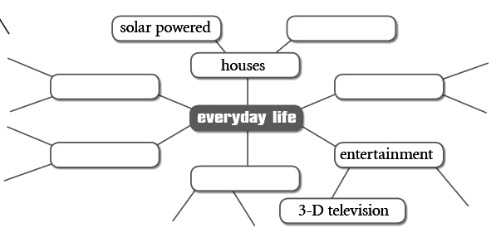

18 | Page

Email
A friend of yours will be visiting your city and has sent you an email. Write an email answering your friend’s email.
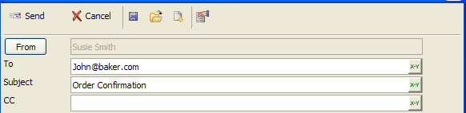
Dear ……………,
I was waiting for this day, I can’ believe that I will see you! Anyway, there is an amazing restaurant near my house. They have Indian meals. We can meat there. When you come from the airport, turn right and you will find it.
Can’t wait to see you.
Take care,
Sarah

Dear ………………….,
How are you? I’m really happy you can visit me.
I think it would be a good idea to meet in a restaurant in the evening. If you don’t like this idea, you can come to my house directly.
My house is on King Abdul aziz road behind a big shopping centre.
I hope to hear from you soon.
Best wishes,
………………..
19 | Page

Dear ……………,
I was waiting for this day, I can’ believe that I will see you! Anyway. There is an amazing restaurant near my house. They have Indian meals. We can meat there. When you come from the airport, turn right and you will find it.
Can’t wait to see you.
Take care,
Sarah

