
Kingdom of Saudi Arabia Final Exam (1st Term )الدورالأول

30

Ministry of Education 3rd Grade (1434-1435)
…………. Secondary School Time: 3 hours
in ………… Seat Number:……......
Q.no | Mark in fig. | Written M | Corrector | Reviser
I |  | فقط
II |  | فقط
III |  | فقط
IV |  | فقط
V |  | فقط
Total |  | فقط
Student's Name :………………………………
I-Language Function
- Composition

6

There are different kinds of travel. Write about Air Travel
explaining its advantages and disadvantages:
(means of – enjoyable- service – waiting )

………………………………………………………………………………………………………………………………………………………………………………………………………………………………………………………………………………………………………………………………………………………………………………………………………………………………………………………………………………………………………………………………………………………………………………………………………………………………………………………………………………………………………………………………………………………………………………………………………………………………………………………………………………………………………………………………………………………………………………………………………………………………………………………………………………………….

- Dialogue:
Rose is interested in helping needy people. Her friend's asking
her for a financial advice. Complete their conversation!

3

Sara: How are you Rose?
Rose: …………………………………………..
Sara: Wealthy countries give their aid to needy ones ,………………..?
Rose :……..., ……..……… . Why?
Sara: Our teacher wants us to think of projects to use Arab Aid there.
Rose : Great! You can help them with…….………………. or ……….……………….
Sara :………………………!Thank you.
Rose : Don't mention it.

II- Comprehension
Read the following passage and then answer the questions below:
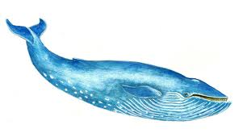
The blue whale is the biggest animal ever to live on Earth. Blue whales can be 33 meters long and weigh 180 tons. They are endangered because people hunt them.
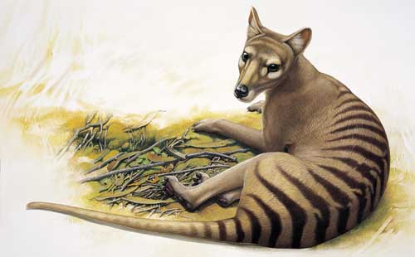
The Thylacine, also called the Tasmanian Tiger or Wolf, became extinct in Australia thousands of years ago, but continued to live on the island of Tasmania until the 20th century .People hunted them till extinction and the last one died in a zoo in 1936.
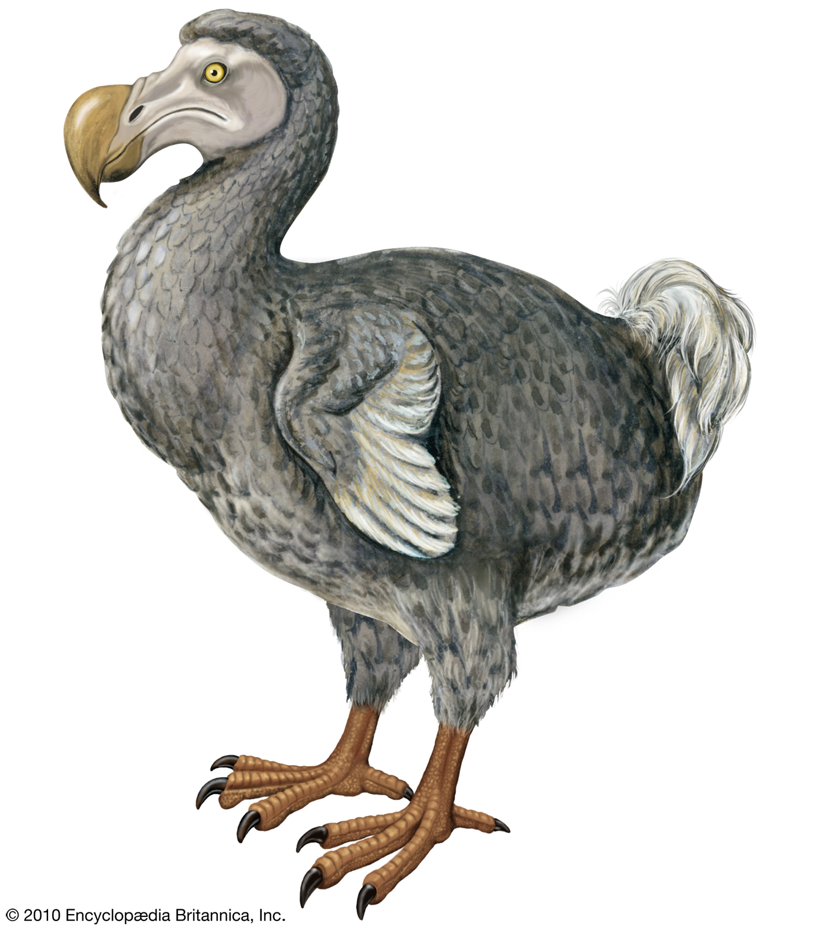
Dodos lived on the Island of Mauritius and they became extinct , in the 17th century. When sailors first arrived on the island they didn't hunt them very much because they didn't taste nice. But the sailors destroyed the forest and brought other animals, like cats and rats onto the island. These animals ate dodos eggs and now dodos don't exist anymore.

6

- Answer these questions correctly:
- Why are blue whales endangered species?
………………………………………………………………………………………………………………..…………..
- When did the last Thylacine die ?
…………………………………………………………………………………………………………………….……….
- Why didn't the sailors hunt dodos?
……………………………………………………………………………………………………………………………….
- Choose the correct answer:
1- The last Thylacine died in a (Mauritius – Forest – Zoo ).
2- Dodos became extinct in the( 13th – 17th -20th ) century .
- Put (T) for the correct statements and (F) for the wrong ones :
- A blue whale is 33 meter long. ( )
- Dodos became extinct because of hunting . ( )
- Both the blue whale and Thylacine are extinct animals. ( )
- Both the Thylacines and Dodos lived in islands. ( )

III- Grammar :
- Choose the correct answer:
- They ( was going – be going – were going ) to Jeddah when I came to Riyadh.
- Muna (has flew-has flown- has flying) by airplane many times.
- He ( played– plays – was playing ) football when his mother called him.
- To make scrambled eggs, you need 3 eggs .Break ( a – an – the – Ø ) eggs
into ( a – an – the – Ø ) pan.
- (When –How long – What time ) have they been waiting here?
- Do as shown between brackets :
- How many books does he read? ( Underline the main verb )
……………………………………………………………………………………………………………………………………………………………….
- They slept early last night. ( Make a Yes-No question)
……………………………………………………………………………………………………………………………………………………………… 3- Do planets orbit the sun? ( Change into passive)
………………………………………………………………………………………………
4- I ( sleep ) ……………………………. since nine o'clock. (Correct the form of the verb)

IV - Vocabulary :

7

5

- Match each words with suitable meaning:
- fraction ( ) not from this country .
- obey ( ) to do what you are told.
- forest ( ) a small piece .
- bit ( ) everything---- stars, plants etc---that exists anywhere .
- official ( ) a part of a number .
- universe ( ) a large area full of trees .
- dozen ( ) a person holding a position in the government or organization.
( ) twelve

- Choose the correct word :
- If you spill petrol on the ground, it quickly ( melts – evaporates- radiates)
- The sea is a good ( nurse – source – pillar ) of food.
- Most governments are interested in the (cannon – sea –conservation) of the environment.
- I saw a ( fleet –fare-rest ) Of buses .
- We can see ourselves in a mirror because it (enables – reflects - completes) light .
- There is a (hunger – thread- mine )near Buraidah which is full of silver .
- The sun rises in the east and (reveals - drops– sets)in the west.

3

V- Writing Skills:
- Do as shown between brackets:
- mr. Al-Amri speaks german French and Spanish ( Punctuate this sentence)
…………………………………………………………………………………………………………….
- express …………………………. ( Add -s )
- Study …………………….. ( Add -ed )
- Rana can drink tea with milk. She can drink tea without milk. ( Join then Shorten )
……………………………………………………………………………………………………………………..........
Best of Luck ; Your English Teacher

