1-Choose the correct answer:-
:- traffic lights , no parking 1- speed restriction,
a-eating places b-city people c-signs and signals d-leisure
2- watch, ring:-
a-leather b-gold c-wool d-silk
3-How many of the shops did you visit?....................of them .I feel exhausted.
a- all b- neither c- none d-both
4-graduation………………
a-bride b- engagement c-groom d-university
5-wedding……………….
a- reception b- degree c- academic d-graduate
6-He decided to travel by bus……………………….he didn't have much money.
a- because b-only c- if d- but
7- We will be………………….for you at seven o'clock. Don't be late.
a-wait b-waits c-waiting d- waited
8-In 2025,we will have………………………a cure for all types of cancer.
a-discover b-discovers c-discovering d-discovered
9-While he was………………………at Fort Hare University ,he organized a boycott.
a-study b- studies c-studying d-studied
10-I got the job .If I hadn't…………………it ,I would have applied for another.
a-get b-gets c-getting d- got

11- these books ………interesting subjects.
a-put out b-spill c- deal with
12- what is his ………… ?he's a major.
a- station b- rank c-spill
13- Ahmad and Adnan ………..brothers but they are not.
a- simple b-smoke c-look like
14-Electric…………can come from playing electrical equipment.
a-smoke b-difficult c-shocks
15- a soldier must …………..for his country.
a-defeat b-control c-fight.
16-softdrinks……………..a lot of sugar.
a- gain b-contain c-supply
17-people often like to sit outside and ……….the stars at night.
a-last b-supply c-observe
18-oil comes from an oil……………..in the ground.
a- well b-youth c-retired
II Grammar:
19-do not smoke inside buildings . (make stronger)
a- always smoke inside buildings b-never smoke inside building c- donot smoke
20-you will succeed if you ……………..hard
a-study b-studies c- studying
21- give + ing
a- giveing b- giving c- giveeing
22-write + ing
a- writeing b- writing c-writting
23-the muslims spread islam. (change into passive)
a-the muslims were spread islam b- islam was spread by the muslime c- the muslims was spread by islam
24-Arabic replaced Latin. (change into passive)
a-Latin was replaced by Arabic b-Arabic replace by Latin c- Arabic replace Latin
25- Spain was ruled by Muslims. (change into active)
a- spain were ruled muslims b- Muslims ruled Spain c- Muslim was ruled Spain
26- the door s…………… closed.
a- was b- the c- were
27-Ali retired last year. (change the sentence with used to)
a- Ali used to retired last year. b- Ali retired last year. c- Ali used to retire last year

1)Read the following passage and answer the questions:-
Jameelah Ahmad was doing her homework when her mobile phone
rang. 'Oh,' she thought, 'that will be Sarah.' Sarah and Jameelah always
phoned each other at this time of the evening. She pressed the answer
button. 'Hello, Sarahl' she said. 'Who's that?' a woman's voice said.
'Oh, sorry,' answered Jameelah. 'I thought you were my friend Sarah,'
'Are you Jameelah Ahmad?' said the voice . 'Er . . . yes . . . who are you?'
The woman explained, and suddenly it all came clear. The day before,
Jameelah had found a bag in the street, on the way back from school.
She had to go past the police station, so she handed the bag in. The
policewoman had asked her if she wanted to leave her name, address,
and phone number. Jameelah couldn't see the point, but left them
anyway. The woman, a Mrs Salwa, who had lost the bag, phoned the
police station to see it someone had found if, and when she went to pick
it up she asked for Jameelah's name and phone number.
_Now, Jameelah,' said Mrs Salwa, 'there was a lot of money in that bag
and you were a very honest young girl. If you give me your address,
1 want to send you 300 SAR as a reward.' Jameelah tried to refuse, but
~Mrs Salwa insisted.
A-Answer the following questions:-
1-What was Jameelah doing when her mobile phone rang?
………………………………………………………………………………………………………………………………………….
2-Where had Jameelah found the bag?
………………………………………………………………………………………………………………………………………….
B- Circle the correct answer:-
1-Sarah and Jameelah phoned each other
a-every evening b-occasionally c-most evenings
2-Jameelah
a-knew who the woman was b-wasn't sure who she was c-didn't know who she was
3-At the police station, Jameelah
a-didn't have to leave her number b-didn't want to leave her number c-had to leave her number
4-Jameelah
a-wanted the ward b-didn't want to give her address c-didn't want the reward

2) Read and answer the question
Fire is dangerous. It can spread quickly .It also can start anywhere .There are many kinds of fires : chemical , oil, gas and electrical fires. A fireman should know how to deal with each kind. A fireman puts out fires .He also helps in car accidents and when chemicals are spilled .He also teaches children in schools about fires .A fireman studies in the Civil Defense Institute in Riyadh. To join this institute he should be over seventeen and has at least the elementary school certificate. If you see a fire just call the civil Defense at 998.

19-A fireman should be to join the fire service
- 15 b- 16 c- 17 d- 20
20-. If you see afire , call.
a- 999 b- 997 c- 998 d-996

21- 1) Fire is dangerous because it can start …………………… .
(a) anywhere (b) nowhere (c) where (d) somewhere
22- the fire engines are in the fire……………
a- rank b- spill c-station d- fire
23- a fireman studies in ………..
a- Civil defense institute b- college c- school d- dangerous

IV Put [T] or [F] from the passage and General questions.
1- The fire isn't dangerous and cann't spread anywhere. [ ]
2- If you see afire, call 997. [ ]
3-The fuel for the human body is gas. [ ]
4- Energy come from two substances in our food. [ ]
5- AH means Hijrah or Islamic calendar. [ ]
6- Camels and Horses are modern ways of travelling. [ ]

1-Matching

1)simple | (a) a very large sea
2)difficult | (b) give
3) death. | (c) the end of life.
4) provide | (d) a material.
5) substance | (e) the ability to do work
6) energy | (f) the opposite of easy
7) convenient | (g) easy to get
8)ocean | (h) easy

2-Match the words with the correct meanings:-
a-to take care of |  | - Buildings
b-skycraper,block of flats, shopping center |  | - Siblings
c-brothers and sisters |  | - A toddler
d-a child who starting to walk |  | - A woman
e- a female adult |  | - Intelligent
f-smart |  | - to create
g-to make |  | - to exhibit
h- to show |  | - to protect
i- to say that something will happen |  | - to predict
j- to keep away from |  | - to avoid


3- Choose the write word under the pictures :
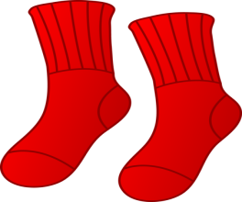
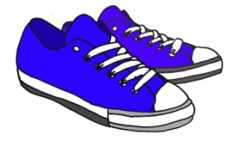
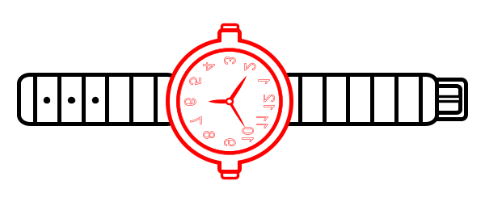

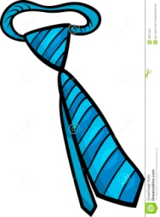
a-( socks – scarf ) b-( ring – watch ) c-( tracksuit- trainers) d-( monitor-mouse pad)



e-( scarf – tie ) f-( headband – sweater)

