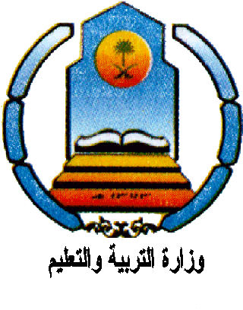
30
----

The Final Exam
first term
1435-1434 AH
Time : 3 hours

Kingdom of Saudi Arabia
Ministry of Education
Hail Educational Zone
Alshoims Intermediate and Secondary school

Name…………………………………………….……………………………………………….………………..
 |  | Corrected by
 |  | Revised by
30 | Thirty marks | Total marks

1.Composition
6
----
Write a paragraph about" fire " .use these words:

( firemen – dangerous – kinds – put out – rescue – deal with - cities- spread - houses - shop - villages )
……………………..
………………………………………………………………………………………………………………………………………………………………………………………………………………………………………………………………………………………………………………………………………………………………………………………………………………………………………………………………………………………………………………………………………………………………………………………………………………………………………………………………………………………………………………………………………………………………………………………………………………………………………………………………………………………………………………………………………………………………………………………………………………………………………..

2 - Dialogue:
3
----

"Ali and Ahmed are talking about the life in the past"
Arrange the dialogue.

( Were rooms small - no it was not - traditional house )

Ali: - Can you tell me , what kind of house which you lived in, in the past?
Ahmed: - I lived in a …… ………………
Ali: -Was it big?
Ahmed: - …………………………….
Ali: - Did it have furniture?
Ahmed: - Yes, but it was not modern.
6
----
Ali: - ………… …………………… ?
Ahmed: - Yes, its rooms were small.

3- Vocabulary :

B- Put the correct number in the space
:
A | 1) hearing |  | To make someone safe | B
 | 2) death |  | A very large sea
 | 3) energy |  | To become more
 | 4) increase |  | The ability to do work
 | 5) ocean |  | The end of life | 2
 | 6) rescue |  | The ability to hear | 2
2

4-Comprehension: Read the following passage , then answer the questions in complete sentences:

We need to eat for several reasons. Firstly, food helps us to grow. Children need to eat so as to become taller. . Secondly, we eat in order to have energy. We need strength so that we can walk, talk and lift things. Thirdly, we eat so that our bodies can go on operating. Food helps our brains to work; it helps our hearts to pump blood; . Food contains nutrients. These are things which are important for our health. They are proteins, carbohydrates, fats, vitamins and minerals. It is important for us to have a balanced diet. We should avoid eating too much carbohydrates and too much fat. Because our bodies will gain fats. Proteins are found in milk and eggs. Carbohydrates are found in bread and sugar.

A- Choose the correct answer:

1-Food help our brains to….
6
----
a) work. b) see.

2- Proteins are found in …
a) sugar. b) eggs. .

B – Put ( × ) or ( √ )

1- Proteins are found in milk and eggs. ( )

2- We should eat too much carbohydrates ( )

C -Answer the following questions:

1-Where can we find Carbohydrates?
……………………………………………………………………………………………………………

2- Why do children need to eat ?
……………………………………………………………………………………………………………

5- Grammar :

A-Do as shown between brackets :
6
----

B-Choose:

1-If you eat too much, you [ would become - will become ] fat.
2- [ reads - reading ] stories is a good thing .
3-Thank you [ for - four ] your letter .
4-Everyone used to [ listened - listen ] to stories .
5-The man [ who - which ] I saw was Turkish .
6- I visit my friend [ active - passive ]

6-Reader :

Choose :
3
----

1-Las Vagas is a [ place - Person ]

2-Near is a [ adjective - preposition ]

3-Cancer is a [ protein - disease ]

