Adjectives | Date : | Period: | Lesson 22
EVALUATION | PROCEDURES |  | CONTENT | OBJECTIVE
Teacher will great students ;check homework and revise the last lesson by dictation and recitation and that will be also the introduction of the lesson
Look at the pictures  Listen then repeat objectives. | Teacher will show Ss pictures and real objects. T will say the names of these objects and their adjectives , Ss will listen then repeat . e.g. this is a good apple ….  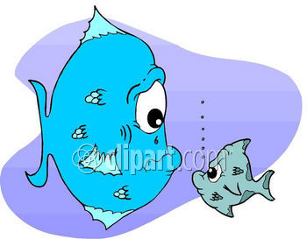  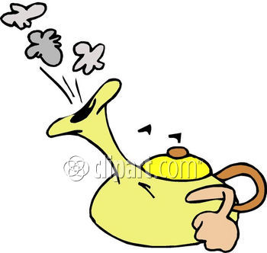    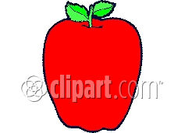  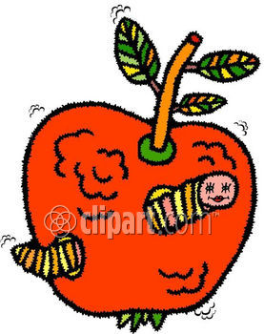  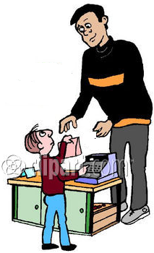 | Reading |  | Looking at cards and real object students will be able to repeat adjectives correctly
Look at the board then write new words in your boards | ,teacher will ask students to write the new words in their board with a good hand writing  Hot – cold – Big – small – Tall – short – Bad – good | Writing  Hot – cold  Big – small  Tall – short  Bad – good |  | Writing on board students will be able to write new words correctly
classify words into objectives. | T will give Ss words and pictures and ask them to classify them into objectives by putting them in a sentences.  E.g. it is a tall house . it is cold water | Classifying |  | Looking at the pictures Ss will be able To classify them into objectives
Read | Teacher will read the lesson Ss will repeat  Homework Workbook lesson 22 -and complete writing their notes | Reading |  | Imitating the teacher students will be able to read the lesson from their book

