 Quiz Unit ( 4 )

My Name ……………………………………………………………………………… Date : ………………/………/1435 .

* Vocabulary :

***Q 1: Write the correctword under each picture :***

( entrance - crazy mirror - competition - the winner - Chinese - rollercoaster - prize - amusement park )

**4**

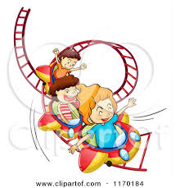

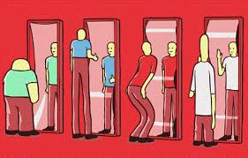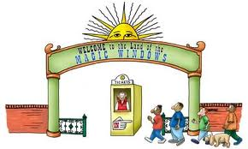……..… …….…… …………… …….….

…………. …….….… ….…. …..… …….…..

* Grammar :

***Q2 : Choose :***

1- ( What – where ) is your father's name ?

**6**

2- ( Who – When ) do you go to school every day ?

3- She can ( speak – speaking ) Chinese .

4- Zainab is good at ( cook – cooking ) pictures .

5- Sara ( can't – not can ) speak English .

6- He likes (watch - watching ) T.V .

7- Can Noor read the word ?

( a ) No, we can . ( b ) No , she can .

8- Do you like watching DVD ?

( a ) Yes, I do . ( b ) Yes , I am .

9- Are you good at bowling ?

 ( a ) Yes, I do . ( b ) Yes , I am .

Mrs: Lamia

**10**