
Model 4
*Vocabulary:
1-Geographical features
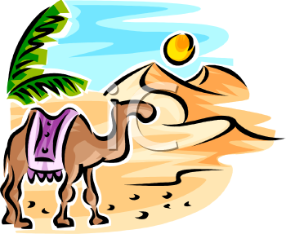
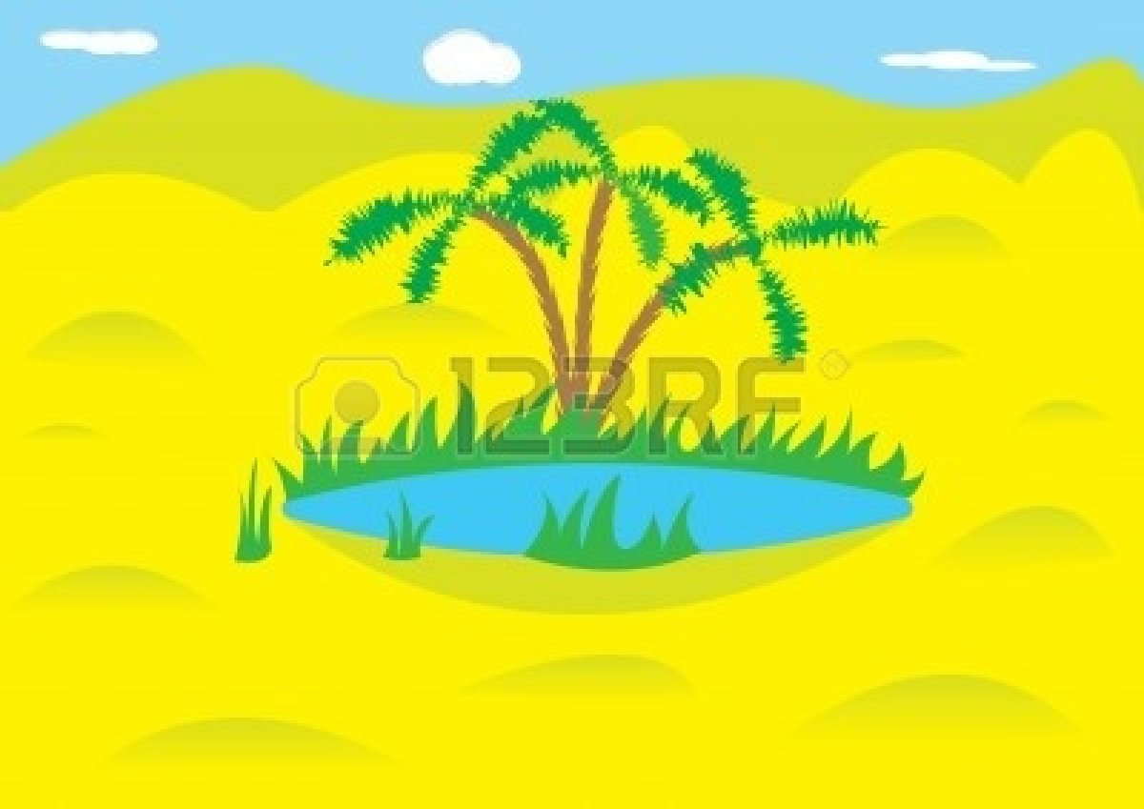
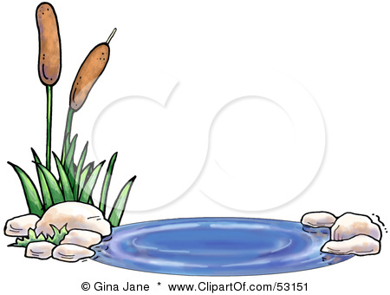
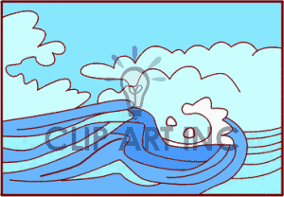

1- Pond 2- Ocean 3- desert 4- oasis

2-Animals

mammals | birds | reptiles | insects
Wolf  Deer  Monkey  kangaroo | Eagle  Goose  Pigeon  peacock | Lizard  Crocodile  Tortoise  cobra | Bee  Fly  Ant  butterfly

*Grammar:
1- Future "will"

S + will + v "base form"

ex: They will play football next day.
Negative:
will --- won't

2- Future "going to"

am
S + is + going to + v
are
ex: Ahmad is going to study now.

3- If conditional type 1

If present simple , (s+ will – can – may – must + base form)
Ex: If you sleep early , you will wake up early.
notice: this type express something which is possible to happen.

4- If conditional type 2

If past simple , (s+ would – could + base form)
Ex: If I were you , I would study hard .
notice: this type express something imaginary\unreal to happen.

5-Articals ( a – an – the )

a before nouns that start with ( consonant letter )
an before nouns that start with ( vowel letters a-u-i-e-o )
the ( noun that found in the previous sentence)

6-Countable and uncountable nouns
uncountable | Countable
How much  much  a little | How many  many  a few

Exercises
*choose:
1-If she was you ,she ( will buy – buy – would buy ) this bag .
2-Gadah have ( a – an) cat .
3- They are(will – going to) visit Paris.
4- ( How much– How many ) books do you have?.
5- There is a ( little – few ) water in this fridge.
*DO as shown between brackets:
1- If she comes early , she will visit me . ( change the order)
………………………………………………………………………………
2- I will eat too much. ( negative )
……………………………………………………………………………………………

3-They will sleep now. ( use going to )
………………………………………………………………………………………
*Vocabulary:
Match the word with the picture:

Ocean - Pond - desert - oasis

1-………… 2-…………… 3-……………… 4-…………

choose:
1- The bee is kind of ( insects – mammals – birds).
2- The animal wolf is kind of (reptiles – mammals – birds).

T.Lammes Al-Omair

