Name......................................................... 1st Module 4+5
Q1)Grammar
A: Do as shown in the brackets;-
1-Andy could write at the age of 4. {Make yes/No question}.
…………………………………………………………………………..
2-Ali should buy a new car. { Make it negative }
…………………………………………………………………………
3-{How much- How many } tomatoes do you need for the salad? (Choose )
4- Would you like( any – some) pizza?
5- Hind is my cousin. Do you know ( him – her )?
6-When I come back from the gym ,I usually drink ( much – a few ) glasses of water.
7- this is an easy exam, I can do it …………….. ( Give the adverb )
8- Ameer…………….( leave ) work at 7 o'clock yesterday. { correct the verb }
Q2: Vocabulary:
A- Circle the correct word :
1-My tooth hurts, I have ( stomach ache – toothache) .
2- Did the police catch the ( burglar- poet ) ? He had a gun.
B - Give the past form of the following verbs :
See: …………….. play :……………….

B: Match the word with it picture :
4-main-courses | 3- dizzy | 2-toothache | 1-salad
8-peppers | 7- strawberry | 6-aubergine. | 5-desserts
12-grapes | 11- horse-riding. | 10-drinks | 9- fishing

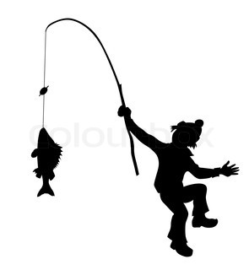 | 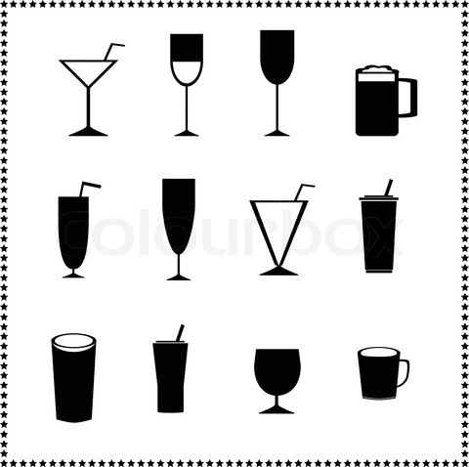 |  | 
 |  |  | 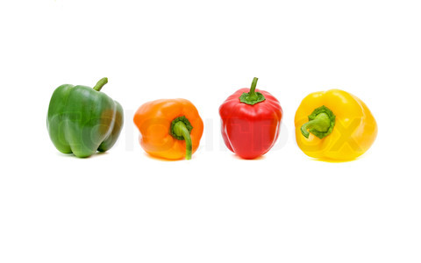
 |  |  | 

End of the Questions .

