Module ( 2 )

Day by day

**1 - Choose the correct phrases to complete the dialogue :**

**Don**: ...........................................................................

a) What time do you start work?

b) What do you do?

c) I don't

d) Where do you work?

e) Do you like your job?

**Sam**: At a hotel.

**Don**:...............................................................................

**Sam**: I'm a receptionist.

**Don**: ...............................................................................

**Sam**: At nine O'clock at night.

**Don**: And when do you finish?

**Sam**: At five in the morning. It's a night job.

**Don:** Oh, I see. ....................................................................

**Sam**: No, ………………………

**2 : Choose the correct words :**

Download - reporter- treadmill - jogging -

1- Jane is a..................................................... She works at a newspaper

2 - I enjoy going ....................................... every morning.

3 . He usually uses the net to ............................................ information.

4. I enjoy running on a ........................................

**3- : Match the first column to the second columns :**

1 . take ( ) with friend.

2- hang out ( ) karate lessons**.**

3 - . read ( ) works at a hospital.

4 **-** . Surf ( ) a magazine.

5 - the nurse ( ) the Net.

إذا كنتي ممن يتخلق بالأخلاق الفاضلة .. فإحذري الخطأ .. فبقدر مايكون الثوب ناصع البياض .. تكون بقعه القذر أكثر وضوحآ

إذا كنت ممن يتخلق بالآداب الفاضلة.. فاحذري الخطأ..

فبقدر ما يكون الثوب ناصع البياض.. تكون بقعة القذر أكثر وضوحاً

إذا كنت ممن يتخلق بالآداب الفاضلة.. فاحذري الخطأ..

فبقدر ما يكون الثوب ناصع البياض.. تكون بقعة القذر أكثر وضوحاً

إذا كنت ممن يتخلق بالآداب الفاضلة.. فاحذري الخطأ..

فبقدر ما يكون الثوب ناصع البياض.. تكون بقعة القذر أكثر وضوحاً

4 – Write correct word under each picture :

**Bellboy – mop the floor – do kickboxing – clean the window**



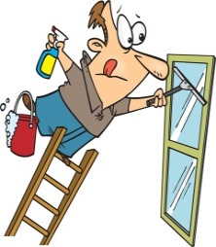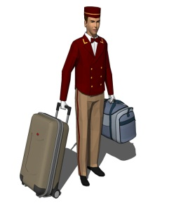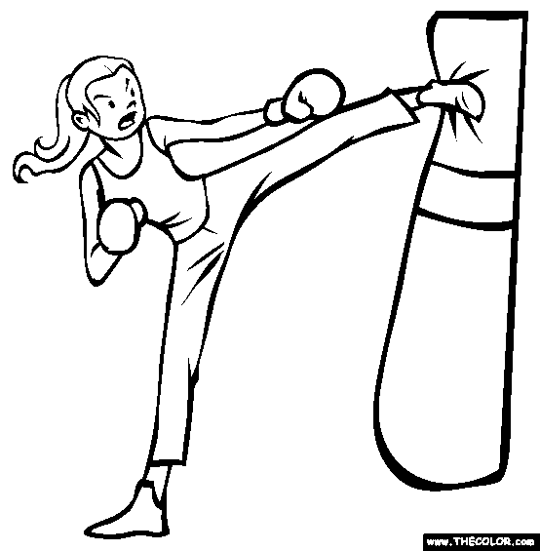

………………………. …………………………….. ………………………… ………………………

5 - Cross out the odd word :

1 – doctor –chef – shopping –receptionist – graphic designer.

2 – lift weights – use machines – cook - do kickboxing.

6 –Write the missing letter :

Cham….ion volunte….r se…..ret

7- *Put the words in correct order*:

In English ,we always put the subject of a sentence before the verb and object after the verb :

S + V + O

1- Thursday / Akram / to / every / goes / Jeddah

…………………………………………………….

2- day / Tony / cooks / every / lunch .

**……………………………………………………………..**

**3-** SMS / Alan / rarely / send / messages**.**

**………………………………………………………………….**

أحيانا نخطئ ولا نشعر أننا أخطأنا.. فيأتي الاعتذار كلمسة سحرية تغسل ما في القلوب من ضيق ونفور..

اعتذري لتكسبي قلوب الناس

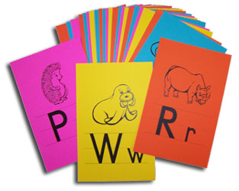

Grammar

**8- Choose the correct answers between the Brackets :**

1 . They work ( on - at - from ) nine to five every day.

2 - I can't stand ( reads - reading - read ) a magazine.

3 – Amal ( clean – cleans – cleaning ) her room everyday.

4 - I don't like ( watching - watches - watch ) football matches.

5 – I would like ( go – to go – going ) out tonight .

6 - They work ( on - at - from ) Saturdays.

9- Do as shown between brackets:

1 – you work from nine to five . { Change to negative }

………………………………………………………………………

2 She cooks the dinner at seven o'clock. { Ask by : When }

……………………………………………………………….

3 – They gets up late on Thursday . { correct the Verb }

……………………………………………………………………….

4 – I work at hotel . { Make yes-no Q }

……………………………………………………………………

5 - ………………………….computer games ? { complete the Q }

I never play computer games.



رافقي أناسا يعشقون الفوز.. فإن لم

تجدي.. فابحثي عن أناس يكرهون الهزيمة