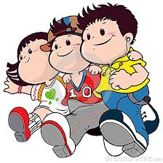 Quiz Unit ( 1 )

My Name :…………… …………………………………………………………Class : ………………………

**10**

Q 1: Write the correct word under each picture :

 ( island - friends – idea - penguin - twins – egg - scientist - shark )

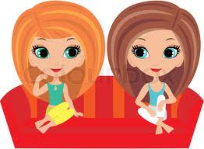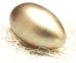

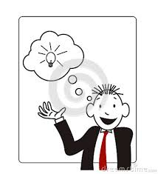………... …....… …..….. …..……

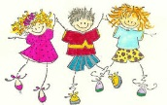

……… ….....… …..….. ………….

Q 2: Choose and Complete :

( wife - grandma – mum )

1- granddad and …………………

2- husband and ……………………

Q 3: Give the opposite :

( clever – dark – short )

a) tall. x ……..…………..

b) stupid x ………………….

Q 4: Choose :

1- I ( am – is – are ) a clever girl .

2- You look happy and ( his – my – your ) sister too .

3- Is he a teacher ? a- Yes , he is . b- Yes they are .

5- They have a car , ( her - our – their ) car is new .

Q 5: Correct :

1- ahmad s friend is badar

…………………………………………………………….

2- He ( Be ) tall and funny .

…………………………………………………………………………

Mrs: Lamia