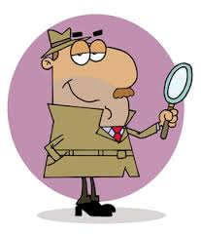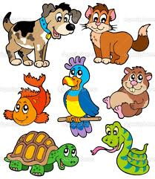 Revision Unit ( 2 )

My Name …………………………………………………………………………… class :………………………………………………..

Q 1: Write the correct word under each picture :

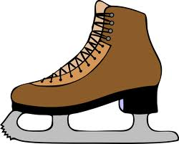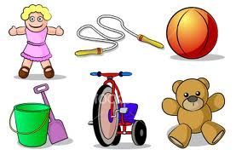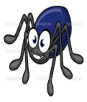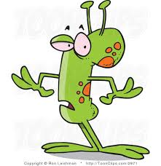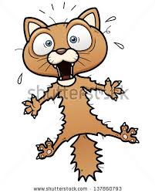 ( present - pieces – toy - message - pet –puzzle - scared – laptop – teddy bear – strange - robot - skateboard – mobile phone - lizard - watch – spider - globe - camera – ice skate )

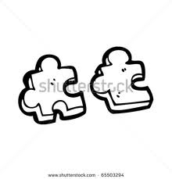

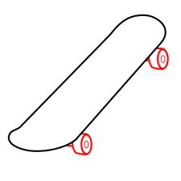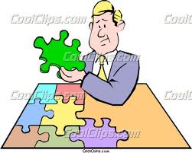……… …....… …..….. …..…. …..…. ….….. ……….

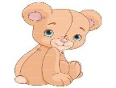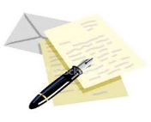

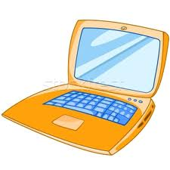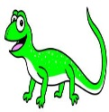 ………... …....… …..….. …..…… …..….. ….…..

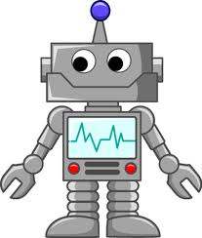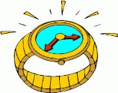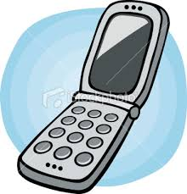

………. ……….. ……….. ………. ………. ………

Q 2: Write the correct preposition :

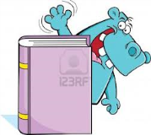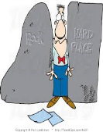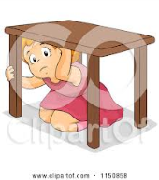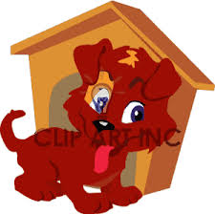

…………………. ….……………. ………………….. …………………… …………………..

Q 3: Choose :

1 - She ( has – have ) got a long hair.

2- My car is too old ( but – and ) works very good .

3- They ( has – have ) got a wonder full family .

4- There ( is - are ) some books under the desk .

5- This house colours are black ( but – and ) white .

6- There ( is – are ) a cat on the tree .

Q 4: Complete :

1- Has Ali got a ball ?

Yes , ……………………………………………..

- Is there a garden in your house ? 2

No , ……………………………………………..

3- There are lots of maps in the classroom . ( Change to negative )

Mrs: Lamia