Quiz Unit 3 . (Crossing cultures ) (B )
Name : ………………………………………………………………….. Class:………………………………………………

*Answer the following questions :
1- How many people go on Hajj yearly?
……………………………………………………………………………………………………………………………………………
2-- People refuse gifts when they are first offered in South Korea .( ) (Put T or F )
2-Grammar : Do as required in brackets :
1- I got the job . If I …………………………………..(get) it, I …………………………….(apply) for another.
(Complete the sentence by putting the verbs in correct form )-
2-The cake burned . ( Use I wish )
……………………………………………………………………………………………………………………………………………………………………………
3-always / in / Muslims /Quran /read/ Ramadan . ( Rearrange the sentence )
…………………………………………………………………………………………………………………………………………………………………………….
Vocab: A-Write the correct word for each picture:

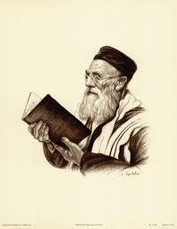
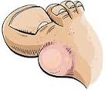

1-………………………….. 2………………………… 3……………………………

___________________________________________________________________________________________
* Easy * Medium * Difficult

Best Wishes: T. Eman ALMulhim


