Quiz Unit 3 . (Crossing cultures ) (A )
Name : ………………………………………………………………….. Class:………………………………………………

*Answer the following questions :
1- When does the naming ceremony for Saudi baby usually take place ?
……………………………………………………………………………………………………………………………………………
2--You become an adult at the age of 18 in Japan .( ) (Put T or F )
2-Grammar : Do as required in brackets :
1-If he (work /harder/be /promoted )…………………………………………………………………………………………………………………
(Make 3rd conditional sentence )-
2-I didn’t call my friend . ( Use I wish )
……………………………………………………………………………………………………………………………………………………………………………
3-always / in / Muslims /Quran /read/ Ramadan . ( Rearrange the sentence )
…………………………………………………………………………………………………………………………………………………………………………….
Vocab: A-Write the correct word for each picture:
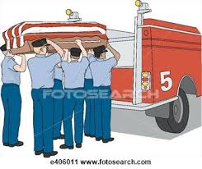



1-………………………….. 2………………………… 3……………………………

___________________________________________________________________________________________
* Easy * Medium * Difficult

Best Wishes: T. Eman ALMulhim


