10

Quiz Unit ( 1 ) 1st year -1434 Name -……………….. …………………………………………

* **☺1- Read the article and answer the questions**

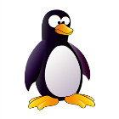 Penguins are birds. They can't fly but they can swim in the sea. The mother has one egg every winter.She gives the egg to the father then she goes to the sea for food .The father keeps the egg warm on his feet. After two months the chick ( baby penguin ) comes out of the egg.

**\*Write T ( true ) or F ( False)**

1. The mother keeps the egg warm on her feet. ( )

**\* Complete with these words**: **birds – sea – food**

1. Penguins swim in the ……………
2. Penguins are …………………..
3. The mother goes to the sea for …………

**********************************************************************************************

**☺2-Answer the following questions .**

**🕊**1-Who is your best friend ?

…………………………………………………

**🕊** 2-Where are you from ?

…………………………………………………

**🕊**3-Can penguins fly ?

…………………………………………………

**☺3-Write ( T ) true OR ( F ) false :-**

**🕊**1-Uncle Samir is a scientist ( ).

**🕊**2-Fadhel is from England. ( ).

***************************************************************************************************

**☺4-Do as shown between brackets :-**

**🕊1-** We [ is – are – am ] friends .  **( Choose )**

**…**……………………………………………………………….

**🕊2-** I am eleven years old .  **( Make the sentence negative )**

**………………………………………………………………….**

**🕊** 3-I am a student . (**Write short form )**

**……………………………………………………………………..**

**☺5-Give the opposite**

1. handsome #.....................
2. tall #......................

☺**6-Circle the odd one out:-**

**🕊**1- father - mother - egg .

**🕊**2-water - son - sea .

☺**7- Circle the correct word:-**

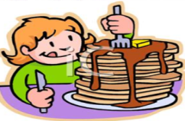

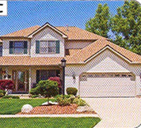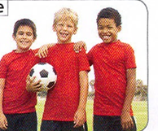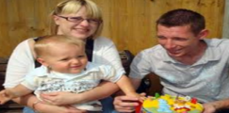

hungry friends house brother and sister warm twins dark mum and dad

☺**8-Match:-**

1- She 2- They 3-We 4- I

🖵 Our 🖵 My 🖵 Her 🖵Their

\☺**9-Copy this sentence :-**

We are at the beach

☺

**With my best wishes,**

**لاتنسي كتابه اسمك ومراجعه ورقتك وفقك الله**