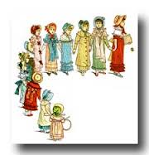

Q1-General Questions:
1-Which jobs are more highly paid?
…………………………………………………………………………………………………………………………..
2-How many people go on Hajj yearly?
…………………………………………………………………………………………………………………………
3-When does the naming ceremony for Saudi baby usually take place ?
……………………………………………………………………………………………………………………….
4-Put (T) or ( F) :
1-You become an adult at the age of 18 in Japan .( )
2-People refuse gifts when they are first offered in South Africa. ( )
3-Ghanaians wear brown or black to the funeral of someone who is over the age of seventy . ( )
Grammar :
A-Complete the sentences by putting the verbs into correct forms:
1-I got the job . If I …………………………………..(get) it, I …………………………….(apply) for another.
2-My doctor gave me some pills .If he …………………………..(give) me them, I ……………………………………..(get) better.
B-Make third conditional sentences :
1-If he (work /harder/be /promoted )…………………………………………………………………………………………………………………
2-I (finish /my project ) on time if my computer (not/break down )
……………………………………………………………………………………………………………………………………………………………………………
C-Rewrite the sentences using ( I wish ) :
1-The teacher was late .
………………………………………………………………………………………………
2-I didn’t have breakfast .
……………………………………………………………………………………………..
D-Do as required in brackets :
1-If I ( had study – had studied – studied ) well, I wouldn’t have ( fail – fails – failed ) the science test .(Choose)
2-I wish I ( don’t leave ) my job . ( Correct the verb )
…………………………………………………………………………………………………………………………………………….
3-The plane ( takes off – taken off – is taking off ) at 2:30 pm . (Choose)
4-Muslims (are reading ) Qur'an in Ramadan . (Correct the verb )
……………………………………………………………………………………………………………………………………………...
5- hadn’t , sweets , wish , you , her , the , I , given . ( Rearrange )
………………………………………………………………………………………………………………………………………………
___________________________________________________________________________________________
Vocabulary :
A-Circle the odd word :
1-Jacket / socks / whistle / trousers .
2-darker / colder / higher / heavy .
3-walk / stroll / stay / climb .
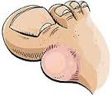
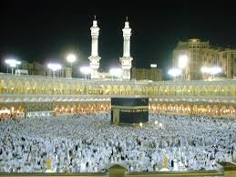
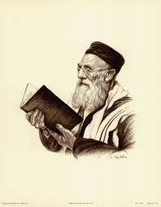

B-Write the correct word for each picture :
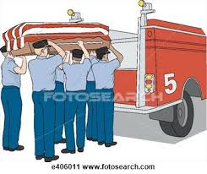

1………………………….. 2…………………………. 3…………………….. 4……………………….. 5…………………….. 6……………….


