### **Kingdom of Saudi Arabia Unit One -Exam**

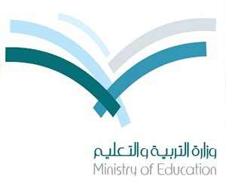

**Ministry of Education The2nd Grade**

**Name: class:**

**Q1. a)** **Match A with B**:

A B

|  |  |  |  |
| --- | --- | --- | --- |
| **1** | **soccer** |  | **holiday** |
| **2** | **gas** |  | **football** |
| **3** | **vacation** |  | **petrol** |

**b) Fill in the space with the correct word:**

|  |  |  |
| --- | --- | --- |
| *customs* | *strangers* | *marvel* |

1. Tourists ……………………..when they see Eiffel tower.
2. Do Chinese have their own wedding ……………………?
3. Mothers always tell their children not to talk to……………………

**Q2. a) Choose the correct form of the verb:**

1. She (is sleeping – sleep – sleeps) late every weekend.
2. They (are eating – eat – eats) apples now.
3. We (went – goes – are going) to school yesterday.
4. (Do – Does – Is) he write a story?

**b) Make questions:**

1. ……………………………………………………?

He is cleaning **his room**.

1. ……………………………………………………?

They are leaving **on Sunday**.

**c)** **Make indirect question:**

Where is the Hospital?

Can you tell me…………………………………?

**Good luck**