First year . First Term 1432 H Module : 2 Title : All about me

IV ) :- Spelling : -
A – Fill in the missing letters :
1- My friend is t----ll & sl----m . He has got br-----n eyes & da----k ha----r .
2- Ahmad can sk----te board very well but he can’t sw----m .
3-Sara’s favourite colour is p----nk . She has got many beautiful h----ad scarves , ju----pers
& tr----users .
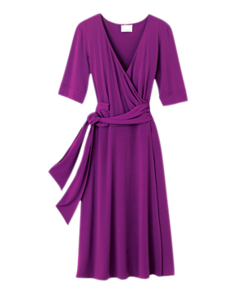
B: complete the words under each pictures :-
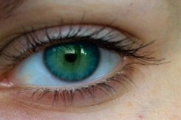
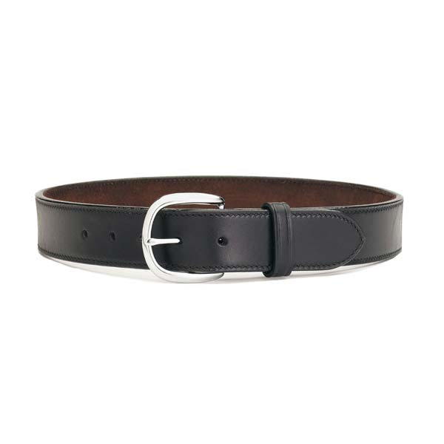
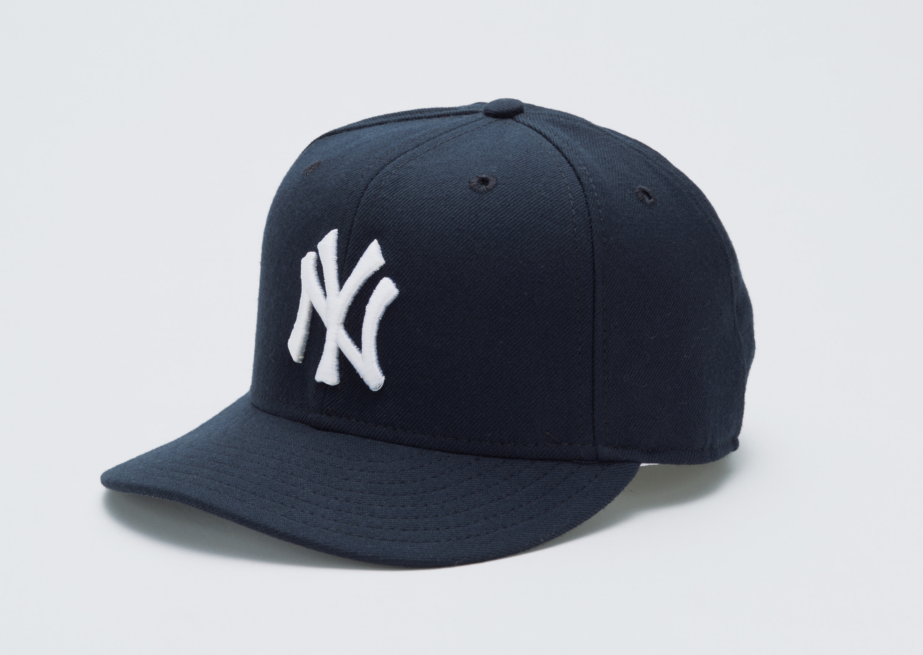

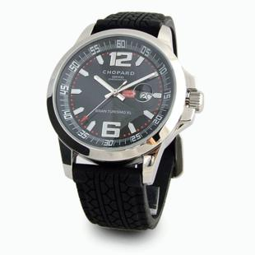

e

d
c
c
w
b

C- unscramble the words : D- Circle the correct letters:
e | u | i | o | i | a
Sw--m |  |  | Parr--t
u | i | a | o | a | e
Pa--nt |  |  | w--tch
1- iwgn
2 - ocok
3 - alit
4 - efca
5 - ohoyd
6 - sejan
7 - sdesr
8 - ibek
u | a | i | a | u | e
Dr--w |  |  | Sn--ke
e | a | o | u | i | a
Th---be |  |  | b---ke
o | a | i | u | a | o
Ab--ya |  |  | h---nd
a | i | u | o | e | i
Sp---der |  |  | n---se

- 5 - Written by : Nesreen Batawi
V ):- Hand Writing:
Write the following sentence once :
A good friend is a blessing from Allah
_____________________________________________________________________________________________________________________-----------------------------------------------------------------------------------

VI ) :-Comprehension:-
Read the following passage then answer the questions :-
My best friend , Deena , is 14 years old & she can speak Arabic , English and French . Deena is a good student , but she is not very good at Art . She can’t draw or paint well . But she is crazy about photography .she’s got three cameras and can take beautiful pictures . She’s got a lot of pictures of her cat . Her name is Ginger . Deena’s got trendy clothes and she’s crazy about accessories .She’s got a lot of belts . Her favourite belt is purple .
Questions :-
1 - How old is Deena ?------------------------------------------------------------------------------------------------
2 – What is her cat’s name ?---------------------------------------------------------------------------------------
3 – Is Deena a good student ?-----------------------------------------------------------------------------------
Choose the right words :-
1 – Her favourite belt is ( pink – purple – red ).
2 –She ’s got three ( camera – watches – sunglasses ).
Put ( T ) or ( F ) :-

- Deena is crazy about photography ( ). 2– Deena can speak Arabic ,English , & French ( ) Ministry of Education . General Administration for Girls’ Education . The (22nd) Intermediate school , Makkah. First Grade Intermediate
- 6 - Written by : Nesreen Batawi

Module 2
All about me
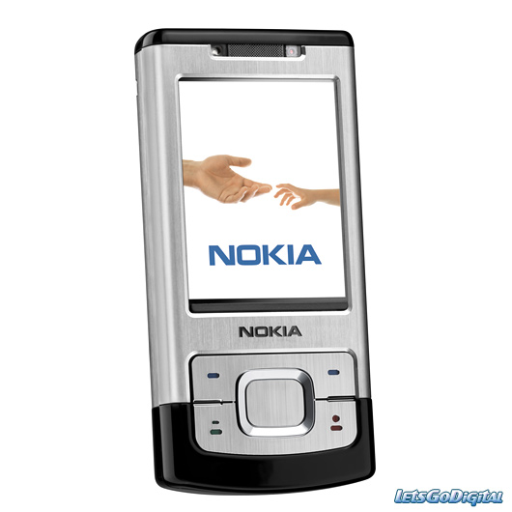
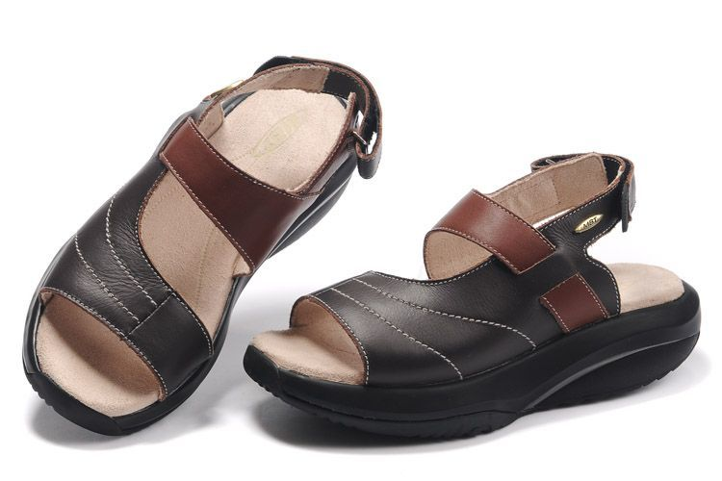
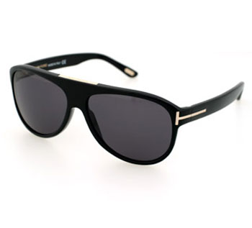
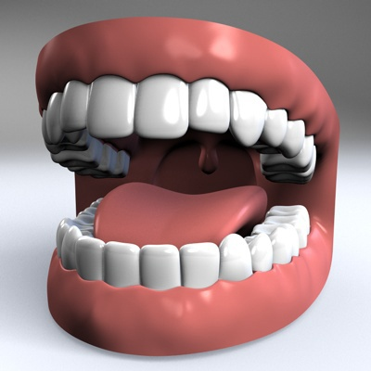
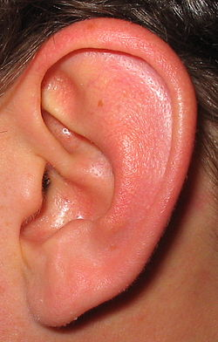


Written by : Nesreen Batawi

