
Kingdom Of Saudi Arabia English Language
Ministry Of Education Second Term .14 _ 14 H
The… Intermediate School First Grade
Time : 2hours
Pages : 3

4
1)-Comprehension

Read the passage then answer the questions below :-

Cheese is a widely eaten food in Arabian counties . Most Arabs usually have cheese for breakfast and dinner . Cheese was first made more than 4.000 years ago by people in Asia. Later ,cheese – making spread to Europe .
Cheese is full of calcium which is necessary for your bones . However ,cheese takes a long time to " digest " . This is because it often has a lot of fat . Nowadays, low –fat cheese is sold at supermarkets.
A – Answer the following questions:-

1.Where was cheese first made ?

-----------------------------------------------------------------------------------------------------------

2.Is cheese sold at supermarkets?

------------------------------------------------------------------------------------------------------------
B – Put "T" or "F"

1.We usually have cheese for lunch . ( )
2.Cheese is good for our bones . ( )

C –Complete the following :-

- Cheese takes a………. time to digest because it has a lot of ………..

****************************************************************************************

2)-General Questions

- Answer the following questions:-

6

1.What language do you speak ?

---------------------------------------------------------------------------------------------------
2. How much do you weigh ?

---------------------------------------------------------------------------------------------------

3. Are you Saudi ?

---------------------------------------------------------------------------------------------------
4 .Is march the third Gregorian month ?
يتبع
---------------------------------------------------------------------------------------------------
( 1 )

- Choose the correct answer :-
2. When do you get up ?
a. I get up at 6:30 am .
b. I go to school at 7:00 .
c. I visit friends at 5 o'clock .

1.What is the matter with her ?
a. She has got a red skirt .
b. She has got a sore throat.
c. She has got curly hair .

3.How many seasons are there in a year?
a. There are 3 seasons .
b. There are 4 seasons .
c. There are 2 seasons .

4. What is your favourite drink ?
a. I like ice cream .
b. I like meat .
c. I like cola .

************************************************************************************

3)-Grammar

5

A-Choose the right word :-

  - On Friday ,I have my breakfast { at – on – in }the morning .
  - She often { eat – eats – eating } pizza .
  - you are carrying a nice bag . Is it { mine – ours – yours } ?
  - Is there any { water – grapes – dates }in the glass ?

- Do as shown between brackets :-

- He is playing now { change into negative }

------------------------------------------------------------------------------------------------------

2.……….. …………… is the perfume ? It is 150 riyals . { form a question }

3.There are not any apples . --------------------------( Make the sentence affirmative)

4.( She ) have got dark hair . ------------------------------ (Write the correct pronoun )
***************************************************************************************

4)-Vocabulary

6
- Match where you can find these items :-
1. belt pharmacy
2.books flower shop
3. flowers furniture shop
4. aspirin bookstore
Dress shop
- For each adjective write the opposite :-
young ≠……………………….. early ≠……………………………
- Choose the right word :-
  - I want a piece of { juice – cake – coffee }
  - We get fruit from { baker's – butcher's – grocer's }يتبع

( 2 )

D- Write the correct word under its picture : -

Month - chicken – rain – elevator jacket

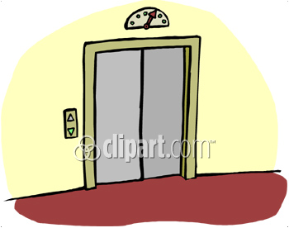
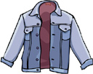


-------------------- -------------------- --------------------- -------------------

*********************************************************************************************

5)-Dictation

4

A. Fill in the missing words :-

1. You can ……… a lot of time in the ……....... but be careful not to

…………. things you do not ………

B. Re-arrange the following words :-
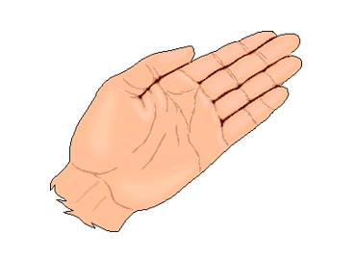



1. hnda 2. wchat 3.freve 4. nynus

-------------------- ------------------ ------------------- -------------------

**************************************************************************************

6)-Handwriting

5

A. Copy the following sentences once :-

  - A penny saved is a penny gained .

………………………………………………………………………………………………………………...........................................
…………………………………………………………………………………………………………………………………………..

2. Speech is silver but silence is gold
……………………………………………………..……………………………………………………………………………….....
………………………………………………………………………………………………………………………………………...

انتهت الأسئلة
Good Luck
3

