صلي الاشياء التي تكون داخل الثلاجة:-

 [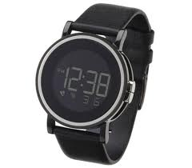](http://www.google.com.sa/imgres?q=%D8%B3%D8%A7%D8%B9%D8%A9+%D9%8A%D8%AF&hl=ar&safe=active&sa=X&biw=1366&bih=596&tbm=isch&prmd=ivns&tbnid=8zLm1UfBR2UUQM:&imgrefurl=http://www.dezeen.com/2011/04/12/skew-by-ross-mcbride-at-dezeen-watch-store/&docid=zhZ2-nBFjyVGjM&imgurl=http://static.dezeen.com/uploads/2011/04/dzn_Skew-by-Ross-McBride-at-Dezeen-Watch-Store-4.jpg&w=468&h=410&ei=qJSvUPO9JaSs0QWfh4DwAw&zoom=1&iact=hc&vpx=381&vpy=257&dur=558&hovh=210&hovw=240&tx=148&ty=123&sig=109835929441876541197&page=3&tbnh=135&tbnw=147&start=57&ndsp=32&ved=1t:429,r:61,s:0,i:251) 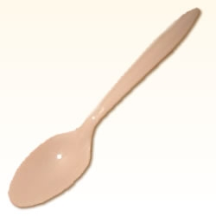 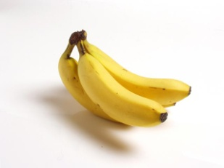

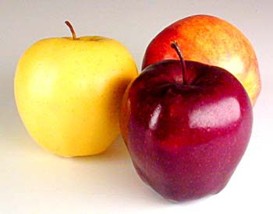 [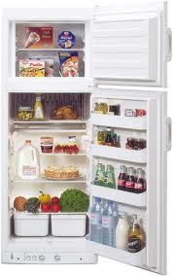](http://www.google.com.sa/imgres?q=%D8%AB%D9%84%D8%A7%D8%AC%D8%A9&hl=ar&safe=active&biw=1366&bih=596&tbm=isch&tbnid=7n2WSksNo5aRrM:&imgrefurl=http://www.hayah.cc/forum/t40437.html&docid=9dsCAh4ooxVL5M&imgurl=http://www.hayah.cc/forum/imgcache/201304.png&w=476&h=760&ei=FJavUOvVKuO_0QW154GIAg&zoom=1&iact=hc&vpx=1041&vpy=101&dur=4083&hovh=284&hovw=178&tx=75&ty=177&sig=109835929441876541197&page=1&tbnh=132&tbnw=83&start=0&ndsp=26&ved=1t:429,r:0,s:0,i:65) [](http://www.google.com.sa/imgres?q=%D8%AD%D9%84%D9%8A%D8%A8&start=259&hl=ar&safe=active&biw=1366&bih=596&tbm=isch&tbnid=RpEZ3H89szSSRM:&imgrefurl=http://www.t555t.com/vb/t149621.html&docid=hbnYf19uz1zM9M&imgurl=http://img.t555t.com/imgcache/139159.jpg&w=220&h=320&ei=V5avUODpE6S80QWNmYDIDQ&zoom=1&iact=hc&vpx=489&vpy=50&dur=364&hovh=256&hovw=176&tx=107&ty=151&sig=109835929441876541197&page=11&tbnh=143&tbnw=96&ndsp=28&ved=1t:429,r:62,s:200,i:190)