1- Comprehension:
4

1-Read the following passage then, answer the questions:
The Souq
In olden times one of the most famous places to meet with friends and listen to the poetry was" Souq Okaz " . Today , a traditional marketplace is also called " Souq " in Saudi Arabia. In these souqs, there are many small shops in an open area . You can go from one shop to another on foot . The shopkeepers are very talkative and make shopping fun . Bargaining over the price is a must at the souq . If you do not bargain, you will buy things for a higher price .
Questions :-
1- What is the name of the famous souq in olden times ?
…………………………………………………………………………….
2 - Are there small shops in the souq ?
……………………………………………………………………………
Choose the correct answer ;-
1-The shopkeepers are very ……………. and make shopping fun .
◻ souq ◻ talkative ◻ friendly
2-you can go from one shop to another on ……...
◻ car ◻ foot ◻ bus
Put (  ) or (  ) :-
1- In these souqs there are many small shops in an closed area . ( )
2- Bargaining over the price is a must at the souq . ( )
~~~~~~~~~~~~~~~~~~~~~~~~~~~~~~~~~~~~~~~~~~~~~~~~~~~~~~~~~~~~~~~~~~~~~~~~~~~~~~~~~~~
2- Information Questions :
6

A-Answer the following questions:
1-What is the weather like ?
………………………………………………………………………

2- What time is it ? 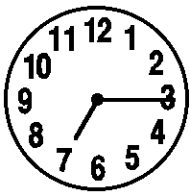
………………………………………………………………………….

B-Choose the correct answer :
1- What color is your dress ? It is ........
a- new b- 25 SR c- blue
2- You look sick , .......
a-what's the matter with you? B-How tall are you? c-what is your name?

3- When do you get up ?
a- In the morning b- in the afternoon c- at night
4- Kabsa is my favorite ..................
a- hobby b- color c- food

C-Put true )T) or false (F) :
1-Riyadh is the capital of Saudi Arabia ( )
2- August is a season ( )
3- Today is Monday yesterday was Friday ( )
4- Arabic is our native language ( )
~~~~~~~~~~~~~~~~~~~~~~~~~~~~~~~~~~~~~~~~~~~~~~~~~~~~~~~~~~~~~~~~~~~~~~~~~~~~~~~~
3 - Grammar:
5
A-Choose the correct answer:
1- She often ( eat – eats – eating ) pizza .
2- Are there ( any , some , an ) eggs in the fridge ?
3- My sister ( has got , have got , have ) a curly brown hair.
5-( How many , How much , How are ) pens do you need ?
6- Waleed (visit – visits – visiting ) his grandfather on Sunday.
7- I have breakfast ( in – on – at ) 6 O'clock .
8- Sarah has ( some – any – a ) oranges .

B ) Do as shown between brackets:
1-Nasser is thin . Nasser is tall. ( join with and )
……………………………………………………………………………………………………………………………..
2-The book is 10 RS. ( make question with How much)
……………………………………………………………………………………………………………………………….

3- black / got / eyes / has / He / a . ( Re- arrange)

………………………………………………………………………………………………………………………………..

4 - I am late for school . ( use never )

…………………………………………………………………………………………………………………………………..
5 - He is wear blue jacket today. (Correct the form of the verb)
……………………………………………………………………………………………………………………………………..
6- Are you busy [at] Sunday evening ? ( Correct the preposition )
………………………………………………………………………………………………………………………………....

4-Vocabulary :
6
A -Choose the correct word :

  headache
  toothache

  young
  old

  skirt
  trousers

  humid
  rainy

B ) Match where you can find these items :-

 | A |  | B
1 | belt |  | pharmacy
2 | books |  | furniture shop
3 | rug |  | flower shop
4 | aspirin |  | bookstore
 |  |  | Dress shop

C- Classify the items in the right category:
meat – India – Monday -- shoulder

Day | Food | My body | Country

D - Circle the odd words :

1- (shirt - skirt –mouth– scarf )
2 - ( tomato – banana - lemon –June )
3- ( humid – stormy – pear – cloudy )
4- ( red – arm – pink – green )

E - Give the opposite adjectives :
1-old # …………………
2-fat # ………………
3-big # ……………….
4-long # ………………

F-Write name each season :
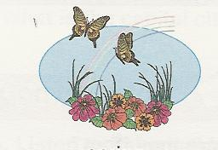
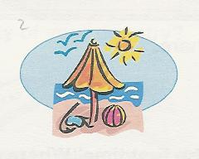
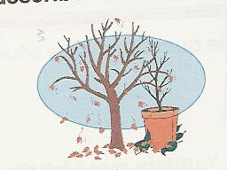
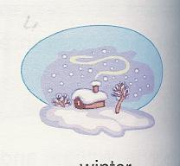

……………………… ………………………… ……………………….. ………………………

~~~~~~~~~~~~~~~~~~~~~~~~~~~~~~~~~~~~~~~~~~~~~~~~~~~~~~~~~~~~~~~~~~~5- Dictation :
4

A-Supply the missing letters :
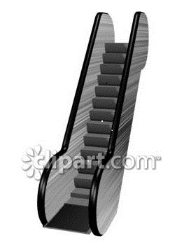

Bu__cher Oni__n p__t esc__lator

B-Re -arrange the letters ,then write the words correctly :

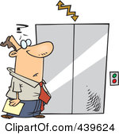
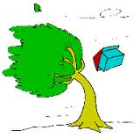
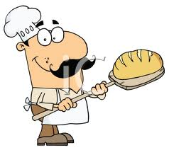
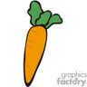

1- inwyd 2- arotcr 3-levaotre 4-akbrec
…………… ………… ………….. …………...

C- Fill the missing letters :
1- In Riyadh , it is sun__y .
2- Ma__ch is the third month .
3-Susan is Briti__h .
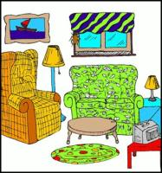
4- I want pie__e of cake .

6-Hand Writing :
5
Copy the following sentences Once :

Brush your teeth twice a day

It is not polite to make people wait for you

Good luck!
T.Al-johara Al-qahtani

