Teacher Frame Review Unit ( 3 )

My Name …………………………………………………………………………………………………………………………………………..

Q 1: Write the correct word under each picture :

( percent - coins - pound – note – sale – calendar )

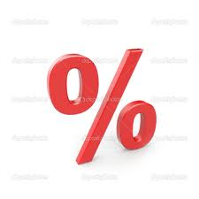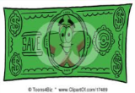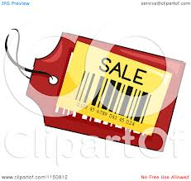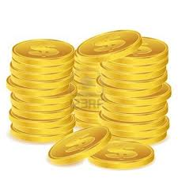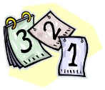

…….… ….…… …..…… ……... ………. ………..

Q2: Choose :

1- Five hundred and thirty - one ( 351 – 153 – 531 ) .

2-One hundred and sixty – four ( 164 – 146 – 461 ) .

3- I like ice cream very much . ( So do I - So am I )

4- I'm hungry . (So do I - So am I ) .

Q3: Choose :

1- Fred is ( small – smaller - smallest ) than Any .

2-The red car is ( expensive – more expensive – expensiver ) than the green one .

3- He has a car , ( his – her – our ) Car is new .

4- I'm Nada , this room is ( my – mine – I )

5- I don't have ( some – any ) dress .

6-Tom has got ( some – any ) books from the library.

7- They ( has – have – had ) got some works .

The European Monthe :

The months of the Year :

January - Febraury - March - April - May - Jun - July - August - September October - November - December .

 