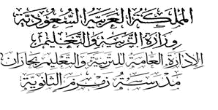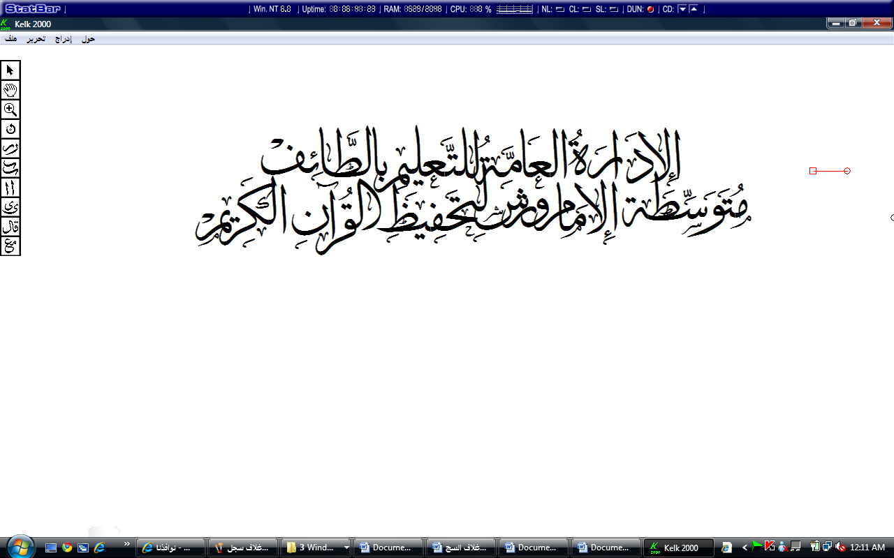...................
م


الصف : الثالث متوسط

Quiz : Unit 1

مدرسة ....................................

الاسم:............................................................................................

10

1)-Choose the correct answer:

listening | C | listening | B | spending | A | I'm …….. my holiday in Dubai. | 1
cutting | C | cut | B | cuting | A | She is….. the material to make a dress. | 2
How | C | How many | B | How much | A | …….. do male caribou weigh? | 3
carpenter | C | tailor | B | baker | A | He is making a thobe. | 4
designs | C | materials | B | pastimes | A | Reading and watching TV are popular | 5
herd | C | migrate | B | mammals | A | Move from one place to another. | 6

2)- Write sentences with so + adjectives/adverb +that :

1- camels/run/quickly/reach 30 kilometres an hour
………………………………………………………………………..…
3)- Write questions for these answers :

1- Caribou live in North America. (where)
………………………………………………………………………………………
4)- Make sentences using the present progressive.

1 -The children/sleep …………………………………………………….

5)- Put ( T ) or ( F ) :
1- The carpenter is a person who making Arabic bread. ( )
2- The meaning of threat is danger. ( )

6-Write the missing letter:

1- The s….ord is very sharp.
2- There's a dr….m playing.
End of the Questions.
I wish you all the best
Your teacher; ………………

