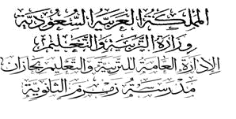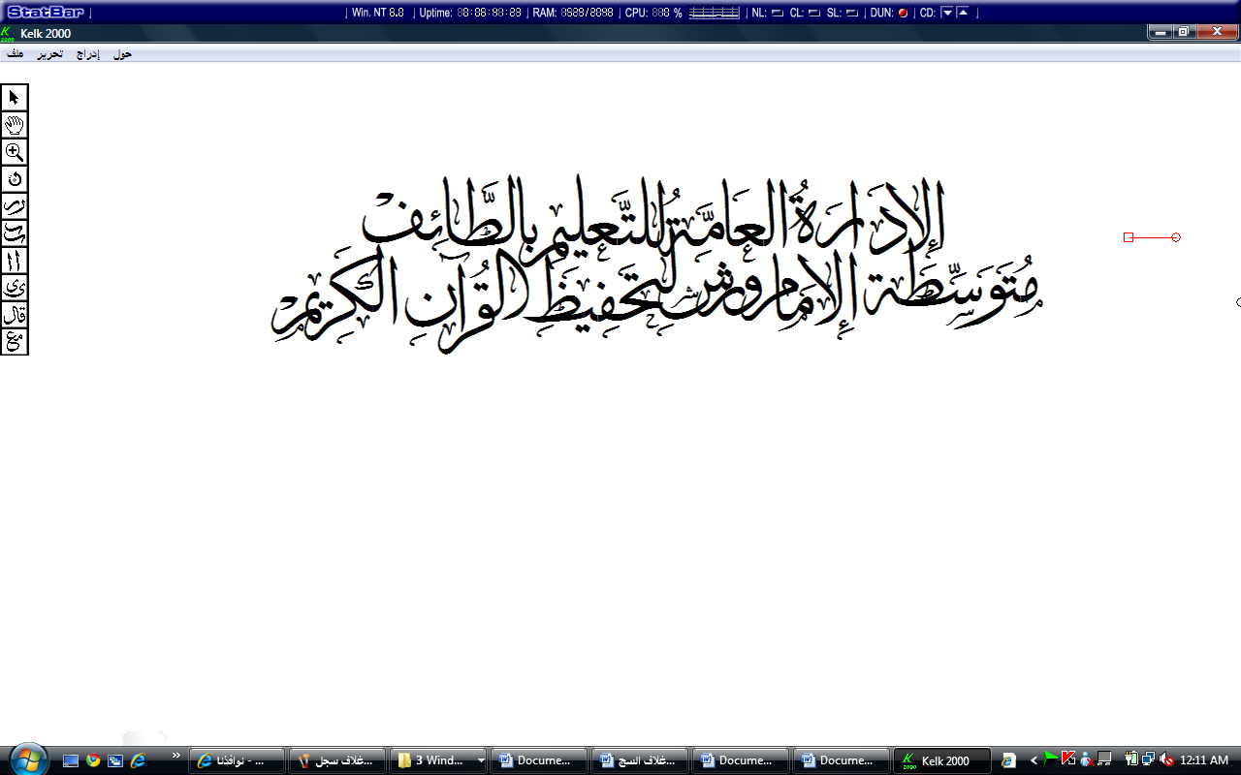...................
م


الصف :الثاني متوسط

Quiz : Unit 1

مدرسة ....................................

الاسم:............................................................................................

10

1)-Choose the correct answer:

drinks | C | drink | B | drinking | A | He's….. orange juice. | 1
too | C | to | B | At | A | I have lessons from 8 …… 12. | 2
too | C | to | B | At | A | …….. 10 I'm going shopping. | 3
on | C | by | B | in | A | Hind is going to her school…... foot. | 4

2)- Write ( N ) for now or ( F ) for future plans :

1- I'm not doing anything. ( )
2- Next week, I'm going to travel to Dubai. ( )

3)- Correct the sentences :

1- I have two foot. ………………………………………………..…….

2- I go to airport on car. ………………………………………………..…….

4) Match the sentences with the same meaning :

B |  | A
a) tower |  | When you have lots to do you are | 1
b) rest |  | A sport where you go under water | 2
c) busy |  | Stop doing things/have a break | 3
d) diving |  | A tall, thin building | 4

5-Write the missing letter:

- I have l….nch with my family.
2- I'd like to make journ….ys around the world.

End of the Questions.
I wish you all the best
Your teacher; ………………

