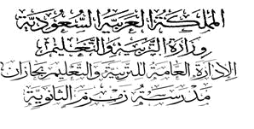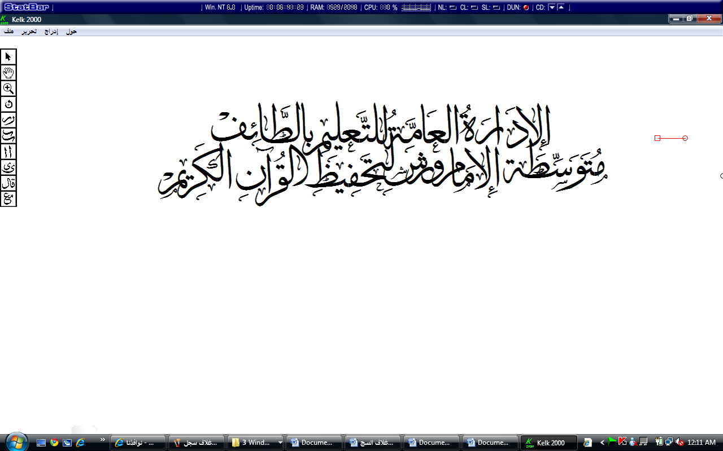...................
م


الصف : الأول متوسط

Quiz : Unit 1

مدرسة ....................................

الاسم:............................................................................................

10

1)-Choose the correct answer:

has | C | having | B | had | A | We …… a great time. | 1
has | C | having | B | had | A | We're …… a great time. | 2
a room | C | a house | B | a picnic | A | Food outside is called | 3
two weeks | C | four weeks | B | one week | A | A fortnight means | 4

2)- Rewrite the sentences :

1- in/assembly/is/nina
……………………………………………………………………

3)- Match the pictures with the subjects :
1- history 2- art 3- science 4- French 5- maths 6- P.E. 7 - technology

3
4
1
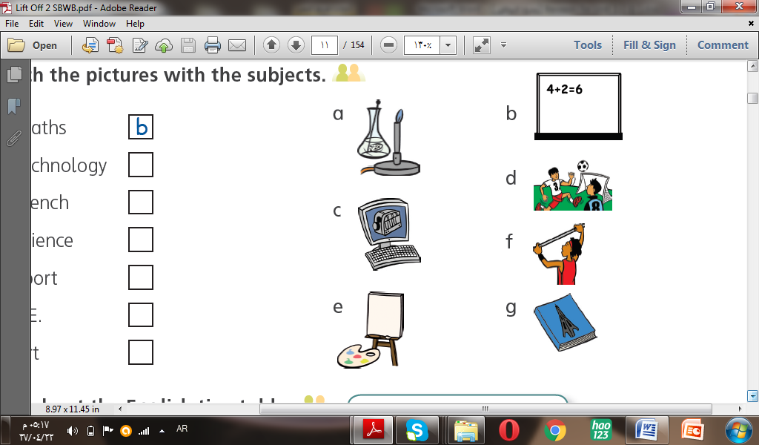

4) Match the sentences with the same meaning :

B |  | A
a) subjects |  | It shows you where different countries are. | 1
b) Assembly |  | This is a very important teacher. | 2
c) Head Teacher |  | You study these at school. | 3
d) map |  | It starts the day at an English school. | 4

5-Write the missing letter:

1- Next hol…day, I'm going to France.
2- We have a sp…rt on Thursday.

End of the Questions.
I wish you all the best
Your teacher; ………………

