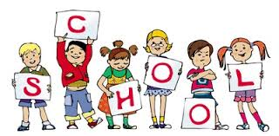  Days  Unit Goal :  Recognize school items | Date | Grade | Title | Unit
 |  | # 1st intermediate | Around the school | #3

Strategies and teaching method | Evaluation | Activates | Objectives
Mind map Simulations  fish pool Brain storming  Role play  Numbered head  Cooperative learning  Self-learning  Problem Solving  searching and exploratory  active learning    Linguistic communication |  | Introduction : A. introduce the lesson  b. write the topic and skim the lesson | At the end of the lesson the Ss will be able to :
 | What is this ? | Ss will recognize the meaning of each words by seeing the flash cards . then Ss will repeat and spell each words | Identify the new Voc
 | Read ? | I will ask Ss to read the dialogue in pairs | Read the conversation fluently
 | Give a sentences ? | Ss will give me some simple sentences using the prepositions | Differ between the Prepositions
 | Complete > | Ss will complete answering the questions | Complete answering the question in their book

Reflection :
Vocabulary :
School teacher
Library classroom gate
H.W
Copy the new words
Page 100 + 102

