بسم الله الرحمن الرحيم
المملكة العربية السعودية | 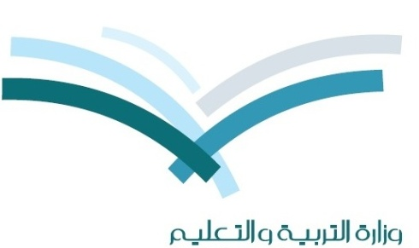 | اختبار نهاية الفصل الدراسي الاول |  | الصف
وزارة التربية والتعليم |  | لعام : 1435-1436هـ |  | الصف
الإدارة العامة للتربية والتعليم بحافظة جده بنين |  | الدور : الأول |  | 1
مكتب التربية والتعليم ......... |  | الزمن : ساعتان |  | 1
متوسطة ............................... |  | المادة : لغة انجليزية |  | متوسط

اسم الطالب : رقم الجلوس: الصف:( / )
Q1- Read the following passage then choose the correct answer:
Ali Mohammad is a student. He is eleven years old. His nationality is Saudi. Ali lives in jeddah. He has two sisters and one brother. His father is a teacher and his mother is a housewife. Ali's favorite subject is Math. He likes swimming. Ali has got a bike.

1- Ali Mohammad is a…………………..
a- student b- teacher c- pilot d- driver
2- He is …………………………. years old.
a- ten b- eleven c- nine d- eight
3- His nationality is……………....
a- Egyptian b- Britain c- Saudi d- American
4- He has ………….. sisters and one brother.
a- two b- three c- six d- one
5- Ali's favorite subject is ……………..
a- English b- Math c- Art d- Geography
6- He likes ………………...
a- football b- fishing c- swimming d- skiing
7- Ali has got a …….………..
a- car b- camera c- bike d- game console
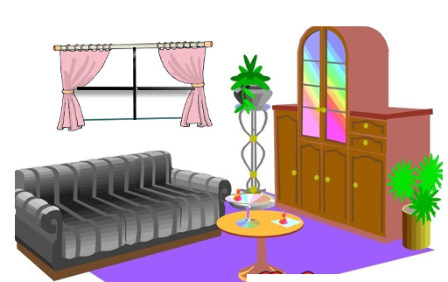
ـــــــــــــــــــــــــــــــــــــــــــــــــــــــــــــــــــــــــــــــــــــــــــــــــــــــــــــــــــــــــــــــــــــــــــــــــــــــــ

Choose the correct answer:
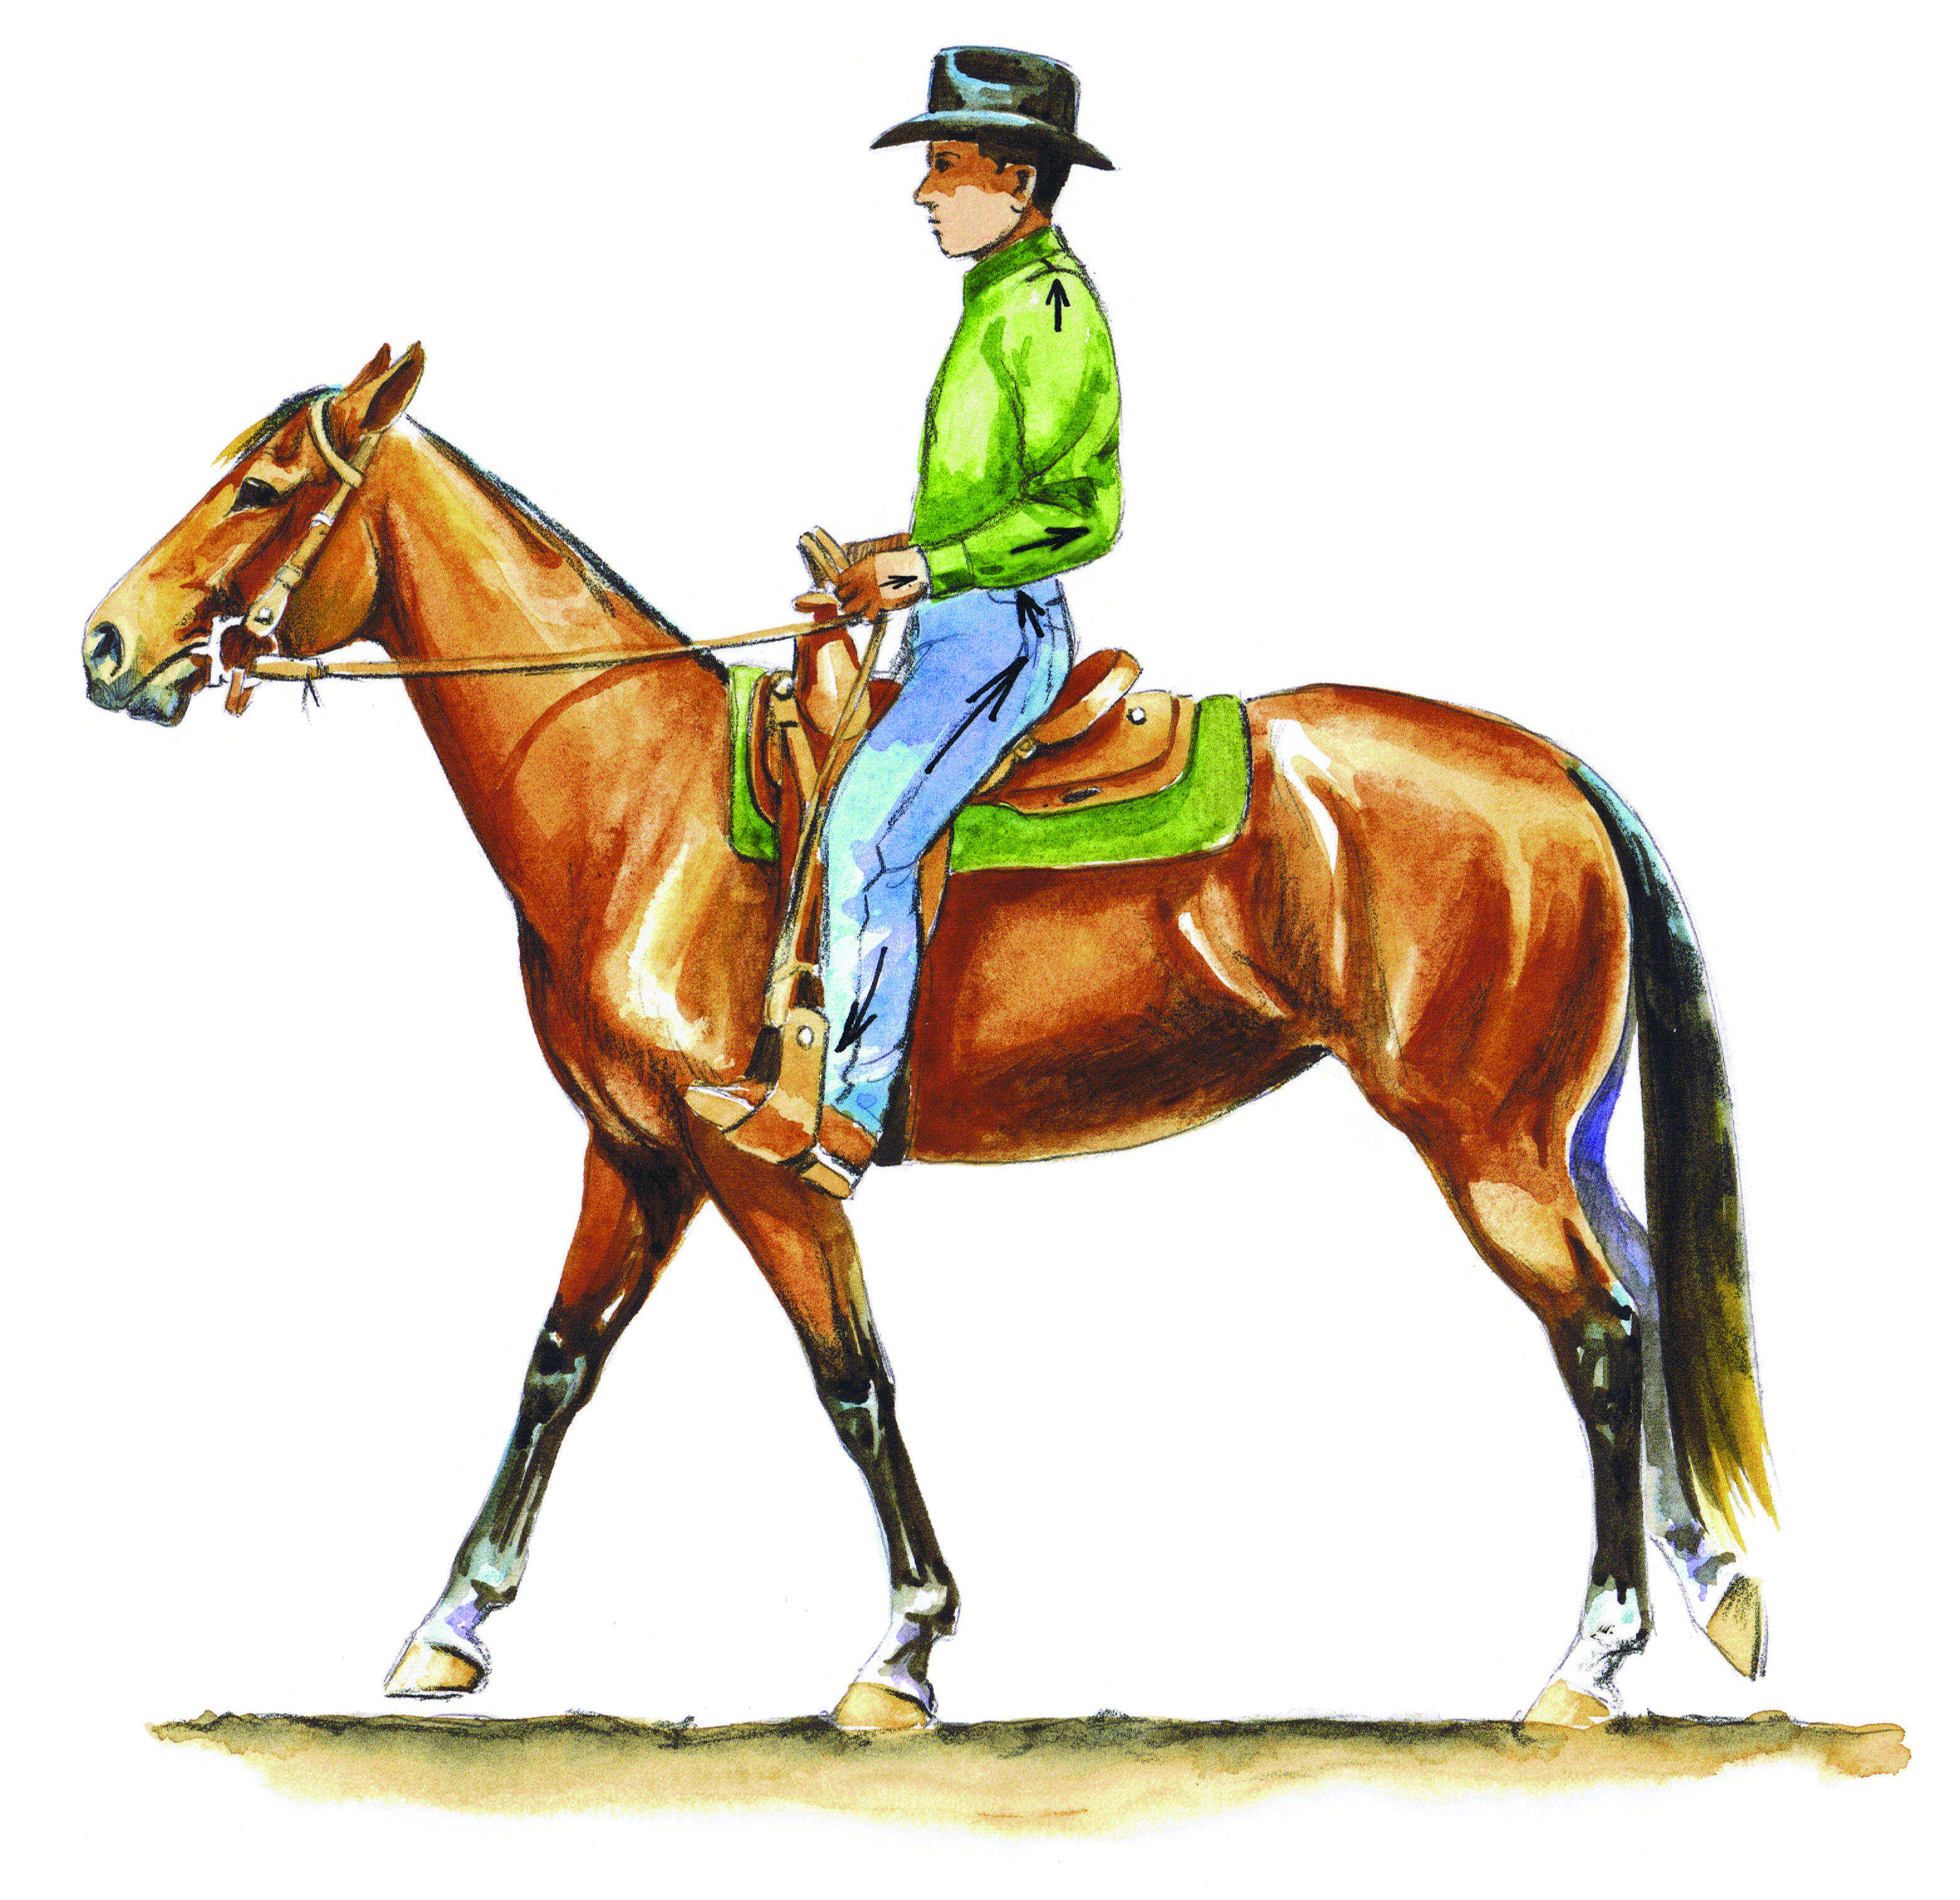
8- a- ride a bike b- cook 13- a- police man b- secretary

c- ride a horse d- swim c- nurse d- doctor

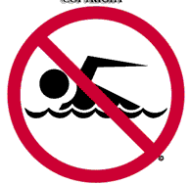
9- a- bedroom b- living room 14 - a- No talking b- No parking

c- bathroom d- kitchen c- No swimming d- No cheating

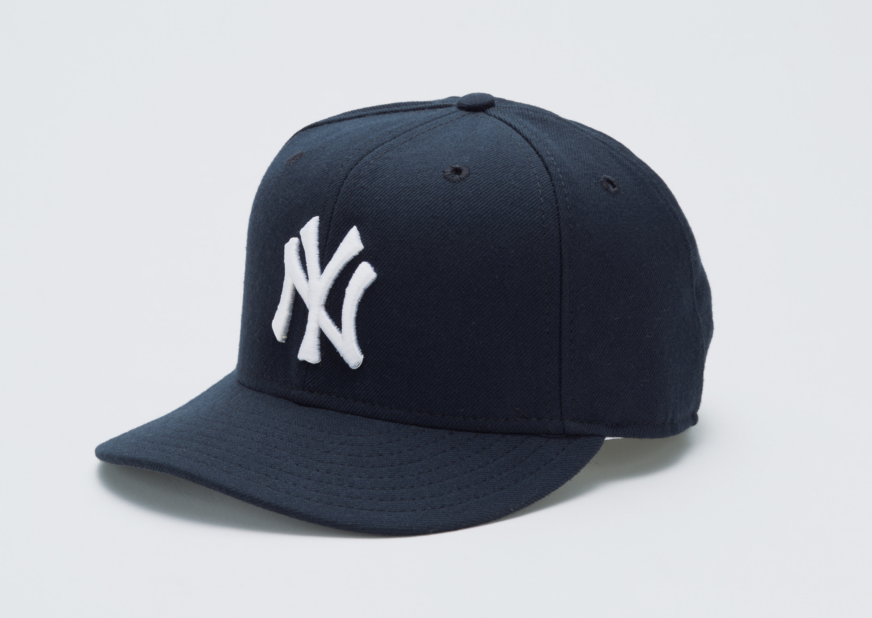
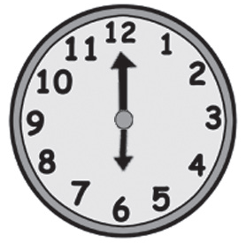
10- a- cap b- bike 15- a- it's six o'clock b- it's ten o'clock

c- skateboard d- watch c- it's half past six c- it's nine o'clock
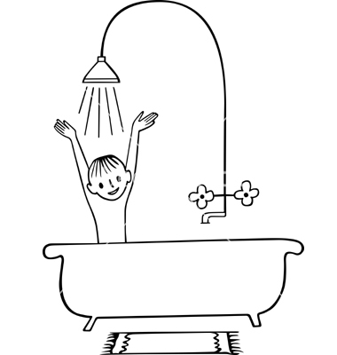
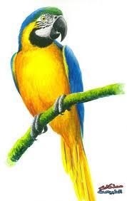
11- a- do homework b- go to bed 16- a- cat b- parrot

c- have a shower d- get up c- snake d- sheep

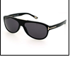

12- a- sunglasses b - shoes 17- a- Science b- Arabic

c- jeans d - T-shirt c - Art d- History

18- This is …… apple. a- an b- a c- in d- on
19- ………….. is a Thobe . a- Those b- This c- These d- The
20- You ……... students. a- is b- am c- are d- our
21- I'm Saudi ,………..name is Ahmad . a- his b- her c- it's d- my
22- I ………..……..got a new car . a- have b- has c- are d- is
23- ……you good at English ? a- Am b- Is c- Are d- Me
24- We play football ………….Monday. a- at b- in c- the d- on
25- I………… draw well ,but I can't cook. a- can b- what c- who d- where
26- Do.……... play golf ? a- he b- she c- you d- it
27- He…………..computer games. a- play b- playing c- play d- plays
28- We………….pray in the mosque . a- always b- sometime c- often d- never
ـــــــــــــــــــــــــــــــــــــــــــــــــــــــــــــــــــــــــــــــــــــــــــــــــــــــــــــــــــــــــــــــــــــــــــــــــــــــــ
Choose the right spelling :
29- C__ef a- ( s ) b- ( h ) c- ( a ) d- ( u )
30- Jac__et a- ( f ) b- ( p ) c- ( k ) d- ( y )
31- Spi__er a- ( u ) b- ( n ) c- ( m ) d- ( d )
32- Ki__chen a- ( t ) b- ( j ) c- ( r ) d- ( e )
33- Ho__pital a- ( w ) b- ( s ) c- ( o ) d- ( h )
34- Gar__en a- ( s ) b- ( b ) c- ( d ) d- ( x )
35- Flo__r a- ( f ) b- ( o ) c- ( c ) d- ( q )
36- Boo__shop a- ( d ) b- ( f ) c- ( s ) d- ( k )

ـــــــــــــــــــــــــــــــــــــــــــــــــــــــــــــــــــــــــــــــــــــــــــــــــــــــــــــــــــــــــــــــــــــــــــــــــــــــــ
Q2- Choose True ( T ) or False ( F ):

1- Ahmad and Ali like swimming. ( T ) ( F )

2- diD he Go To SChOol yEsteRDAy ( T ) ( F )

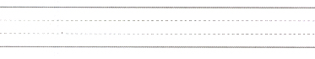
3- I like my school. ( T ) ( F )
4- ( T ) ( F )
aMaZinG
5- I'm proud of Saudi. ( T ) ( F )
ـــــــــــــــــــــــــــــــــــــــــــــــــــــــــــــــــــــــــــــــــــــــــــــــــــــــــــــــــــــــــــــــــــــــــــــــــــــــــ
Q3- Match column A with column B
B |  | A
PE | a | 1- What is your name ?
Children . | b | 2- How old are you ?
An old man . | c | 3- What is your favourite sport ?
Riyadh . | d | 4- Where is Al - Faisaliah Tower ?
Football . | e | 5- The plural of child is …………..
I am 13 years old . | f | 6- The opposite of a young man is …………
My name is Ali . | g | 7- What is your favourite subject ?

