skill1-Recognize and produce the sound of English alphabet.
أكملي كتابة الحرف الناقص
Complete the missing letters :
A a – ____ – Cc – ____ – Ee – Ff – ____ –

Hh – Ii– ____ – Kk – Ll – ____ – Nn – Oo –

____ – ____ – Rr – Ss – Tt – ____ – Vv – ___

___ – Xx – ____ – Zz

Skill2:Recognize and produce only some English digraphs such as, (wh, sh, ch).
ضعي دائرةعلى الحرف الذي تسمعينه
A. Listen & circle the letter you hear in the words :

1) ch sh th 2) ch sh ph

\
_______________________________________________

اختاري الاجابة الصحيحة
B. Choose the correct letters to complete the words :
___air | ___one
Ch-Ph- | Sh- Ph

Skill3:Ask questions using (what, who, where ):
استخدامه | صيغة السؤال
ماذا | What
للسوال عن المكان | Where
للسؤال عن العاقل | who

Q : Choose : اختاري الاجابة الصحيحة من بين الاقواس
1- ………………. are you from ?(where -what -who)
2-………….is this  ? (what - who – where)
3- …………. Is your name? (who –where -what)

Skill4:Identify irregular plural nouns:
اختاري الاجابة الصحيحةChoose :
a - 1 ( men - man )
b - 6 ( men - man )
c - 8 ( feet - foot )
d - 1 ( foot - feet )
Skill5:Introduce people to each other ,eg:This is Ali:
صلي 1/ Match :
1/What is your name?
2/How are you ?
3/How old are you ?
I am 11 .
My name is Ahmad.
I am fine , thank you .


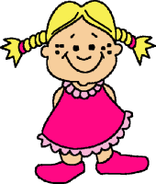

Skill6:Identify and talk about people using verb to be:
Choose the correct word اختاري الاجابة الصحيحة:
- (She-He- It) is Fatima.
- (She-He- It) is Ali.
- (She- He - It) is a pencil.
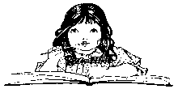
- I (is- are- am) a girl

Skill7:Express possession using the verb to have and my/your/his/her: "Speaking"
"by asking questions during the class orally and individual"
Skill11: talk about the weather:
صلي بين الكلمة والصورة:Match between the word and the picture
 |  | windy
 |  | snowy
 |  | Rainy
 | 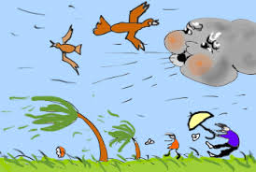 | Sunny

Skill13 : Ask about and tell the time (o'clock) only:
اكتبي الوقت المعطى أمامكWrite the times shown.
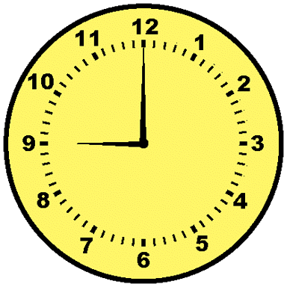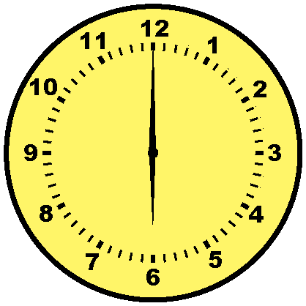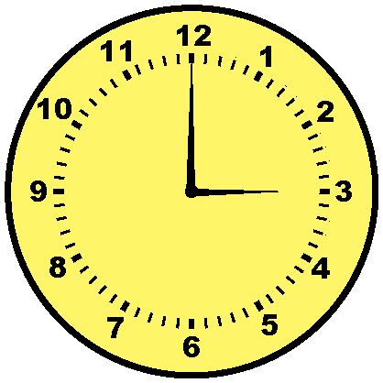
:
:

:

Skill15:Ask and respond to simple sentences about every day activities in the Present Simple tense using the first and second person singular:
Q : Fill in the spaces with the correct choiceاملئي الفراغ بالاجابة المناسبة :
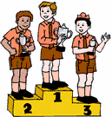
( First – second – third )
Ali

Ahmad

Sami

1- Sami is the …………………………..
2- Ahmad is the …………………….....
3- Ali is the ……………………………...

Skill16:Greetsome one politely at different times of the day eg:Good morning…..
Match:
Good morning Goodbye
Good afternoon Good morning
Good afternoon

Skill17:Identify anf talk about different tomes of day (morning-afternoon-evening,night)
صلي :Match
(Night - Morning)


Skill18:Identify prepositions of times (in,on,at)

Q : Choose اختاري:
- We eat breakfast ( in / on / at ) the morning.

- We eat dinner ( in / on / at ) the night.
Skill19:Identify occupations talk about what someone does using the present simple (affirmative,negative,interrogative,short answers)
اختاري الاجابة الصحيحةChoose the correct answer:

1- Is he a teacher ? 
(no , she is not - no ,he is not)
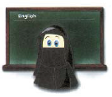

2- Is she a teacher ?
(yes , you are - yes she is)
Skill20:Follow a short simple text while listening to the audio recording:
Listening activity
Skill22:Read and count ordinal numbers from 1 th to 10th :
Q : Matchصلي كل رقم بمايناسبه :
third fourth second first

1st 4th 2nd 3rd
Skill23:Read and comprehend simple sentences :
Put the correct numbers:

1-Where Are you from? | I am fine thank you
2-What is today? | I am from Saudi Arabia
3-How are you? | It is Sunday
Skill24:Read simple short illustrated stories :
Skill26:Write short simple words/phrases to complete a paragraph:

B- Complete: (Fahad / 60/teacher )

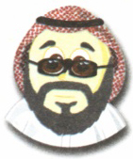
This is my.....................
His name is................
He is ...............years old.

Skill25:Spell accurately a small number of high frequency a paragraph:
اختاري الكلمة الصحيحةChoose the correct word :
She is a (teasher - teacher) He is an(engineer-imjiner)

Skill27:Write short simple sentences to convey basic information:
Complete اكملي الجمل التالية:
1-My name is _______________________________
2-I am __________________________________
3-I am from ________________________________________

Skill30:Link ideas with commas and,but, and or
أختاري الاجابة الصحيحةChoose the right answer:
1-She likes apples,she likes oranges (but - and )
2-Ali can speak Arabic.Ali can not Speak English ( but - and)
Done by/Miss.Jehan Abduljabbar

